**LAB FILE**

**INTRODUCTION TO C PROGRAMMING**

**BATCH 2023-2027**

**BCA(Hons.) AI&DS**

**SUBMITTED BY: SUBMITTED TO:**

**Himanshu Mawdi Mr. Rishi Kumar**

**23011782 Assistant. Prof (CS/IT)**

**GEU**

***INDEX***

|  |  |  |  |  |  |  |
| --- | --- | --- | --- | --- | --- | --- |
| **S.NO** | **NAME** | **PG.NO** | | **REMARKS** | | **T.SIGN** |
| **1** | **THIS IS MY FIRST PROGRAM** | **01-01** | |  | |  |
| **2** | **ADDITION OF TWO NUMBERS** | **02-02** | |  | |  |
| **3** | **AREA OF CIRCLE** | **03-03** | |  | |  |
| **4** | **DIVIDE TWO NUMBERS** | **04-04** | |  | |  |
| **5** | **FIND ASCII VALUE** | **05-05** | |  | |  |
| **6** | **MULTIPLY FLOATING POINT NUMBERS** | **06-06** | |  | |  |
| **7** | **SWAP TWO NUMBERS USING 3RD VARIABLE** | **07-08** | |  | |  |
| **8** | **SWAP TWO NUMBERS WITHOUT USING 3RD VARIABLE** | **09-10** | |  | |  |
| **9** | **SWAP THREE NUMBER WITHOUT USING 3RD VARIABLE** | **11-12** | |  | |  |
| **10** | **AREA OF CIRCLE** | **13-13** | |  | |  |
| **11** | **AREA OF SQUARE** | **14-14** | |  | |  |
| **12** | **AREA OF RIGHT ANGLED TRIANGLE** | **15-15** | |  | |  |
| **13** | **AREA OF ISOSCELES TRIANGLE** | **16-16** | |  | |  |
| **14** | **AREA OF TRIANGLE WITH ANY THREE SIDES** | **17-18** | |  | |  |
| **15** | **AREA AND VOLUME OF A CUBE** | **19-19** | |  | |  |
| **16** | **AREA AND VOLUME OF A CUBOID** | **20-20** | |  | |  |
| **17** | **FIND THE LARGEST NUMBER USING THE LOGICAL AND OPERATOR** | **21-21** | |  | |  |
| **18** | **VALIDATE THE USERNAME AND PASSWORD ENTERED BY THE USER IS CORRECT OR NOT USING THE PREDEFINED USERNAME AND PASSWORD** | **22-23** | |  | |  |
| **19** | **TO INPUT THE POSITIVE NUMBER FROM THE USER TO PERFORM THE LEFT SHIFT OPERATOR** | **24-24** | |  | |  |
| **20** | **TO INPUT THE POSITIVE NUMBER FROM THE USER TO PERFORM THE RIGHT SHIFT OPERATOR** | **25-25** | |  | |  |
| **21** | **TO PERFORM THE PRE-INCREMENT AND PRE-DECREMENT OPERATOR ON TWO INTEGER AND PRINT BOTH ORIGINAL VALUE AND UPDATE VALUE** | **26-26** | |  | |  |
| **22** | **TO PERFORM THE POST-INCREMENT AND POST-DECREMENT OPERATOR ON TWO INTEGER AND PRINT BOTH ORIGINAL VALUE AND UPDATE VALUE** | **27-27** | |  | |  |
| **23** | **TO CHECK WHETHER FOR AN INTEGER NUMBER THAT IT IS DIVISIBLE BY 9 OR 7 USING OR OPERATOR** | **28-28** | |  | |  |
| **24** | **TO IDENTIFY GENDER IN SINGLE CHARACTER AND PRINT FULL GENDER(EX: IF INPUT IS ‘M’ OR ‘M’-IT SHOULD PRINT “MALE”** | **29-29** | |  | |  |
| **25** | **TO PRINT ALL NATURAL NUMBERS IN REVERSE (FROM N TO 1)** | **30-31** | |  | |  |
| **26** | **TO PRINT ALL APLPHABET FROM A TO Z** | **31-32** | |  | |  |
| **27** | **TO PRINT ALL NATURAL NUMBER FROM 1TON** | **32-33** | |  | |  |
| **28** | **TO PRINT ALL EVEN NUMBER FROM 1 TO 100** | **33-34** | |  | |  |
| **29** | **TO PRINT ALL ODD NUMBER BETWEEN 1 TO 100** | **34-36** | |  | |  |
| **30** | **TO FIND SUM OF ALL NATURAL NUMBERS BETWEEN 1 TO N** | **36-37** | |  | |  |
| **31** | **TO FIND THE SUM OF ALL EVEN NUMBER FROM 1 TO N** | **38-39** | |  | |  |
| **32** | **TO FIND THE SUM OF ALL ODD NUMBER FROM 1 TO N** | **39-40** | |  | |  |
| **33** | **TO PRINT MULTIPLICATION TABLE OF ANY NUMBER** | **41-42** | |  | |  |
| **34** | **TO COUNT NUMBERS OF DIGIT IN A NUMBER** | **42-43** | |  | |  |
| **35** | **TO FIND FIRST AND LAST DIGIT OF A NUMBER** | **43-44** | |  | |  |
| **36** | **TO FIND SUM OF FIRST AND LAST DIGIT OF A NUMBER** | **45-46** | |  | |  |
| **37** | **TO SWAP FIRST AND LAST DIGIT OF A NUMBER** | **46-47** | |  | |  |
| **38** | **TO CALCULATE SUM OF DIGIT IN A NUMBER** | **47-48** | |  | |  |
| **39** | **TO CALCULATE PRODUCT OF DIGIT OF A NUMBER** | **49-50** | |  | |  |
| **40** | **TO ENTER A NUMBER AND PRINT ITS REVERSE** | **50-51** | |  | |  |
| **41** | **TO CHECK WHETHER NUMBER IS PALINDROME OR NOT** | **53-54** | |  | |  |
| **42** | **TO FIND ALL FACTORS OF A NUMBER** | **54-55** | |  | |  |
| **43** | **TO FIND FACTORIAL OF A NUMBER** | **55-56** | |  | |  |
| **44** | **TO FIND HCF OF TWO NUMBER** | **56-57** | |  | |  |
| **45** | **TO FIND LCM OF TWO NUMBER** | **58-59** | |  | |  |
| **46** | **TO CHECK WHETHER NUMBER IS PRIME OR NOT** | **59-60** | |  | |  |
| **47** | **TO PRINT ALL PRIME NUMBER BETWEEN 1 TO N** | **61-62** | |  | |  |
| **48** | **TO FIND SUM OF ALL PRIME NUMBER BETWEEN 1 TO N** | **62-63** | |  | |  |
| **49** | **TO FIND ALL PRIME FACTORS OF A NUMBER** | **63-64** | |  | |  |
| **50** | **TO CHECK WHETHER A NUMBER IS ARMSTRONG OR NOT** | **64-65** | |  | |  |
| **51** | **TO PRINT ALL ARMSTRONG NUMBER BETWEEN 1 TO N** | **66-67** | |  | |  |
| **52** | **TO CHECK WHETHER NUMBER IS PERFECT NUMBER OR NOT** | **67-68** | |  | |  |
| **53** | **TO PRINT ALL PERFECT NUMBER BETWEEN 1 TO N** | **69-70** | |  | |  |
| **54** | **TO CHECK WHETHER NUMBER IS STRONG NUMBER OR NOT** | **70-72** | |  | |  |
| **55** | **TO PRINT ALL STRONG NUMBER BETWEEN 1 TO N** | **72-74** | |  | |  |
| **56** | **TO PRINT FIBONACCI SERIES UPTO N TERMS** | **74-75** | |  | |  |
| **57** | **TO FIND ONE’S COMPLEMENT OF A BINARY NUMBER** | **75-77** | |  | |  |
| **58** | **TO FIND TWO’S COMPLEMENT OF A BINARY NUMBER** | **77-80** | |  | |  |
| **59** | **TO CONVERT BINARY NUMBER TO OCTAL NUMBER** | **80-81** | |  | |  |
| **60** | **TO CONVERT BINARY NUMBER TO DECIMAL NUMBER** | **82-83** | |  | |  |
| **61** |  | **84-87** | |  | |  |
| **62** | **TO CONVERT OCTAL NUMBER TO BINARY NUMBER** | **88-89** | |  | |  |
| **63** | **TO CONVERT OCTAL NUMBER TO DECIMAL NUMBER** | **89-90** | |  | |  |
| **64** | **TO CONVERT OCTAL NUMBER TO HEXADECIMAL NUMBER** | **91-93** | |  | |  |
| **65** | **TO CONVERT DECIMAL NUMBER TO BINARY NUMBER** | **93-94** | |  | |  |
| **66** | **TO FIND MAXIMUM BETWEEN TWO NUMBERS** | **95-96** | |  | |  |
| **67** | **TO FIND MAXIMUM BETWEEN THREE NUMBERS** | **96-98** | |  | |  |
| **68** | **TO CHECK WHETHER NUMBER IS POSITIVE NEGATIVE OR ZERO** | **98-99** | |  | |  |
| **69** | **TO CHECK WHETHER NUMBER IS DIVISIBLE BY 5 AND 11 OR NOT** | **99-100** | |  | |  |
| **70** | **TO CHECK WHETHER NUMBER IS EVEN OR ODD** | **101-102** | |  | |  |
| **71** | **TO CHECK WHETHER A YEAR IS LEAP YEAR OR NOT** | **102-103** | |  | |  |
| **72** | **TO CHECK WHETHER A CHARACTER IS ALPHABET OR NOT** | **103-104** | |  | |  |
| **73** | **TO INPUT AND ALPHABET AND CHECK WHETHER IT IS VOWEL OR CONSONANT** | **104-106** | |  | |  |
| **74** | **TO INPUT ANY CHARACTER AND CHECK WHETHER IT IS ALPHABET DIGIT OR SPECIAL CHARACTER** | **106-107** | |  | |  |
| **75** | **TO CHECK WHETHER A CHARACTER IS UPPERCASE OR LOWERCASE ALPHABET** | **107-109** | |  | |  |
| **76** | **TO INPUT WEEK NUMBERS AND PRINT WEEK DAYS** | **109-111** | |  | |  |
| **77** | **TO INPUT MONTH NUMBER AND PRINT NUMBER OF DAYS IN THAT MONTH** | **111-114** | |  | |  |
| **78** | **TO COUNT TOTAL NUMBER OF NOTES IN GIVEN AMOUNT** | **114-117** | |  | |  |
| **79** | **TO INPUT ANGLE OF A TRIANGLE AND CHECK WHETHER TRIANGLE IS VALID OR NOT** | **117-118** | |  | |  |
| **80** | **TO INPUT ALL SIDES OF A TRIANGLE AND CHECK WHETHER TRIANGLE IS VALID OR NOT** | **118-120** | |  | |  |
| **81** | **TO CHECK WHETHER THE TRIANGLE IS EQUILATERAL OR SCALE IN TRIANGLE** | **120-121** | |  | |  |
| **82** | **TO FIND ALL ROOTS OF A QUADRATIC EQUATION** | **121-123** | |  | |  |
| **83** | **TO CALCULATE PROFIT AND LOSS** | **123-125** | |  | |  |
| **84** | **TO INPUT MARKS OF FIVE SUBJECTS PHYSICS, CHEMISTRY, BIOLOGY, MATHEMATICS AND COMPUTER. CALCULATE PERCENTAGE AND GRADE ACCORDING TO FOLLOWING:**  **PERCENTAGE >= 90% : GRADE A**  **PERCENTAGE >= 80% : GRADE B**  **PERCENTAGE >= 70% : GRADE C**  **PERCENTAGE >= 60% : GRADE D**  **PERCENTAGE >= 40% : GRADE E**  **PERCENTAGE < 40% : GRADE F** | **125-127** | |  | |  |
| **85** | **TO INPUT BASIC SALARY OF AN EMPLOYEE AND CALCULATE ITS GROSS SALARY ACCORDING TO FOLLOWING:**  **BASIC SALARY <= 10000 : HRA = 20%,**  **DA = 80% BASIC SALARY <= 20000 : HRA = 25%,**  **DA = 90% BASIC SALARY > 20000 : HRA = 30%,**  **DA = 95%** | **127-129** | |  | |  |
| **86** | **TO INPUT ELECTRICITY UNIT CHARGES AND CALCULATE TOTAL ELECTRICITY BILL ACCORDING TO THE GIVEN CONDITION:**  **FOR FIRST 50 UNITS RS. 0.50/UNIT**  **FOR NEXT 100 UNITS RS. 0.75/UNIT**  **FOR NEXT 100 UNITS RS. 1.20/UNIT**  **FOR UNIT ABOVE 250 RS. 1.50/UNIT**  **AN ADDITIONAL SURCHARGE OF 20% IS ADDED TO THE BILL** | **129-131** | |  | |  |
| **87** | **TO CONVERT SPECIFIED DAYS INTO YEARS WEEKS AND DAYS** | **131-132** | |  | |  |
| **88** | **PYRAMID STAR PATTERN** | **133-134** | |  | |  |
| **89** | **HOLO PYRAMID STAR PATTERN** | **134-135** | |  | |  |
| **90** | **INVERTED PYRAMID STAR PATTERN** | **136-137** | |  | |  |
| **91** | **HOLLOW INVERTED STAR PATTERN** | **137-138** | |  | |  |
| **92** | **HALF DIAMOND STAR PATTERN** | **139-140** | |  | |  |
| **93** | **MIRRORED HALF DIAMOND STAR PATTERN** | **140-142** | |  | |  |
| **94** | **NUMBER PATTERN 1** | **142-143** | |  | |  |
| **95** | **NUMBER PATTERN 2** | **143-145** | |  | |  |
| **96** | **NUMBER PATTERN 3** | **145-147** | |  | |  |
| **97** | **NUMBER PATTERN 4** | **147-149** | |  | |  |
| **98** | **NUMBER PATTERN 5** | **149-151** | |  | |  |
| **99** | **NUMBER PATTERN 6** | **151-153** | |  | |  |
| **100** | **TO READ N NUMBERS OF VALUES IN AN ARRAY AND DISPLAY THEM IN REVERSE ORDER** | **153-154** | |  | |  |
| **101** | **TO FIND THE SUM OF ALL ELEMENTS OF THE ARRAY** | **155-156** | |  | |  |
| **102** | **TO COPY THE ELEMENTS OF ONE ARRAY INTO ANOTHER ARRAY** | **156-157** | |  | |  |
| **103** | **TO COUNT THE TOTAL NUMBERS OF DUPLICATE ELEMENTS IN AN ARRAY** | **157-159** | |  | |  |
| **104** | **TO FIND THE MAXIMUM AND MINIMUM ELEMENTS IN AN ARRAY** | | **159-161** | |  |  | |
| **105** | **TO SORT THE ELEMENTS OF AN ARRAY IN DESCENDING ORDER** | | **161-162** | |  |  | |
| **106** | **TO SEPARATE ODD AND EVEN INTEGERS INTO SEPARATE ARRAY** | | **162-164** | |  |  | |
| **107** | **TO MERGE TWO ARRAYS OF THE SAME SIZE SORTED IN ASCENDING ORDER** | | **164-166** | |  |  | |
| **108** | **TO MERGE TWO ARRAYS OF THE SAME SIZE SORTED IN DESCENDING ORDER** | | **167-169** | |  |  | |
| **109** | **READ MATRIX ELEMENT AND DISPLAY** | | **169-171** | |  |  | |
| **110** | **MATRIX MULTIPLICATION AND DISPLAY** | | **172-174** | |  |  | |
| **111** | **ADDITION OF MATRIX AND DISPLAY** | | **175-178** | |  |  | |
| **112** | **SUBTRACTION OF MATRIX AND DISPLAY** | | **179-182** | |  |  | |
| **113** | **TRANSPOSE OF MATRIX AND DISPLAY** | | **183-186** | |  |  | |

* **PROGRAM 1:- THIS IS MY FIRST PROGRAM**

**#include<stdio.h>**

**int main()**

**{**

**printf(“This is my First Program and My Name is Himanshu Mawdi”);**

**return 0;**

**}**

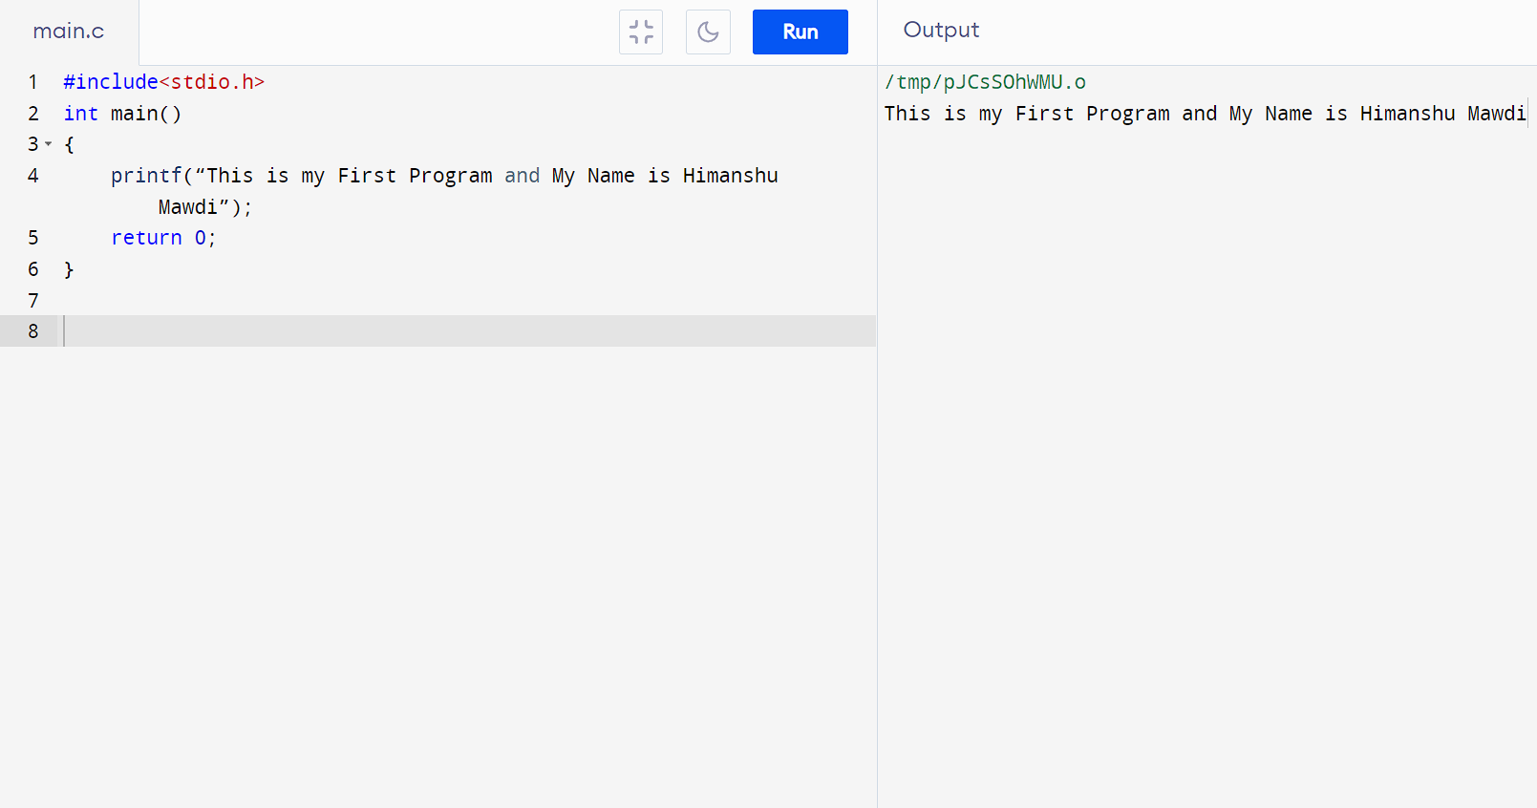

* **PROGRAM 2:- TO ADD TWO NUMBERS**

**#include<stdio.h>**

**int main()**

**{**

**printf("HIMANSHU MAWDI");**

**float Num1,Num2,Sum;**

**printf("\nENTER FIRST NUMBER:");**

**scanf("%f",&Num1);**

**printf("ENTER SECOND NUMBER:");**

**scanf("%f",&Num2);**

**Sum=Num1+Num2;**

**printf("THE SUM OF TWO NUMBERS IS:%.2f\n",Sum);**

**return 0;**

**}**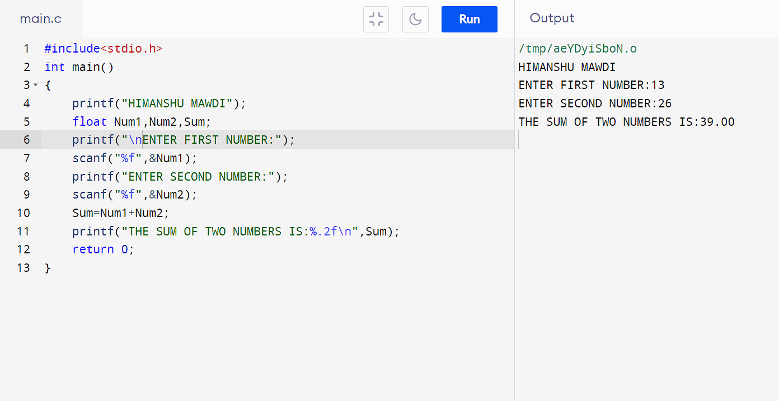

* **PROGRAM 3:- TO FIND AREA OF CIRCLE**

**#include<stdio.h>**

**int main()**

**{**

**printf(“HIMANSHU MAWDI”);**

**float Radius,Area,;**

**printf(“\nEnter Radius of a circle:”);**

**scanf(“%f”,&Radius);**

**Area=(3.14*Radius*Radius;**

**printf(“The Area of a circle is:%.2f\n”,Area);**

**return 0;**

**}**

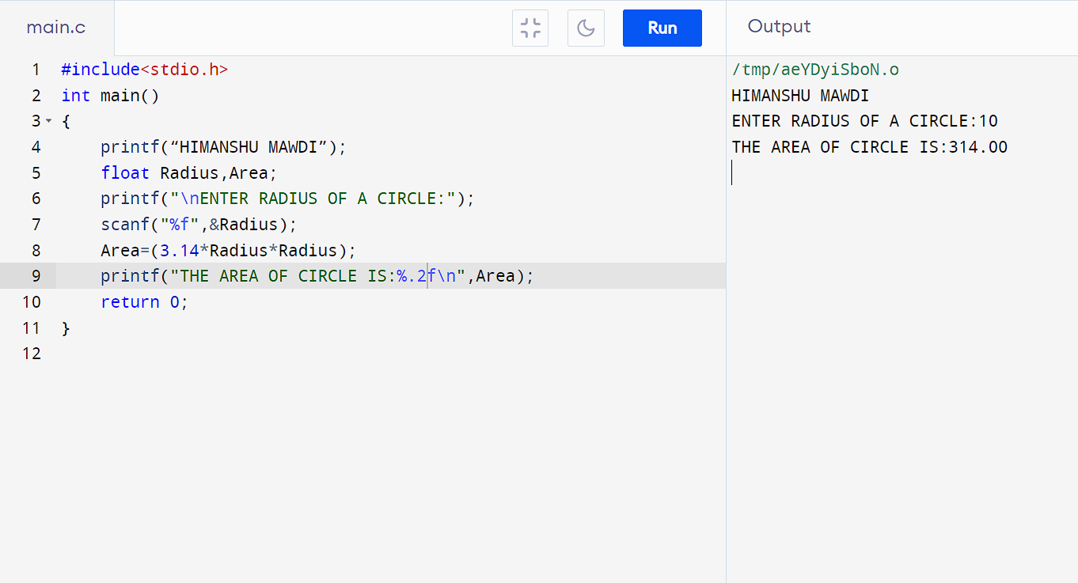

* **PROGRAM 4:- TO DIVIDE TWO NUMBERS**

**#include<stdio.h>**

**int main()**

**{**

**printf(“HIMANSHU MAWDI”);**

**float Num1,Num2,Result;**

**printf("\nEnter First Number:");**

**scanf("%f",&Num1);**

**printf("Enter Second Number:");**

**scanf("%f",&Num2);**

**Result=(Num1/Num2);**

**printf("The Division Result of two numbers is:%.2f\n",Result);**

**return 0;**

**}**

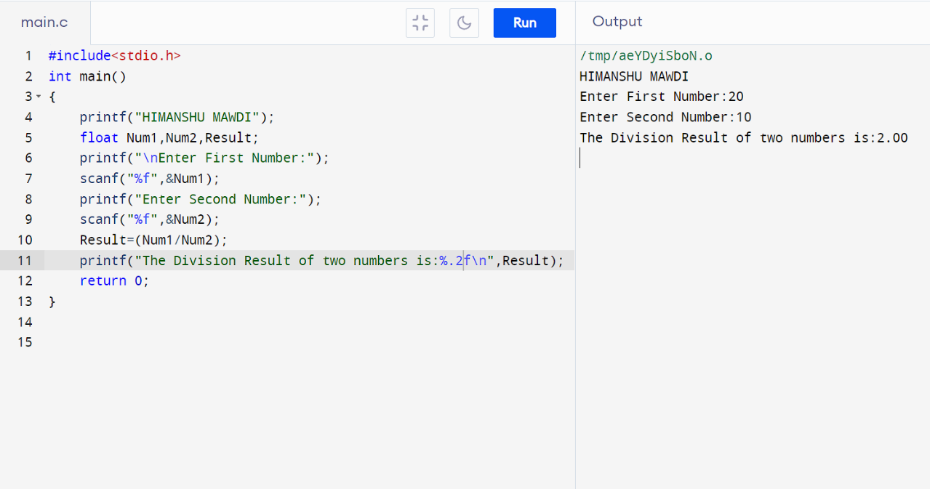

* **PROGRAM 5:- TO PRINT ASCII VALUE**

**#include<stdio.h>**

**int main()**

**{**

**printf(“HIMANSHU MAWDI”);**

**char H;**

**printf("\nEnter a character:");**

**scanf("%c",&H);**

**printf("ASCII value of given character:%d",H);**

**return 0;**

**}**

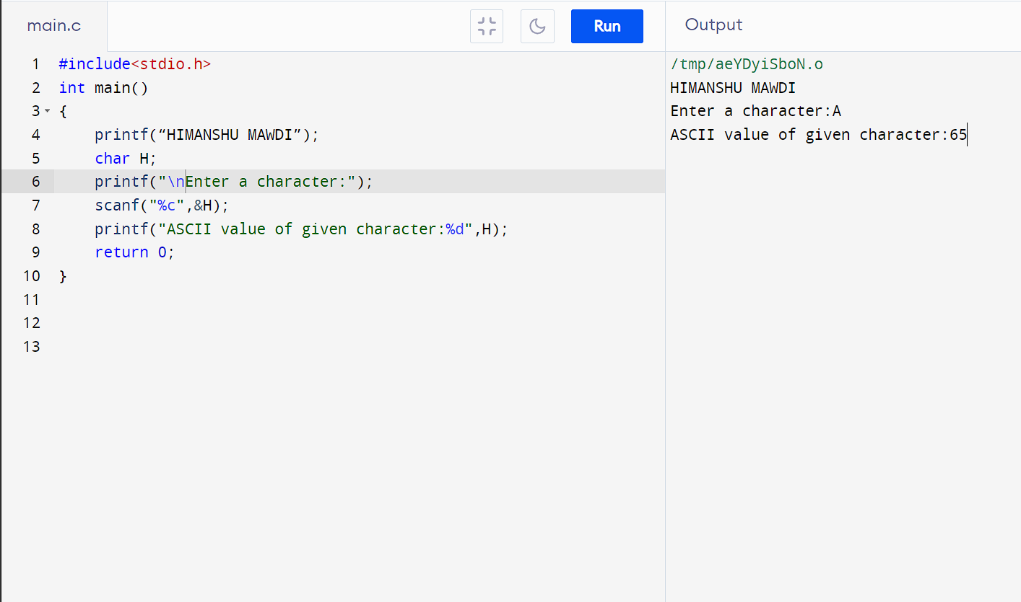

* **PROGRAM 6:- TO MULTIPLY FLOATING NUMBERS**

**#include<stdio.h>**

**int main()**

**{**

**printf(“HIMANSHU MAWDI”);**

**float num1, num2, result;**

**printf("\nEnter the first number: ");**

**scanf("%f", &num1);**

**printf("Enter the second number: ");**

**scanf("%f", &num2);**

**result = num1 * num2;**

**printf("The product of two numbers is %.2f\n",result);**

**return 0;**

**}**

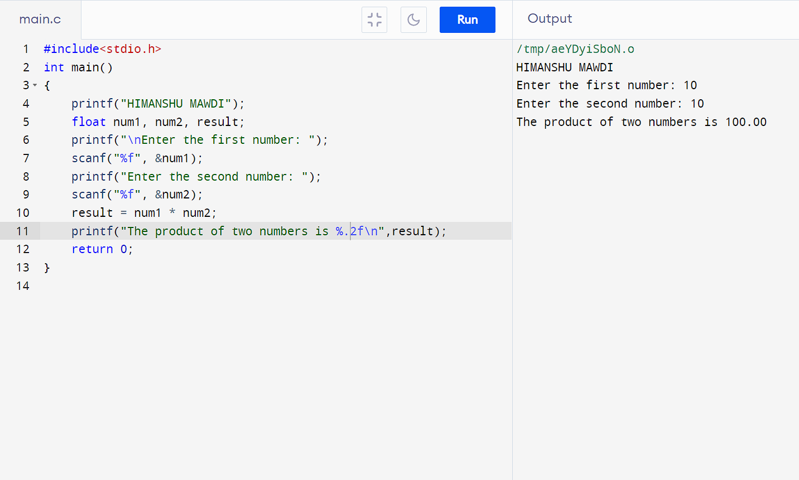

* **PROGRAM 7:- TO SWAP TWO NUMBERS BY USING 3rd VARIABLE**

**#include<stdio.h>**

**int main()**

**{**

**printf(“HIMANSHU MAWDI”);**

**int N1,N2;**

**int T;**

**printf("\nEnter N1:");**

**scanf("%d",&N1);**

**printf("Enter N2:");**

**scanf("%d",&N2);**

**T=N1;**

**N1=N2;**

**N2=T;**

**printf("N1=%d\n",N1);**

**printf("N2=%d\n",N2);**

**return 0;**

**}**

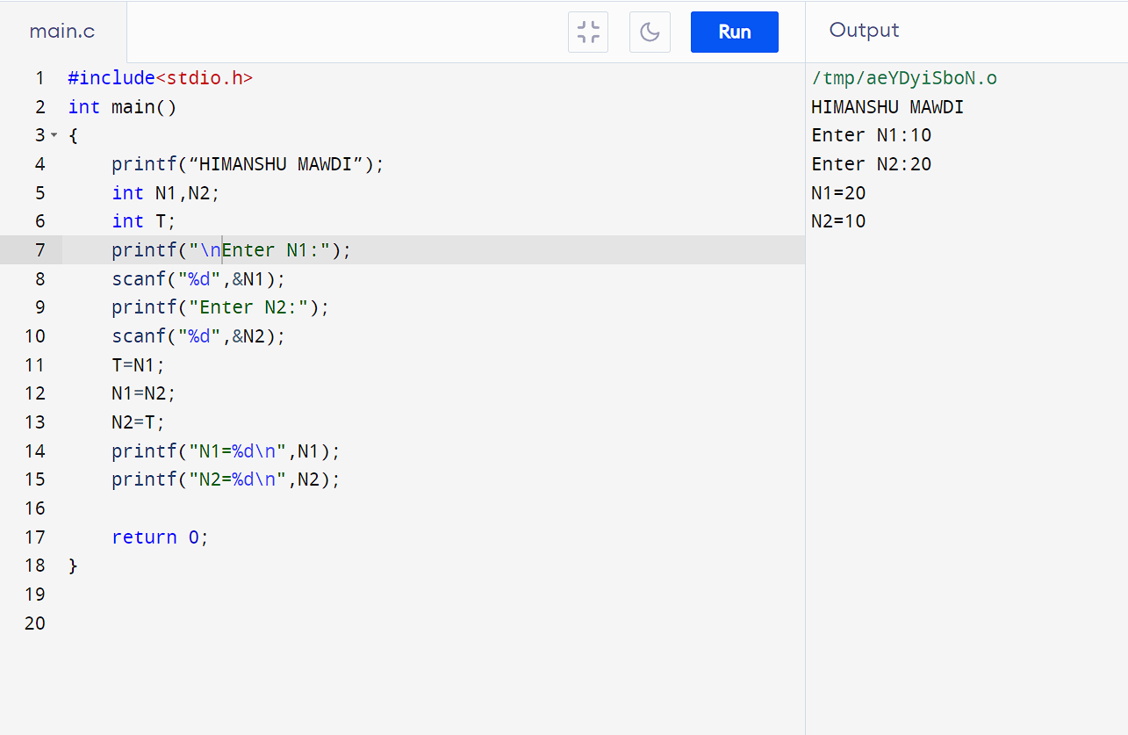

* **PROGRAM 8:- TO SWAP TWO VARIABLES WITHOUT USING 3rd  VARIABLE**

**#include<stdio.h>**

**int main()**

**{**

**printf(“HIMANSHU MAWDI”);**

**int N1,N2;**

**printf("\nEnter N1:");**

**scanf("%d",&N1);**

**printf("Enter N2:");**

**scanf("%d",&N2);**

**N1=N1+N2;**

**N2=N1-N2;**

**N1=N1-N2;**

**printf("N1=%d\n",N1);**

**printf("N2=%d\n",N2);**

**return 0;**

**}**

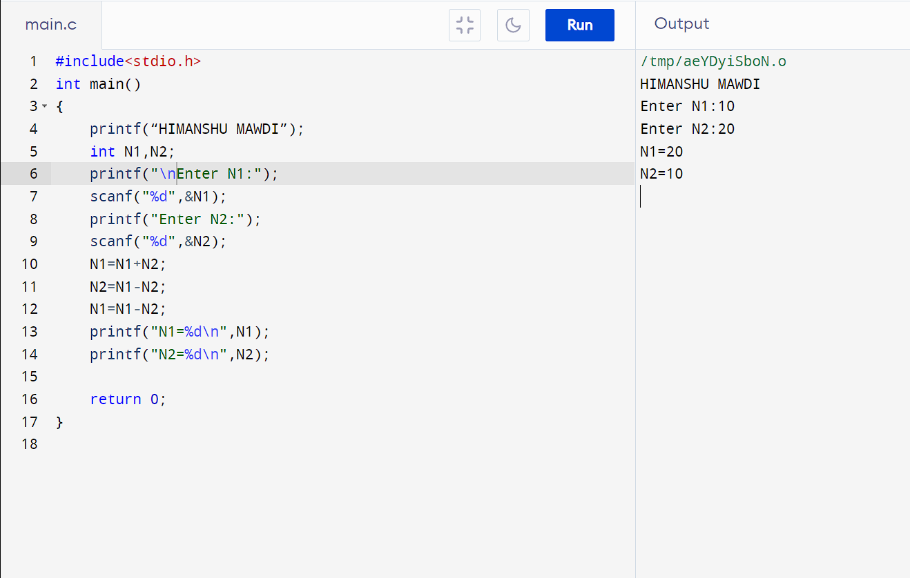

* **PROGRAM 9:- TO SWAP THREE VARIABLES WITHOUT USING 3rd VARIABLE**

**#include<stdio.h>**

**int main()**

**{**

**printf(“HIMANSHU MAWDI”);**

**int N1,N2,N3;**

**printf("\nEnter N1:");**

**scanf("%d",&N1);**

**printf("Enter N2:");**

**scanf("%d",&N2);**

**printf("Enter N3:");**

**scanf("%d",&N3);**

**N1=N1+N2+N3;**

**N2=N1-(N2+N3);**

**N3=N1-(N2+N3);**

**N1=N1-(N2+N3);**

**printf("N1=%d\n",N1);**

**printf("N2=%d\n",N2);**

**printf("N3=%d\n",N3);**

**return 0;**

**}**

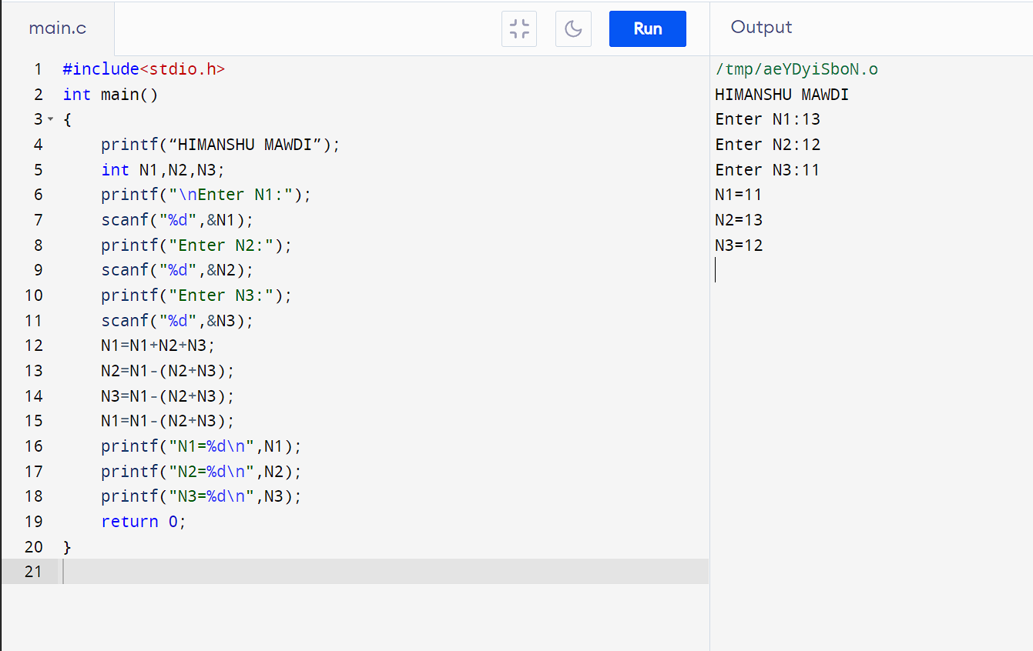

* **PROGRAM 10:- TO FIND AREA OF RECTANGLE**

**#include<stdio.h>**

**int main()**

**{**

**printf(“HIMANSHU MAWDI”);**

**float Length,Breadth,Area;**

**printf("\nENTER LENGTH:");**

**scanf("%f",&Length);**

**printf("ENTER BREADTH:");**

**scanf("%f",&Breadth);**

**Area=Length*Breadth;**

**printf("THE AREA IS:%.2f\n",Area);**

**return 0;**

**}**

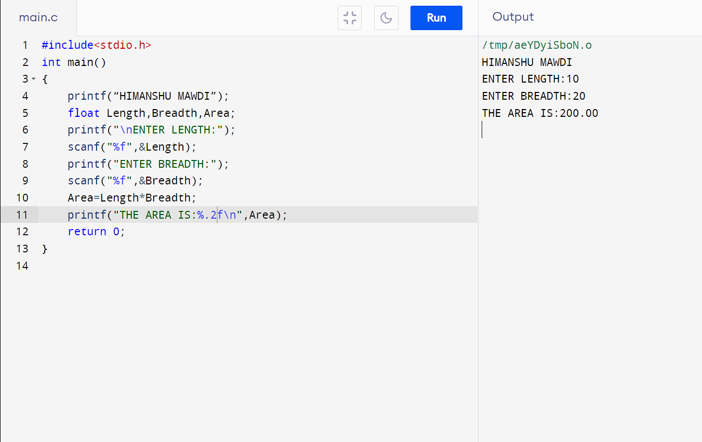

* **PROGRAM 11:- TO FIND AREA OF SQUARE**

**#include<stdio.h>**

**int main()**

**{**

**Printf(“HIMANSHU MAWDI”);**

**float Side,Area;**

**printf("\nENTER SIDE:");**

**scanf("%f",&Side);**

**Area=Side*Side;**

**printf("THE AREA IS:%.2f\n",Area);**

**return 0;**

**}**

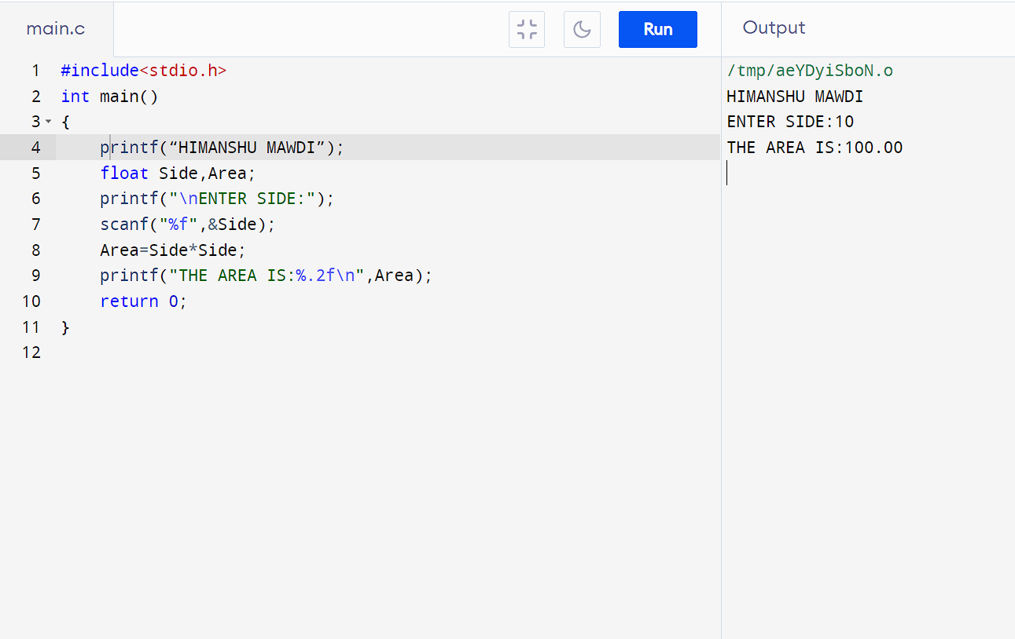

* **PROGRAM 12:- TO FIND AREA OF RIGHT ANGLED TRIANGLE**

**#include<stdio.h>**

**int main()**

**{**

**printf("HIMANSHU MAWDI");**

**float Base,Height,Area;**

**printf("\nENTER THE VALUE OF BASE:");**

**scanf("%f",&Base);**

**printf("ENTER THE VALUE OF HEIGHT:");**

**scanf("%f",&Height);**

**Area=0.5*Base*Height;**

**printf("THE AREA OF RIGHT ANGLED TRIANGLE IS:%.2f\n",Area);**

**return 0;**

**}**

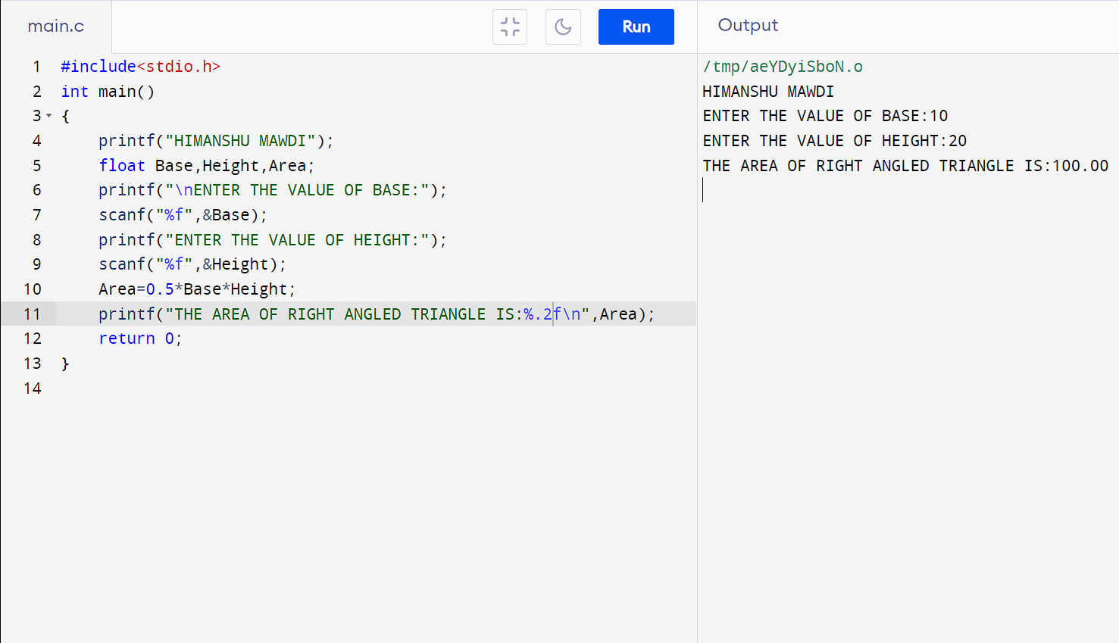

* **PROGRAM 13:- TO FIND AREA OF ISOSCLES TRIANGLE**

**#include<stdio.h>**

**int main()**

**{**

**printf(“HIMANSHU MAWDI”);**

**float Base,Height,Area;**

**printf("\nENTER THE VALUE OF BASE:");**

**scanf("%f",&Base);**

**printf("ENTER THE VALUE OF HEIGHT:");**

**scanf("%f",&Height);**

**Area=(Base*Height)/2;**

**printf("THE AREA OF ISOSCELES TRIANGLE IS:%.2f\n",Area);**

**return 0;**

**}**

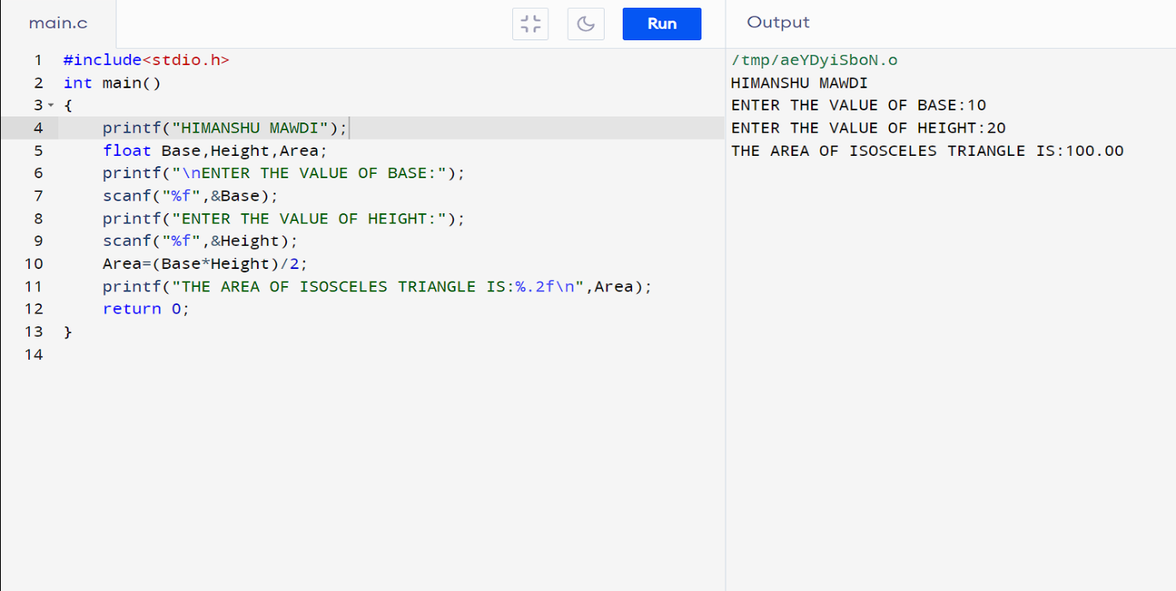

* **PROGRAM 14:- TO FIND AREA OF TRIANGLE WITH ANY THREE SIDES**

**#include <stdio.h>**

**#include <math.h>**

**int main()**

**{**

**printf(“HIMANSHU MAWDI”);**

**float side1, side2, side3;**

**printf("\nEnter the length of side 1: ");**

**scanf("%f", &side1);**

**printf("Enter the length of side 2: ");**

**scanf("%f", &side2);**

**printf("Enter the length of side 3: ");**

**scanf("%f", &side3);**

**float s = (side1 + side2 + side3) / 2;**

**float area = sqrt(s * (s - side1) * (s - side2) * (s - side3));**

**printf("The area of the triangle is: %.2f\n", area);**

**return 0;**

**}**

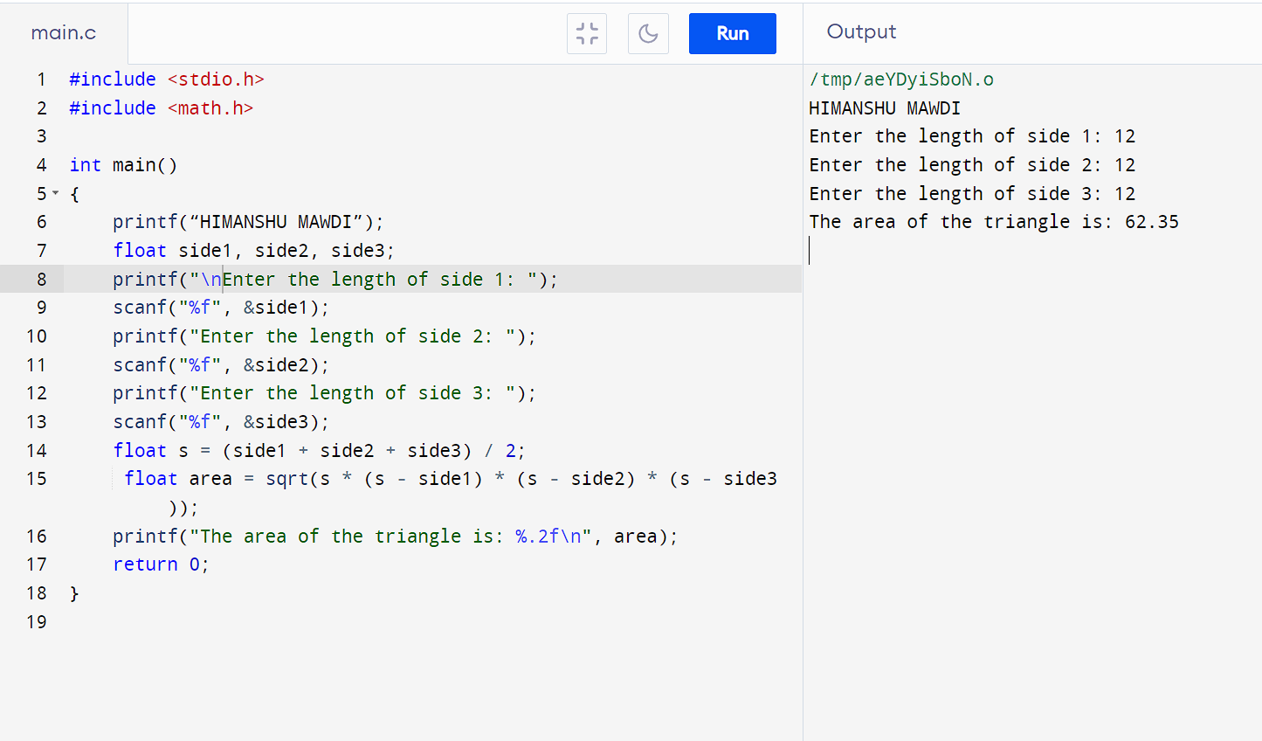

**PROGRAM 15:- TO FIND AREA AND VOLUME OF CUBE**

**#include<stdio.h>**

**int main()**

**{**

**printf(“HIMANSHU MAWDI’);**

**float Side,Area,Volume;**

**printf("\nENTER SIDE OF A CUBE:");**

**scanf("%f",&Side);**

**Area=6*Side*Side;**

**Volume=Side*Side*Side;**

**printf("The Area of Cube is %.2f\n",Area);**

**printf("The Volume of Cube is %.2f\n",Volume);**

**return 0;**

**}**

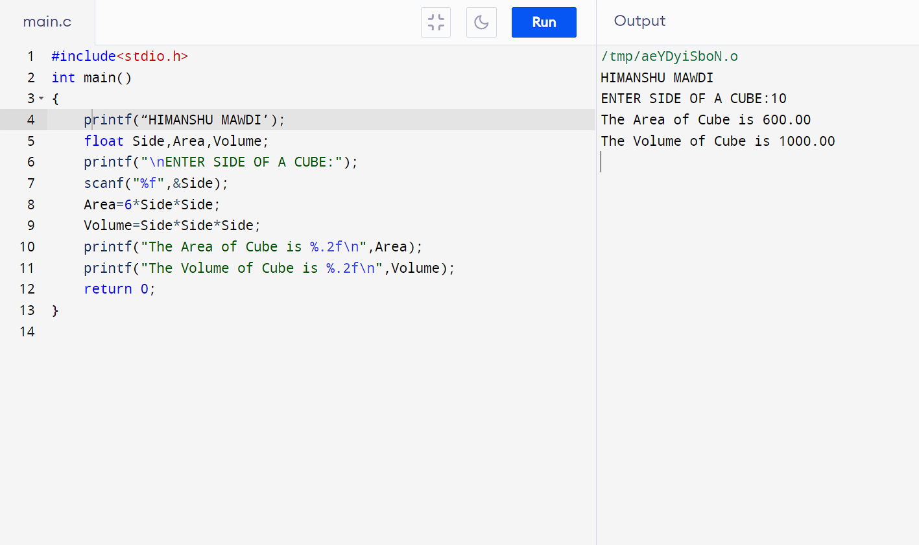

* **PROGRAM 16: -TO FIND AREA AND VOLUME OF CUBOID**

**#include<stdio.h>**

**int main()**

**{**

**printf(“HIMANSHU MAWDI”);**

**float L,B,H,Volume,Area;**

**printf("\nENTER LENGTH OF CUBOID:");**

**scanf("%f",&L);**

**printf("ENTER BREADTH OF CUBOID");**

**scanf("%f",&B);**

**printf("ENTER HEIGHT OF CUBOID");**

**scanf("%f",&H);**

**Area=(2*(L*B)+(B*H)+(H*L));**

**Volume=L*B*H;**

**printf("The Area of Cuboid is %.2f\n",Area);**

**printf("The Volume of Cuboid is %.2f\n",Volume);**

**return 0;**

**}**

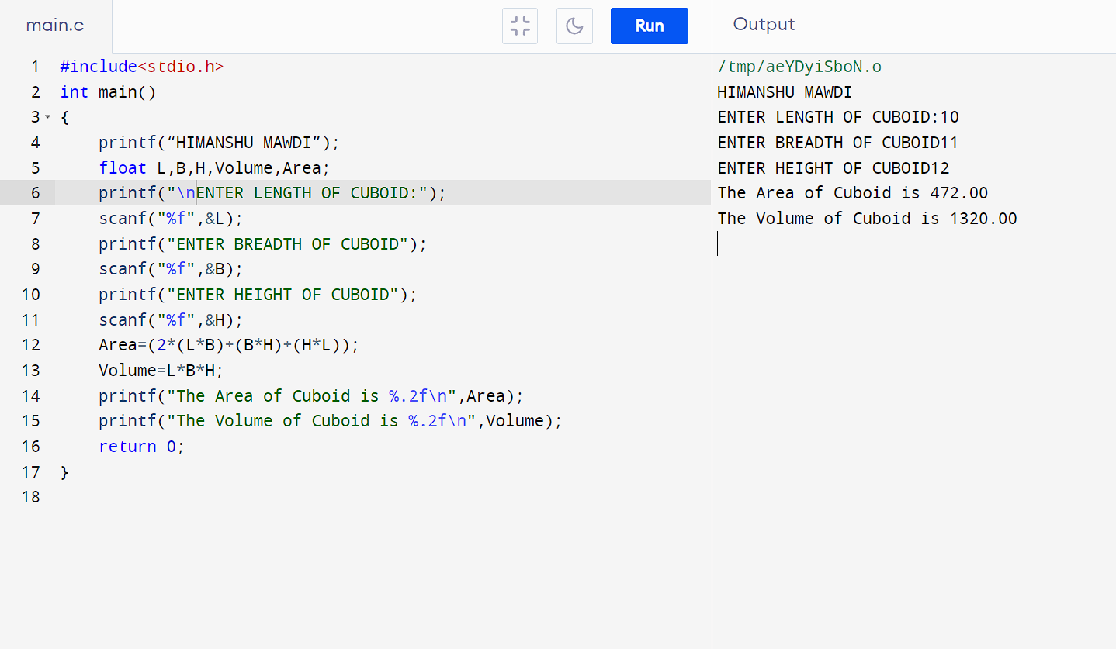

* **PROGRAM 17: - TO FIND LARGEST NUMBER USING LOGICAL AND OPERATOR**

**#include <stdio.h>**

**int main()**

**{**

**printf(“HIMANSHU MAWDI”);**

**int num1, num2;**

**printf("\nEnter the first number: ");**

**scanf("%d", &num1);**

**printf("Enter the second number: ");**

**scanf("%d", &num2);**

**if (num1 > num2 && num1 != num2) {**

**printf("The largest number is: %d\n", num1);**

**} else if (num2 > num1 && num1 != num2) {**

**printf("The largest number is: %d\n", num2);**

**} else {**

**printf("Both numbers are equal.\n");**

**}**

**return 0;**

**}**

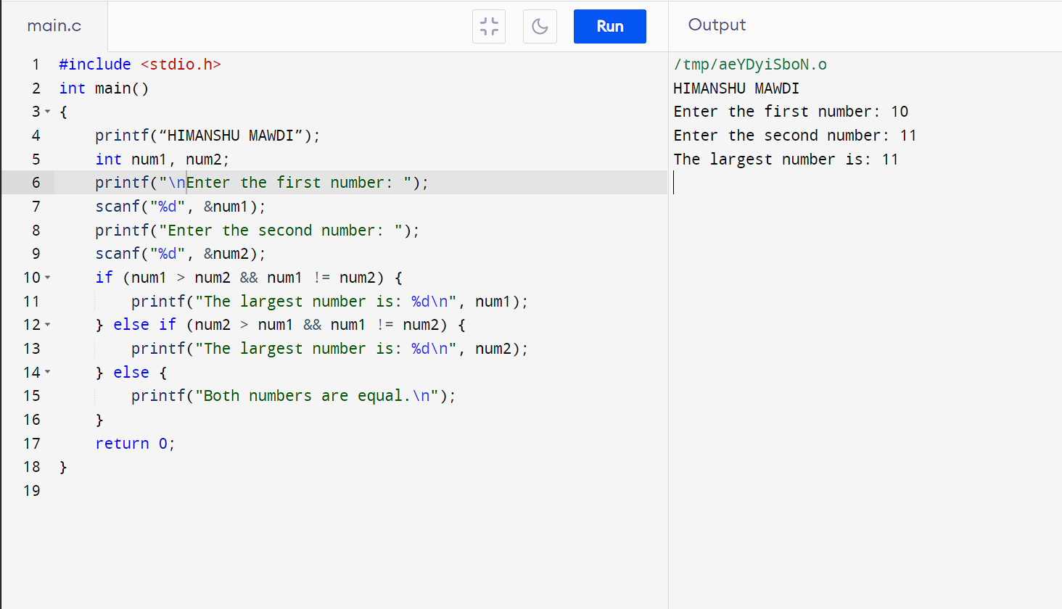

* **PROGRAM 18: - TO VALIDATE THE USERNAME AND PASSWORD ENTERED BY USER IS CORRECT OR NOT USING THE PREDEFINED USERNAME AND PASSWORD**

**#include <stdio.h>**

**#include <string.h>**

**int main()**

**{**

**printf(“HIMANSHU MAWDI”);**

**char correctUsername[] = "HIMANSHUMAWDI";**

**char correctPassword[] = "MAWDIHIMANSHU";**

**char enteredUsername[100];**

**char enteredPassword[100];**

**printf("\nEnter username: ");**

**scanf("%s", enteredUsername);**

**printf("Enter password: ");**

**scanf("%s", enteredPassword);**

**if (strcmp(enteredUsername, correctUsername) == 0 && strcmp(enteredPassword, correctPassword) == 0) {**

**printf("Login successful!");**

**} else {**

**printf("Login failed. Incorrect username or password.\n");**

**}**

**return 0;**

**}**

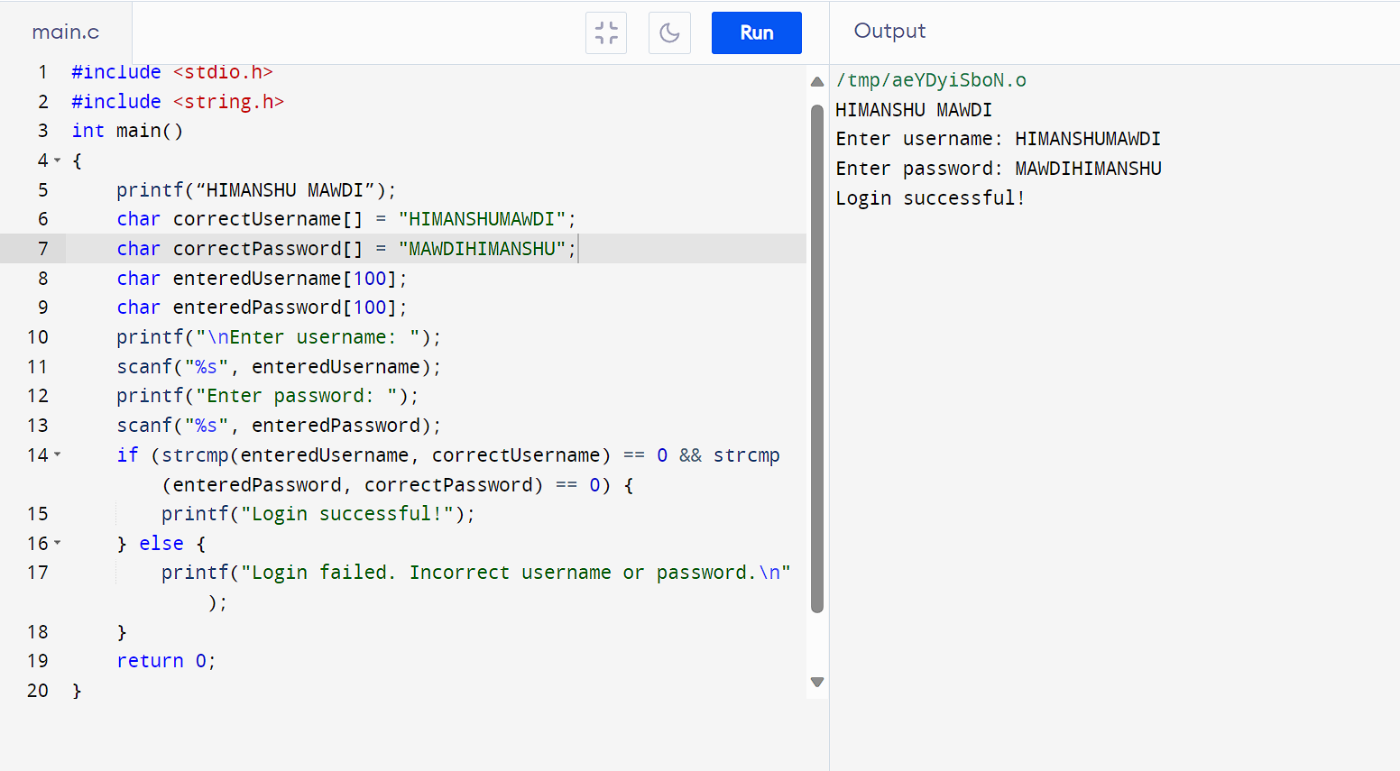

* **PROGRAM 19: - TO INPUT A POSITIVE NUMBER FROM THE USER AND PERFORM THE LEFT SHIFT OPERATOR**

**#include <stdio.h>**

**int main()**

**{**

**printf(“HIMANSHU MAWDI”);**

**int number, shift, result;**

**printf("\nEnter a number: ");**

**scanf("%d", &number);**

**printf("Enter the number of positions to shift left: ");**

**scanf("%d", &shift);**

**result = number << shift;**

**printf("Result: %d\n", result);**

**return 0;**

**}**

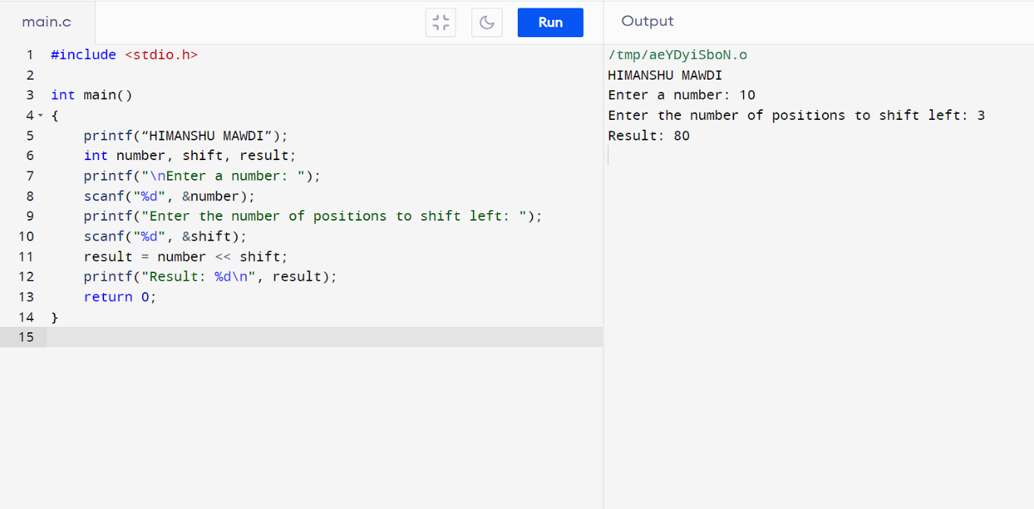

* **PROGRAM 20: - TO INPUT THE POSITIVE NUMBER FROM THE USER TO PERFORM THE RIGHT SHIFT OPERATOR**

**#include <stdio.h>**

**int main()**

**{**

**printf(“HIMANSHU MAWDI”);**

**int number, shift, result;**

**printf("\nEnter a number: ");**

**scanf("%d", &number);**

**printf("Enter the number of positions to shift right: ");**

**scanf("%d", &shift);**

**result = number >> shift;**

**printf("Result: %d\n", result);**

**return 0;**

**}**

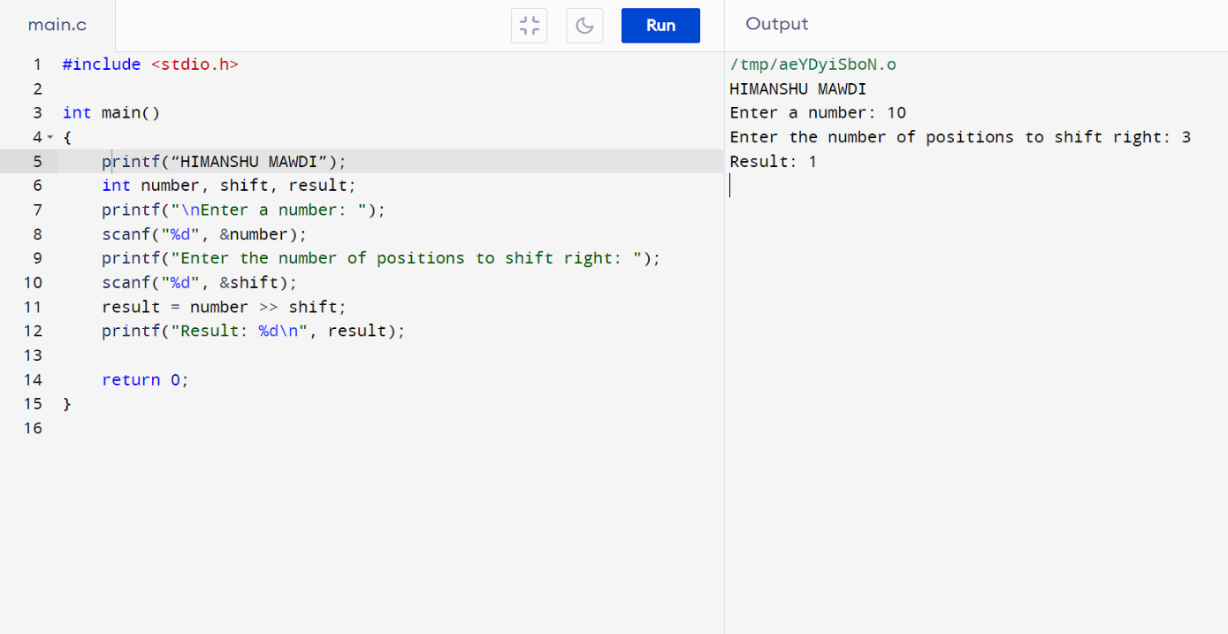

* **PROGRAM 21: - TO PERFORM THE PRE-INCREMENT AND PRE-DECREMENT OPERATOR ON TWO INTEGER AND PRINT BOTH ORIGINAL VALUE AND UPDATE VALUE**

**#include <stdio.h>**

**int main()**

**{**

**printf(“HIMANSHU MAWDI”);**

**int num1, num2;**

**printf("\nEnter the first integer: ");**

**scanf("%d", &num1);**

**printf("Enter the second integer: ");**

**scanf("%d", &num2);**

**int updatedNum1 = ++num1;**

**int updatedNum2 = --num2;**

**printf("Original num1: %d, Updated num1: %d\n", num1 - 1, updatedNum1);**

**printf("Original num2: %d, Updated num2: %d\n", num2 + 1, updatedNum2);**

**return 0;**

**}**

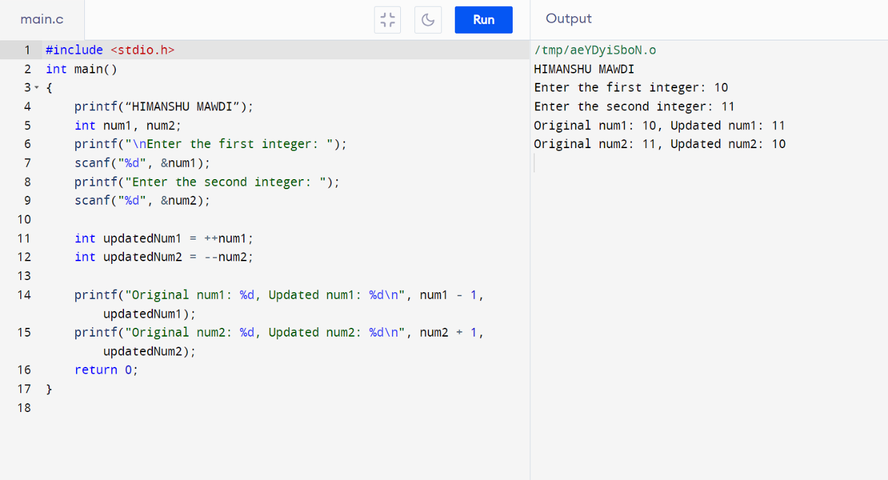

* **PROGRAM 22: - TO PERFORM THE POST-INCREMENT AND POST-DECREMENT OPERATOR ON TWO INTEGER AND PRINT BOTH ORIGINAL VALUE AND UPDATE VALUE**

**#include <stdio.h>**

**int main()**

**{**

**printf(“HIMANSHU MAWDI”);**

**int num1, num2;**

**printf("\nEnter the first integer: ");**

**scanf("%d", &num1);**

**printf("Enter the second integer: ");**

**scanf("%d", &num2);**

**int originalNum1 = num1++;**

**int originalNum2 = num2--;**

**printf("Original value of num1: %d\n", originalNum1);**

**printf("Updated value of num1 (after post-increment): %d\n", num1);**

**printf("Original value of num2: %d\n", originalNum2);**

**printf("Updated value of num2 (after post-decrement): %d\n", num2);**

**return 0;**

**}**

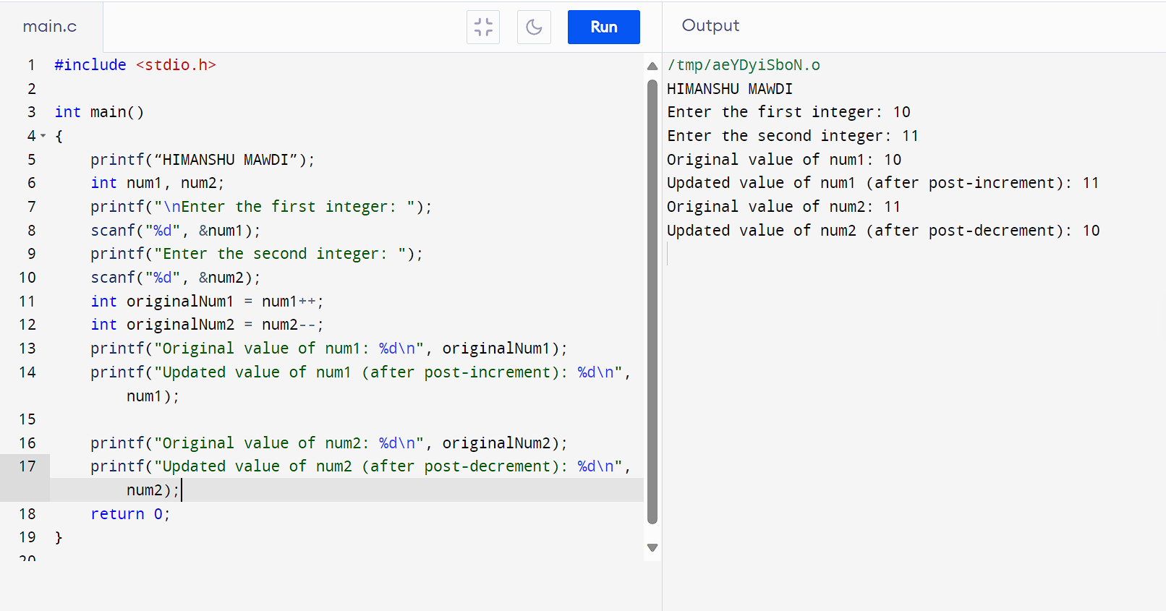

* **PROGRAM 23: -** **TO CHECK WHETHER FOR AN INTEGER NUMBER THAT IT IS DIVISIBLE BY 9 OR 7 USING OR OPERATOR.**

**#include <stdio.h>**

**int main()**

**{**

**printf(“HIMANSHU MAWDI”);**

**int number;**

**printf("\nEnter an integer: ");**

**scanf("%d", &number);**

**if (number % 9 == 0 || number % 7 == 0) {**

**printf("%d is divisible by either 9 or 7.\n", number);**

**} else {**

**printf("%d is not divisible by either 9 or 7.\n", number);**

**}**

**return 0;**

**}**

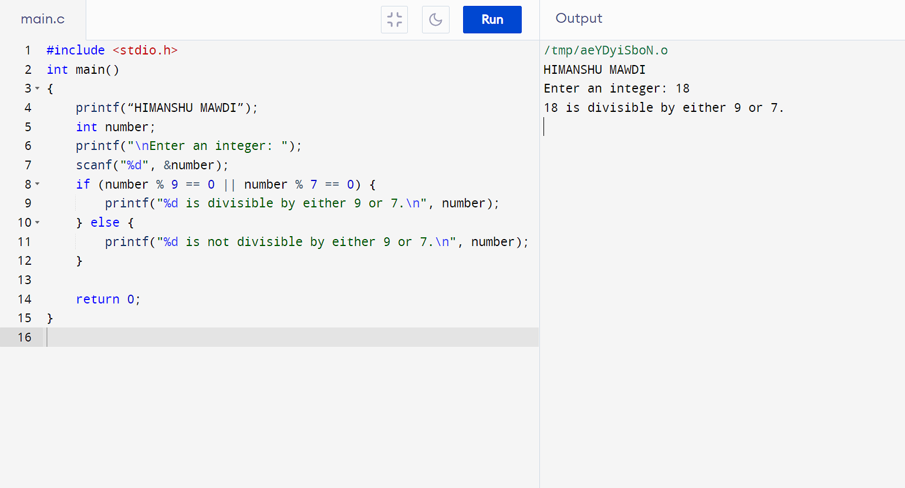

* **PROGRAM 24: - TO IDENTIFY GENDER IN SINGLE CHARACTER AND PRINT FULL GENDER(EX: IF INPUT IS ‘M’ OR ‘m’-IT SHOULD PRINT “MALE”**

**#include <stdio.h>**

**int main()**

**{**

**printf(“HIMANSHU MAWDI”);**

**char gender;**

**printf("\nEnter 'M' or 'm' for Male, 'F' or 'f' for Female: ");**

**scanf(" %c", &gender);**

**if (gender == 'M' || gender == 'm') {**

**printf("Male\n");**

**} else if (gender == 'F' || gender == 'f') {**

**printf("Female\n");**

**} else {**

**printf("Invalid input.\n");**

**}**

**return 0;**

**}**

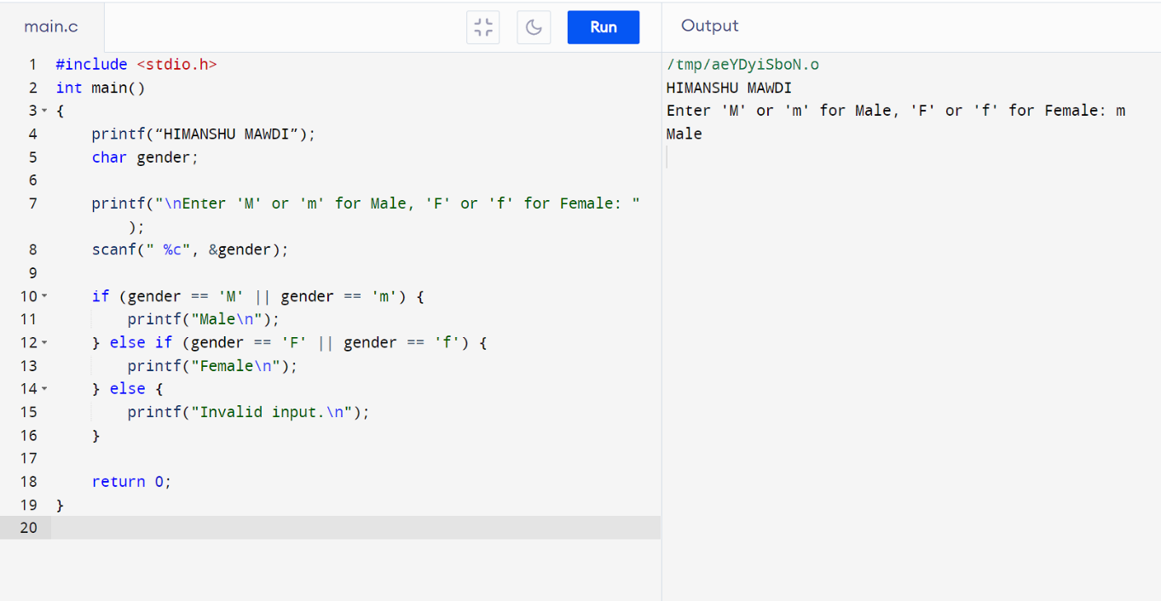

* **PROGRAM 25:- TO PRINT ALL NATURAL NUMBERS IN REVERSE (FROM n TO 1)**

**#include <stdio.h>**

**int main()**

**{**

**printf("HIMANSHU MAWDI");**

**int n;**

**printf("\nENTER THE VALUE OF N:");**

**scanf("%d",&n);**

**printf("NATURAL NUMBERS IN REVERSE ORDER:\n");**

**for (int i=n;i>=1;i--)**

**{printf("%d\n",i);**

**}**

**return 0;**

**}**

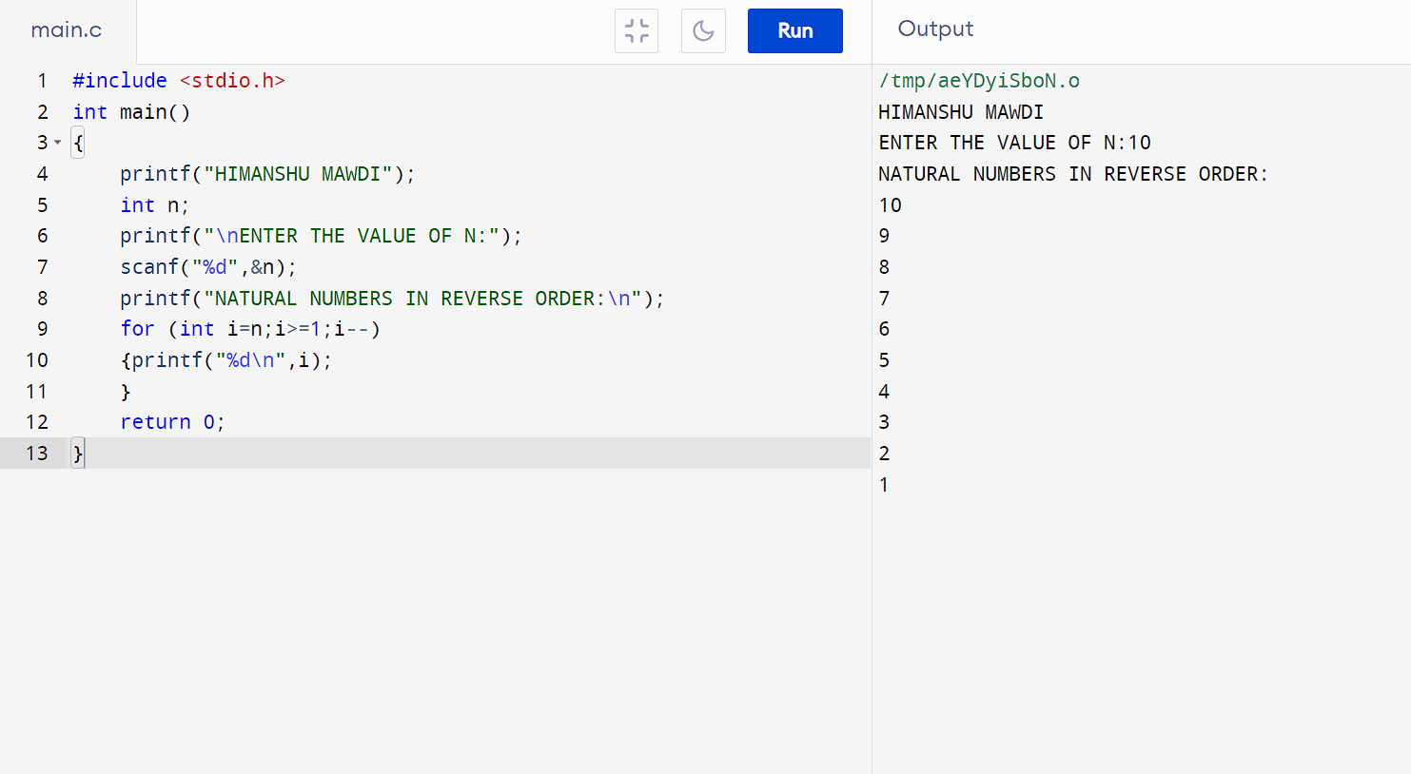

* **PROGRAM 26:- TO PRINT ALL ALPHABET FROM a TO z**

**#include <stdio.h>**

**int main()**

**{**

**printf("HIMANSHU MAWDI");**

**char a;**

**printf("\nALPHABETS FROM a TO z :\n");**

**for (a='a';a<='z';a++)**

**{printf("%c",a);**

**}**

**return 0;**

**}**

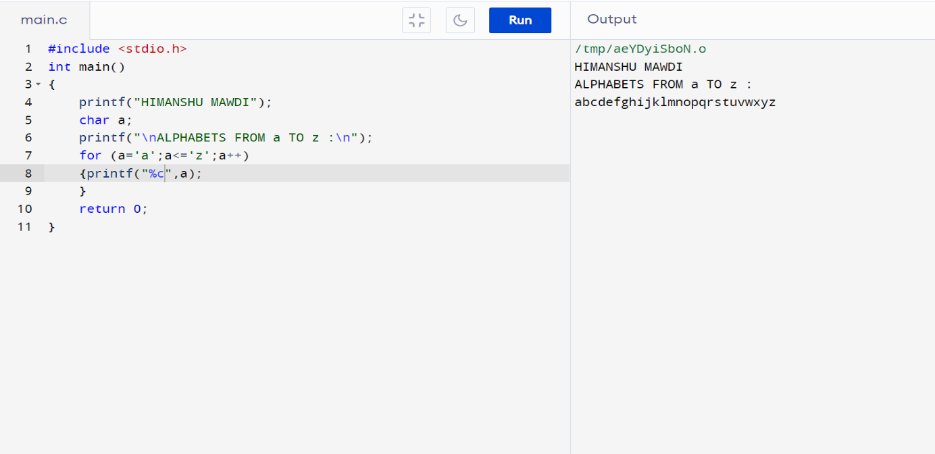

* **PROGRAM 27:- TO PRINT ALL NATURAL NUMBERS FROM 1 TO n**

**#include <stdio.h>**

**int main()**

**{**

**printf("HIMANSHU MAWDI");**

**int n;**

**printf("\nENTER THE VALUE OF N:");**

**scanf("%d",&n);**

**printf("NATURAL NUMBERS ARE:\n",n);**

**for (int i=1;i<=n;i++)**

**{printf("%d\n",i);**

**}**

**return 0;**

**}**

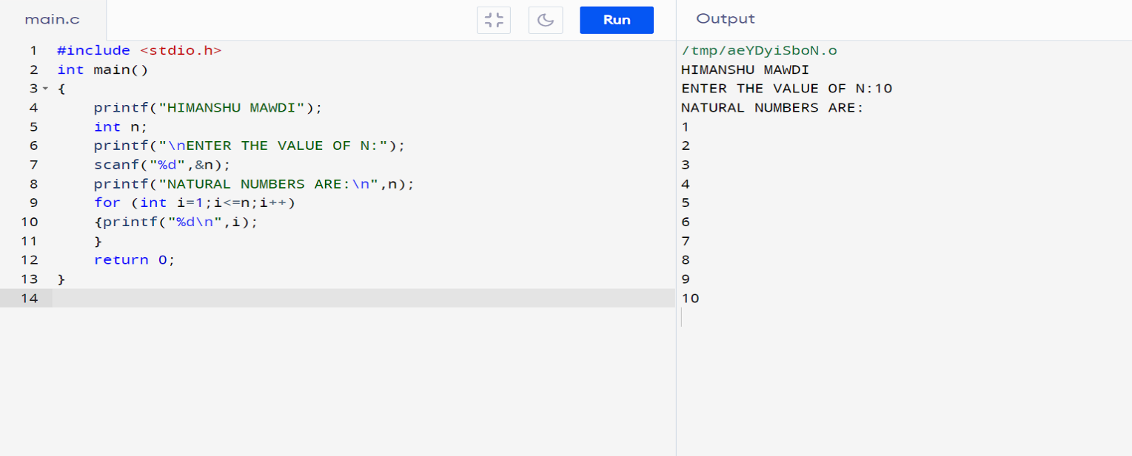

* **PROGRAM 28:- TO PRINT ALL EVEN NUMBERS BETWEEN 1 TO 100**

**#include <stdio.h>**

**int main()**

**{**

**printf("HIMANSHU MAWDI");**

**int i;**

**printf("\nEven numbers between 1 and 100:\n");**

**for (i = 1; i <= 100; i++)**

**{**

**if (i % 2 == 0)**

**{**

**printf("%d\n", i);**

**}**

**}**

**return 0;**

**}**

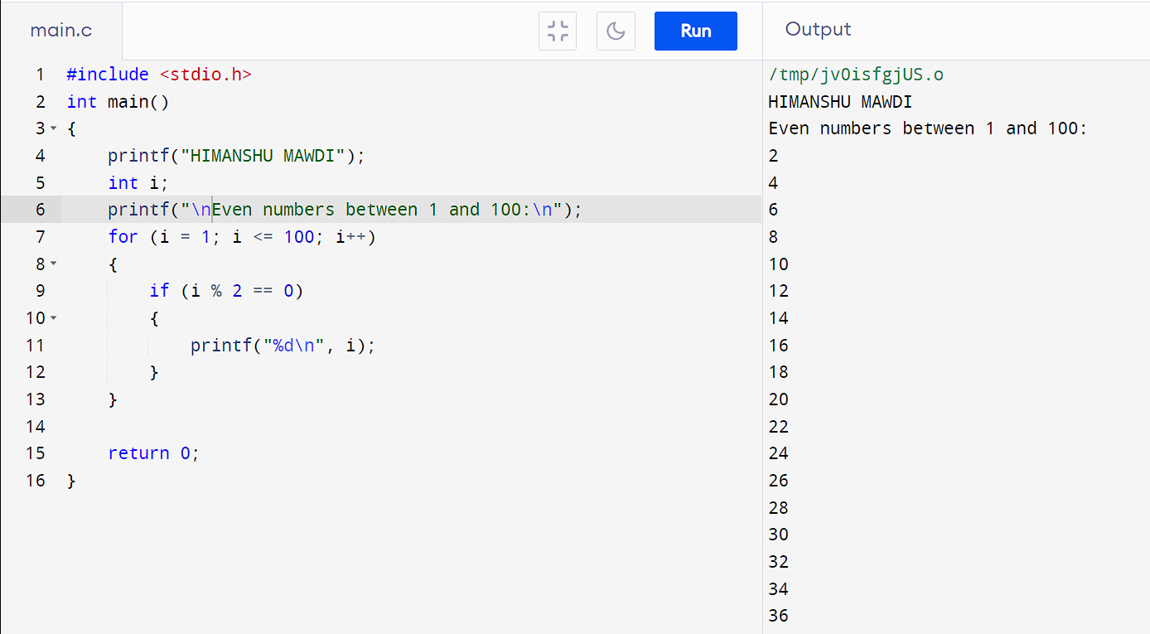

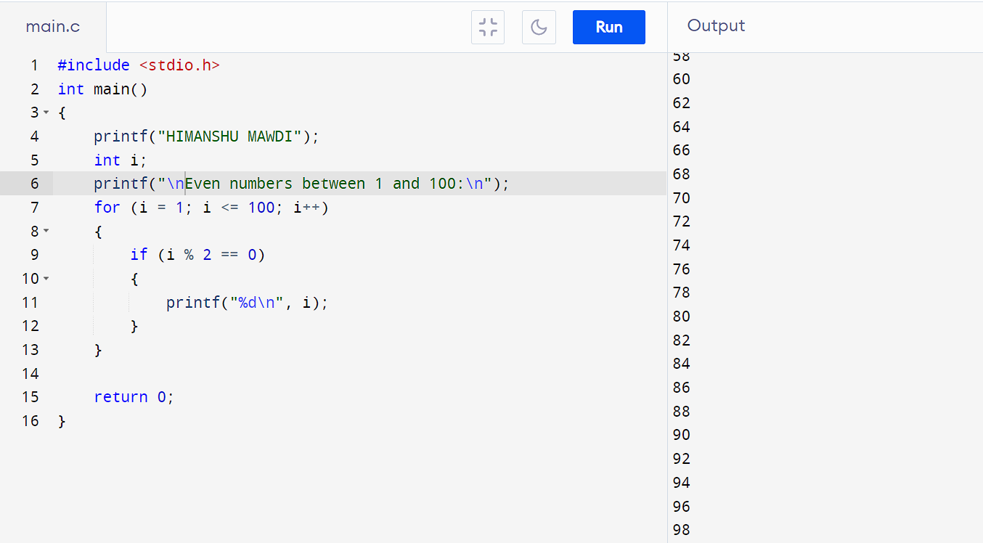**PROGRAM 29:- TO PRINT ALL ODD NUMBER BETWEEN 1 TO 100**

**#include <stdio.h>**

**int main()**

**{**

**printf("HIMANSHU MAWDI");**

**int i;**

**printf("\nEven numbers between 1 and 100:\n");**

**for (i = 1; i <= 100; i++)**

**{**

**if (i % 2 != 0)**

**{**

**printf("%d\n", i);**

**}**

**}**

**return 0;**

**}**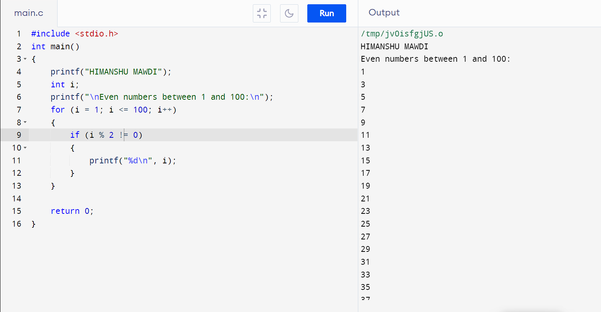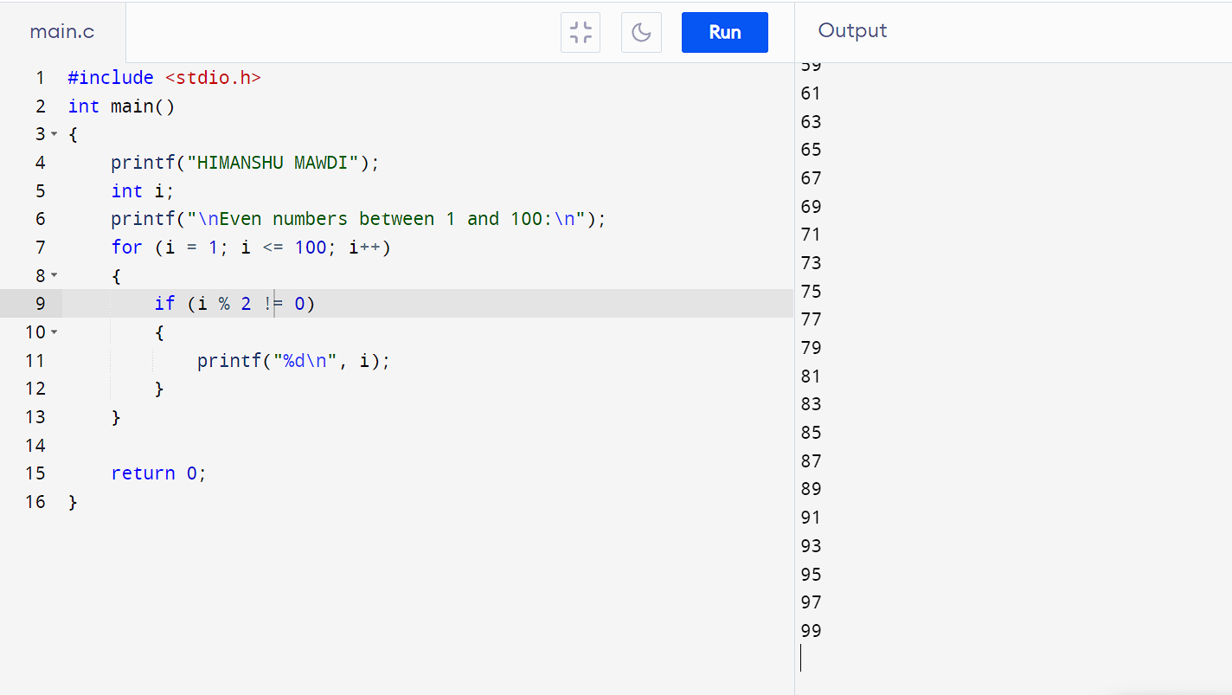

* **PROGRAM 30:- TO FIND SUM OF ALL NATURAL NUMBERS BETWEEN 1 TO N**

**#include<stdio.h>**

**int main()**

**{**

**printf("HIMANSHU MAWDI");**

**int n;**

**long sum = 0;**

**printf("\nEnter a value of n: ");**

**scanf("%d", &n);**

**if (n < 0) {**

**printf("Please enter a positive integer.\n");**

**}**

**else {**

**for (int i = 1; i <= n; i++)**

**{**

**sum += i;**

**}**

**printf("Sum of natural numbers from 1 to %d is %d.\n", n, sum);**

**}**

**return 0;**

**}**

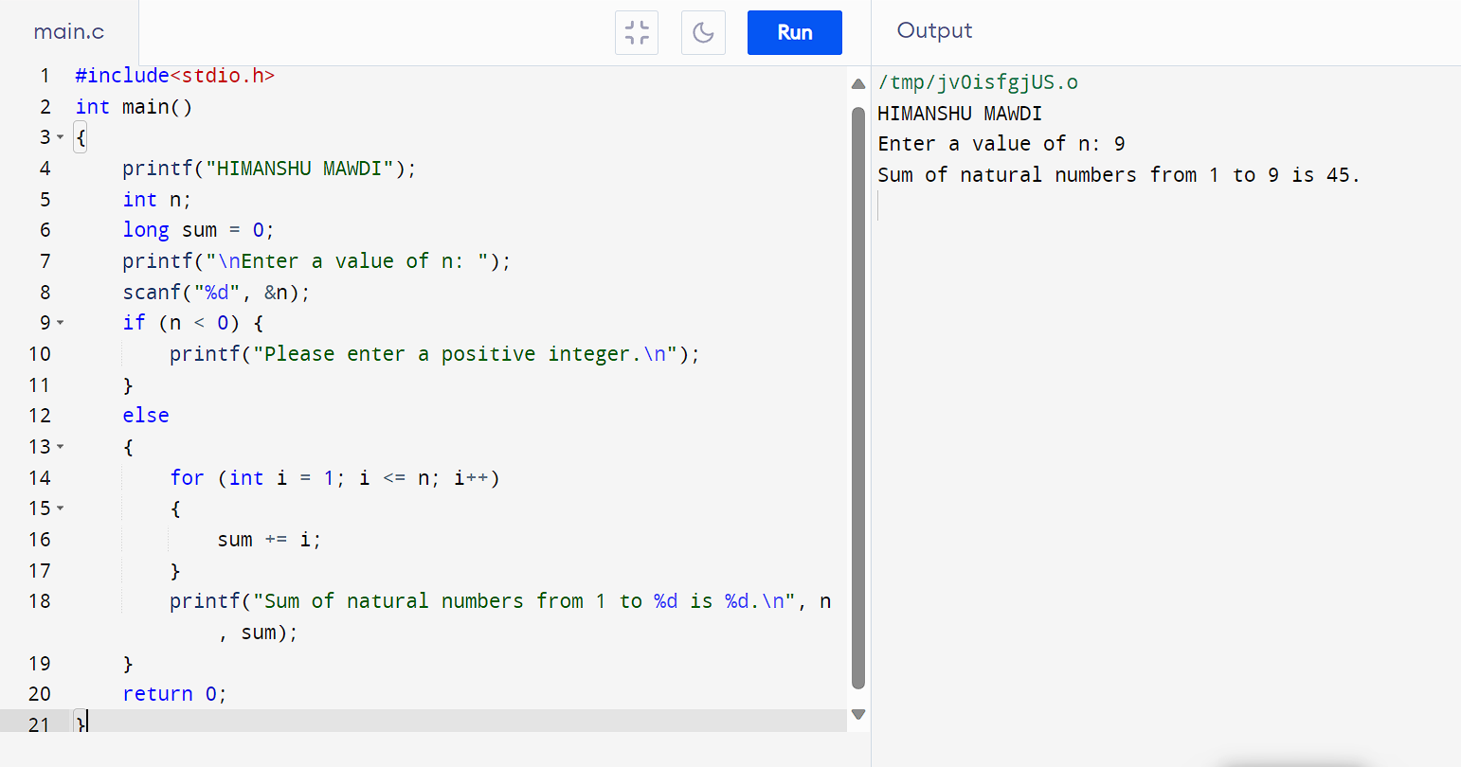

* **PROGRAM 31:- TO FIND SUM AF ALL EVEN NUMBER BETWEEN 1 TO N**

**#include <stdio.h>**

**int main()**

**{**

**printf("HIMANSHU MAWDI");**

**int n, sum = 0;**

**printf("\nEnter value of n: ");**

**scanf("%d", &n);**

**if (n < 1)**

**{**

**printf("Invailid\n");**

**return 0;**

**}**

**for (int i = 2; i <= n; i += 2)**

**{**

**sum += i;**

**}**

**printf("Sum of even numbers between 1 and %d is %d\n", n, sum);**

**return 0;**

**}**

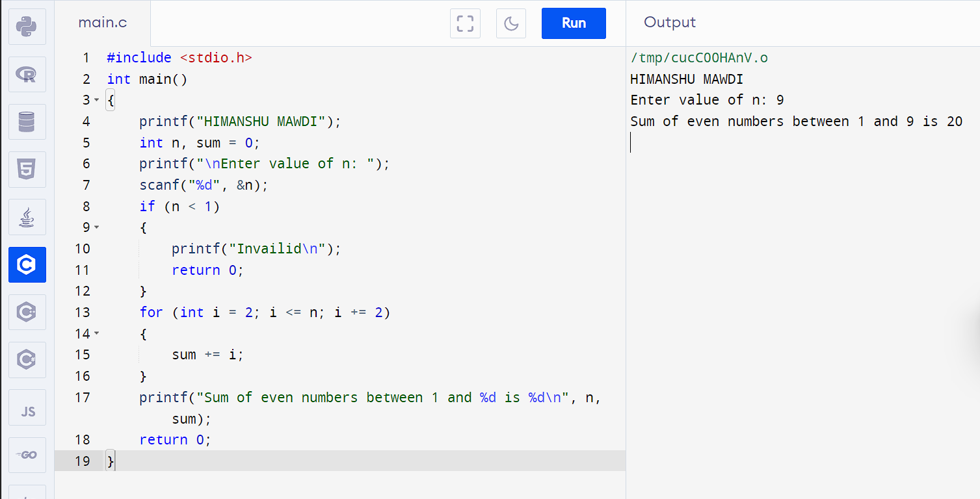

* **PROGRAM 32:- TO FIND SUM OF ALL ODD NUMBER BETWEEN 1 TO N**

**#include <stdio.h>**

**int main()**

**{**

**Printf(“HIMANSHU MAWDI”);**

**int n, sum = 0;**

**printf("\nEnter value of n: ");**

**scanf("%d", &n);**

**if (n < 1)**

**{**

**printf("Invalid\n");**

**return 1;**

**}**

**for (int i = 1; i <= n; i += 2)**

**{**

**sum += i;**

**}**

**printf("Sum of odd numbers between 1 and %d is %d\n", n, sum);**

**return 0;**

**}**

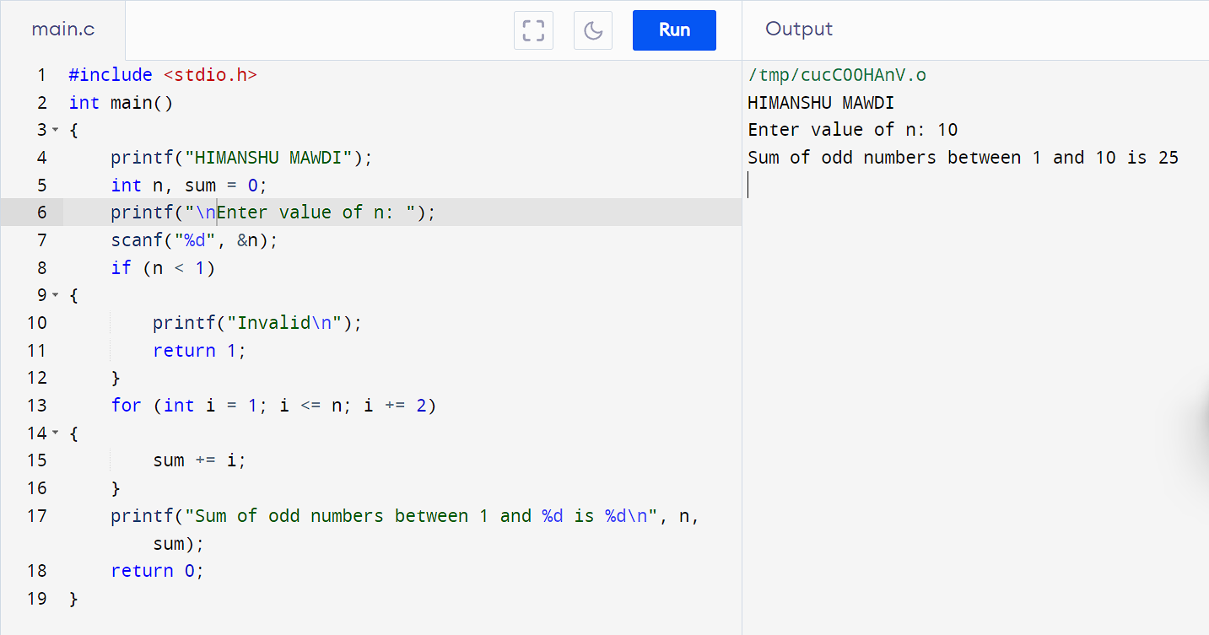

* **PROGRAM 33:- TO PRINT MULTIPLICATION TABLE OF ANY NUMBER**

**#include <stdio.h>**

**int main()**

**{**

**printf("HIMANSHU MAWDI");**

**int num;**

**printf("\nEnter an integer to get its multiplication table: ");**

**scanf("%d", &num);**

**printf("Multiplication Table for %d:\n", num);**

**for (int i = 1; i <= 10; i++)**

**{**

**printf("%d x %d = %d\n", num, i, num * i);**

**}**

**return 0;**

**}**

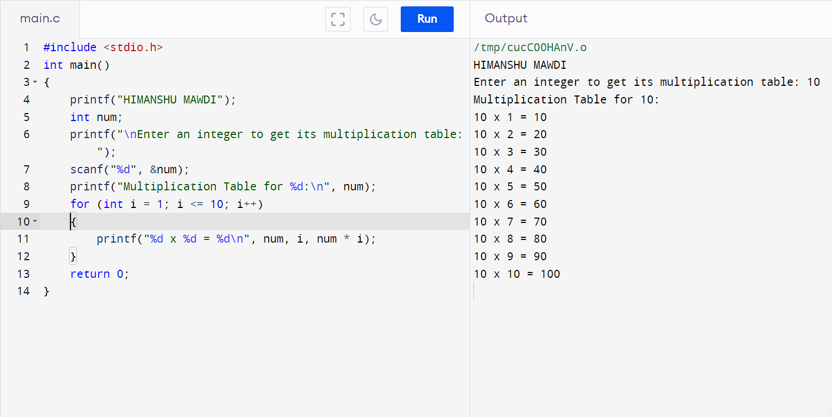

* **PROGRAM 34:- TO COUNT NUMBERS OF DIGITS IN A NUMBER**

**#include <stdio.h>**

**int main()**

**{**

**printf("HIMANSHU MAWDI");**

**long num;**

**int count = 0;**

**printf("\nEnter an integer: ");**

**scanf("%lld", &num);**

**if (num == 0)**

**{**

**count = 1;**

**} else {**

**while (num != 0) {**

**num /= 10;**

**count++;**

**}**

**}**

**printf("Number of digits in the entered number is: %d\n", count);**

**return 0;**

**}**

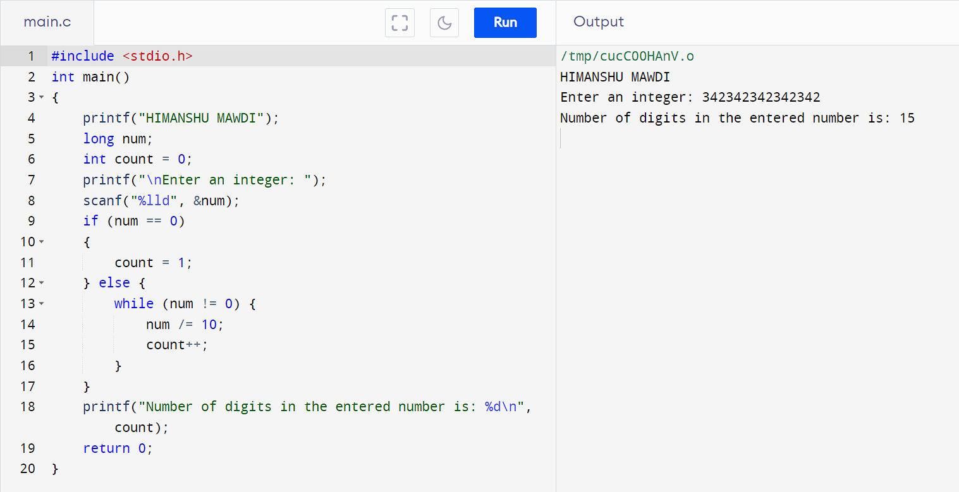

* **PROGRAM 35:- TO FIND FIRST AND LAST DIGIT OF A NUMBER**

**#include <stdio.h>**

**int main()**

**{**

**printf("HIMANSHU MAWDI");**

**int num, firstDigit, lastDigit;**

**printf("\nEnter an integer: ");**

**scanf("%d", &num);**

**lastDigit = num % 10;**

**while (num >= 10)**

**{**

**num /= 10;**

**}**

**firstDigit = num;**

**printf("First digit: %d\n", firstDigit);**

**printf("Last digit: %d\n", lastDigit);**

**return 0;**

**}**

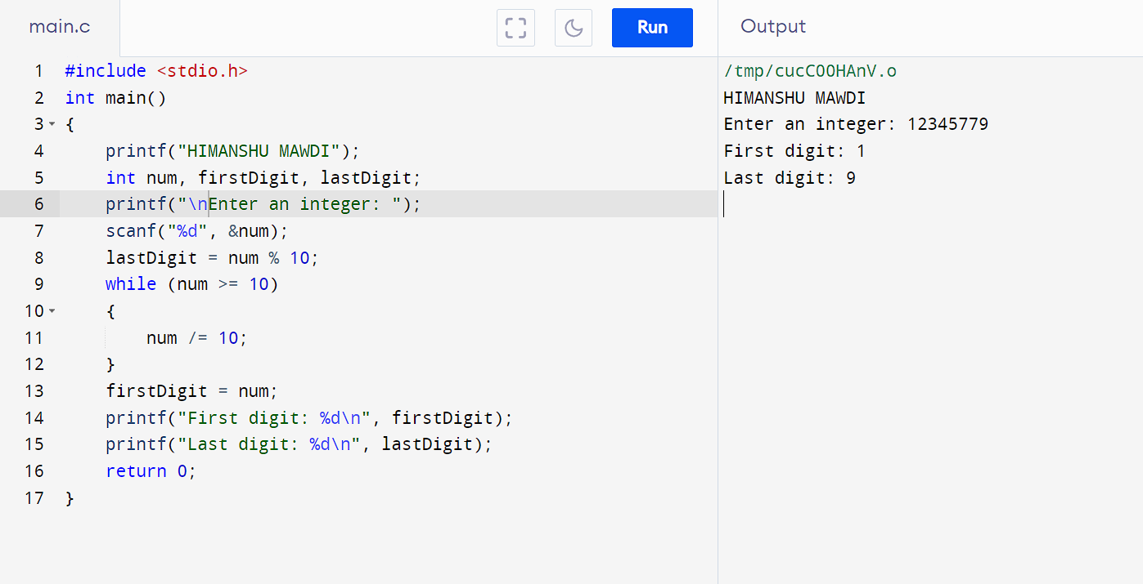

**PROGRAM 36:- TO FIND SUM OF FIRST AND LAST DIGIT OF A NUMBER**

**#include <stdio.h>**

**int main()**

**{**

**printf("HIMANSHU MAWDI");**

**int num, firstDigit, lastDigit, sum;**

**printf("\nEnter an integer: ");**

**scanf("%d", &num);**

**lastDigit = num % 10;**

**while (num >= 10) {**

**num /= 10;**

**}**

**firstDigit = num;**

**sum = firstDigit + lastDigit;**

**printf("Sum of the first and last digits: %d\n", sum);**

**return 0;**

**}**

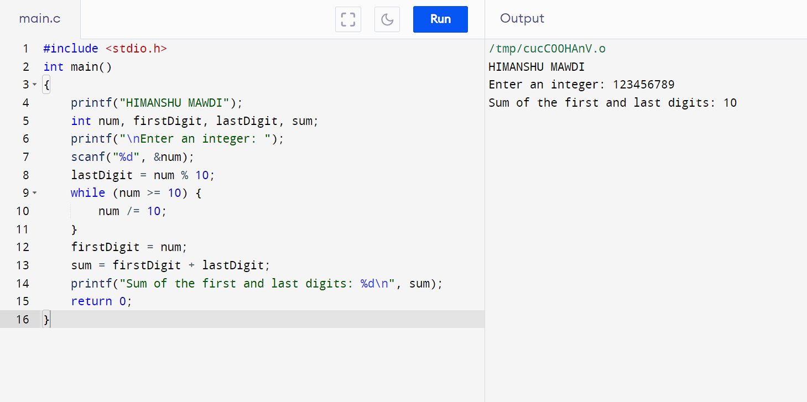

* **PROGRAM 38:- TO CALCULATE SUM OF DIGITS IN A NUMBER**

**#include <stdio.h>**

**int main()**

**{**

**printf("HIMANSHU MAWDI");**

**int num, originalNum, sum = 0, digit;**

**printf("\nEnter an integer: ");**

**scanf("%d", &num);**

**originalNum = num;**

**while (num != 0) {**

**digit = num % 10;**

**sum += digit;**

**num /= 10;**

**}**

**printf("The sum of digits in %d is: %d\n", originalNum, sum);**

**return 0;**

**}**

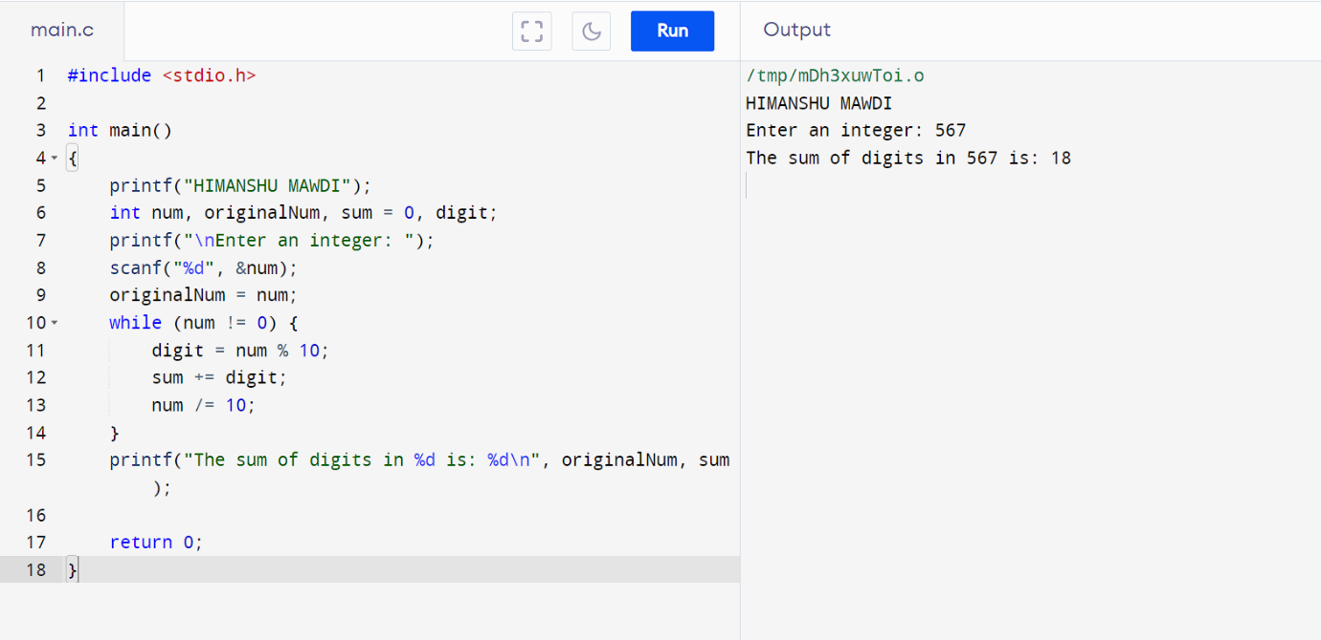

* **PROGRAM 39:- TO CALCULATE PRODUCT OF DIGITS OF A NUMBER**

**#include <stdio.h>**

**int main()**

**{**

**printf("HIMANSHU MAWDI");**

**int num, originalNum, product = 1, digit;**

**printf("\nEnter an integer: ");**

**scanf("%d", &num);**

**originalNum = num;**

**while (num != 0) {**

**digit = num % 10;**

**product *= digit;**

**num /= 10;**

**}**

**printf("The product of digits in %d is: %d\n", originalNum, product);**

**return 0;**

**}**

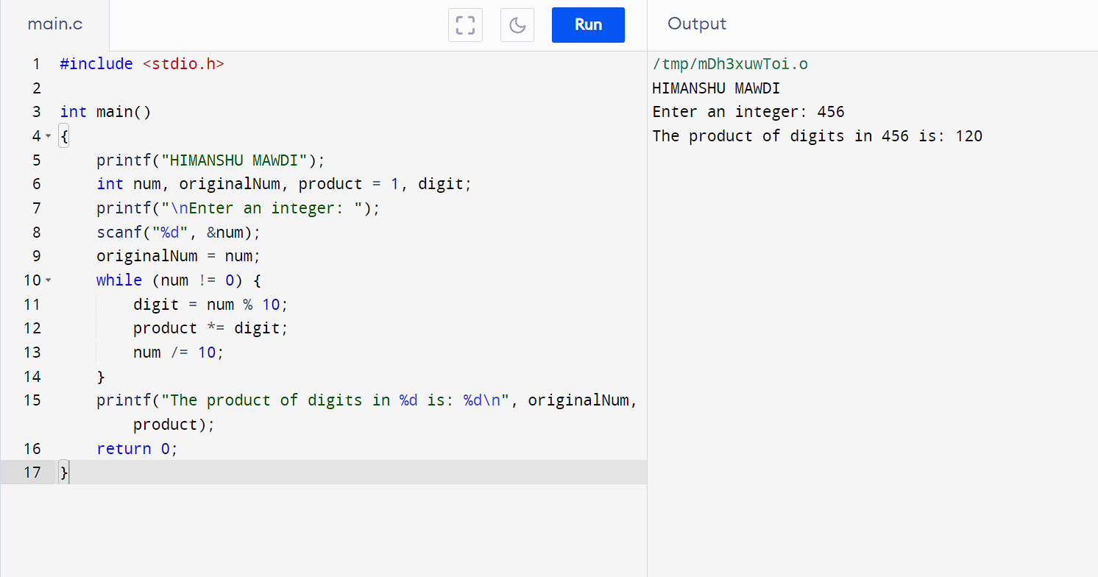

* **PROGRAM 40:- TO ENTER A NUMBER AND PRINT ITS REVERSE**

**#include <stdio.h>**

**int main()**

**{**

**printf("HIMANSHU MAWDI");**

**int num, rNum = 0, remainder;**

**printf("\nEnter an integer: ");**

**scanf("%d", &num);**

**while (num != 0) {**

**remainder = num % 10;**

**rNum = rNum * 10 + remainder;**

**num = num / 10;**

**}**

**printf("Reversed number: %d\n", rNum);**

**return 0;**

**}**

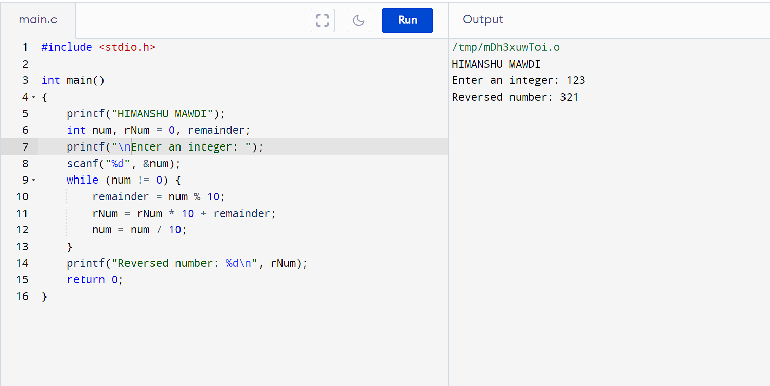

* **PROGRAM 41:- TO CHECK WHETHER THE NUMBER IS PALINDROME OR NOT**

**#include <stdio.h>**

**int main()**

**{**

**printf("HIMANSHU MAWDI");**

**int num, originalNum, rNum = 0, remainder;**

**printf("\nEnter an integer: ");**

**scanf("%d", &num);**

**originalNum = num;**

**while (num != 0) {**

**remainder = num % 10;**

**rNum = rNum * 10 + remainder;**

**num = num / 10;**

**}**

**if (originalNum == rNum) {**

**printf("%d is a palindrome.\n", originalNum);**

**} else {**

**printf("%d is not a palindrome.\n", originalNum);**

**}**

**return 0;**

**}**

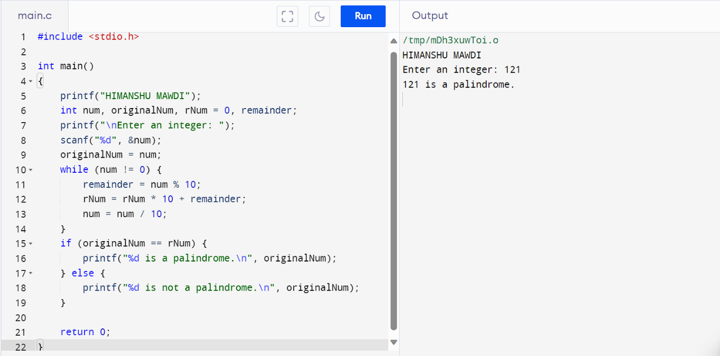

**PROGRAM 42:- TO FIND ALL FACTORS OF A NUMBER**

**#include <stdio.h>**

**int main()**

**{**

**printf("HIMANSHU MAWDI");**

**int num;**

**printf("\nEnter an integer: ");**

**scanf("%d", &num);**

**printf("Factors of %d are: ", num);**

**for (int i = 1; i <= num; i++) {**

**if (num % i == 0) {**

**printf("%d ", i);**

**}**

**}**

**printf("\n");**

**return 0;**

**}**

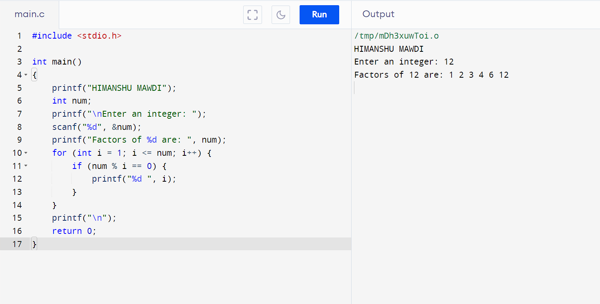

**PROGRAM 43**:- **TO FIND FACTORIAL OF A NUMBER**

**#include <stdio.h>**

**int main()**

**{**

**int i, num,fact=1;**

**printf("HIMANSHU MAWDI");**

**printf("\nEnter any number to calculate factorial: ");**

**scanf("%d", &num);**

**for(i=1; i<=num; i++)**

**{**

**fact = fact * i;**

**}**

**printf("\nFactorial of %d = %d", num, fact);**

**return 0;**

**}**

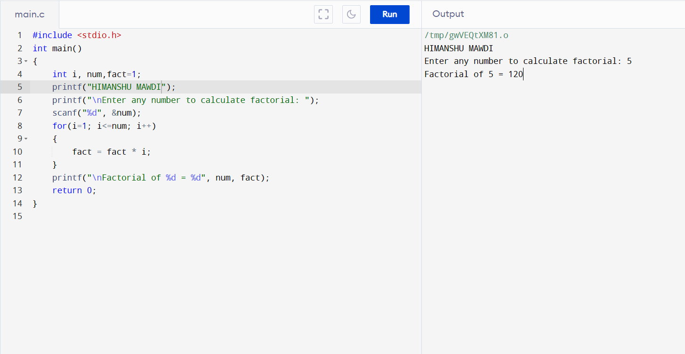

**PROGRAM 44:- TO FIND HCF OF TWO NUMBERS**

**#include <stdio.h>**

**int main()**

**{**

**int i, num1, num2, min, hcf=1;**

**printf("HIMANSHU MAWDI");**

**printf("\nEnter any two numbers to find HCF: ");**

**scanf("%d%d", &num1, &num2);**

**min = (num1<num2) ? num1 : num2;**

**for(i=1; i<=min; i++)**

**{**

**if(num1%i==0 && num2%i==0)**

**{**

**hcf = i;**

**}**

**}**

**printf("HCF of %d and %d = %d\n", num1, num2, hcf);**

**return 0;**

**}**

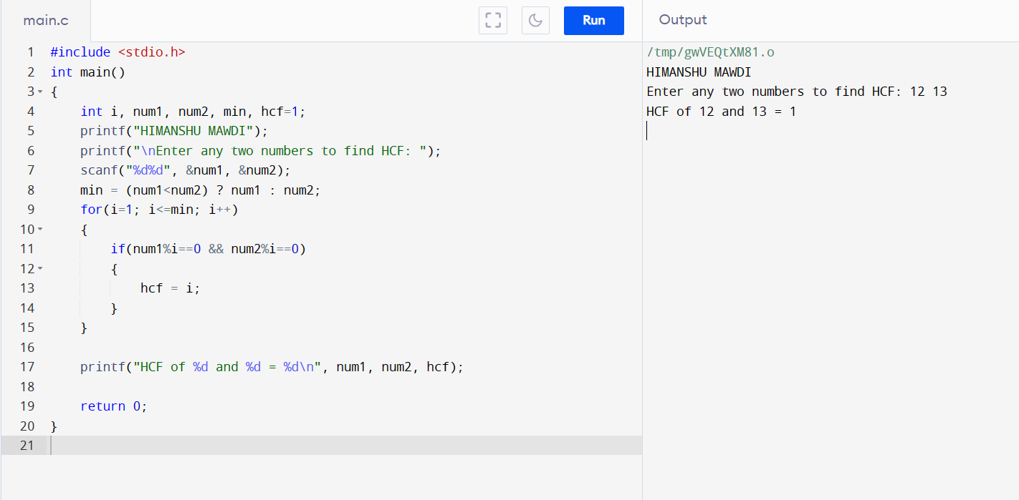

**PROGRAM 45:- TO FIND LCM OF TWO NUMBERS**

**#include <stdio.h>**

**int main()**

**{**

**int i, num1, num2, max, lcm=1;**

**printf("HIMANSHU MAWDI");**

**printf("\nEnter any two numbers to find LCM: ");**

**scanf("%d%d", &num1, &num2);**

**max = (num1 > num2) ? num1 : num2;**

**i = max;**

**while(1)**

**{**

**if(i%num1==0 && i%num2==0)**

**{**

**lcm = i;**

**break;**

**}**

**i =i+ max;**

**}**

**printf("LCM of %d and %d = %d", num1, num2, lcm);**

**return 0;**

**}**

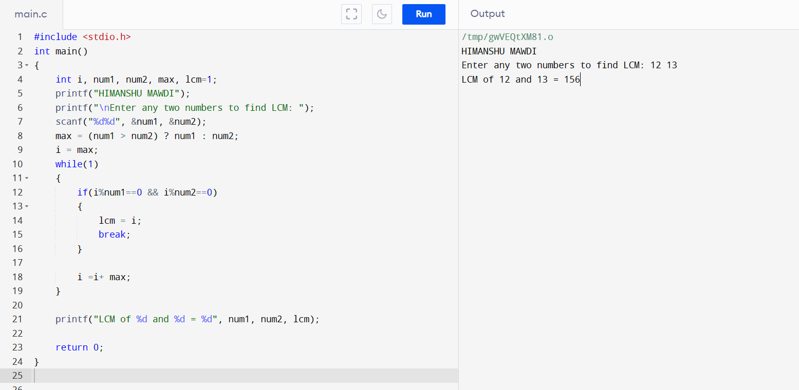

**PROGRAM 46:- TO CHECK WHETHER THE NUMBER IS PRIME OR NOT**

**#include <stdio.h>**

**int main()**

**{**

**int i, num, temp = 0;**

**printf("HIMANSHU MAWDI");**

**printf("\nEnter any number to Check for Prime: ");**

**scanf("%d", &num);**

**for (i = 2; i <= num / 2; i++)**

**{**

**if (num % i == 0)**

**{**

**temp++;**

**break;**

**}**

**}**

**if (temp == 0 && num != 1)**

**{**

**printf("%d is a Prime number", num);**

**}**

**else**

**{**

**printf("%d is not a Prime number", num);**

**}**

**return 0;**

**}**

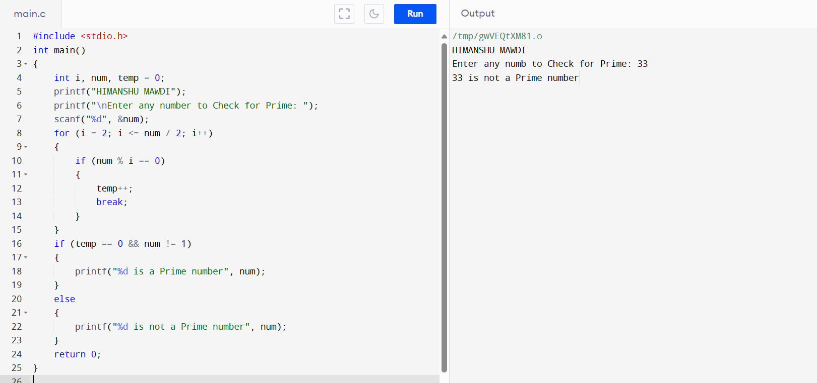

**PROGRAM 47:- TO PRINT ALL PRIME NUMBER BETWEEN 1 to n**

**#include<stdio.h>**

**int main()**

**{**

**int num,i,count,n;**

**printf("HIMANSHU MAWDI");**

**printf("\nEnter num: ");**

**scanf("%d",&n);**

**for(num = 1;num<=n;num++)**

**{**

**count = 0;**

**for(i=2;i<=num/2;i++)**

**{**

**if(num%i==0)**

**{**

**count++;**

**break;**

**}**

**}**

**if(count==0 && num!= 1)**

**{**

**printf("%d ",num);**

**}**

**}**

**return 0;**

**}**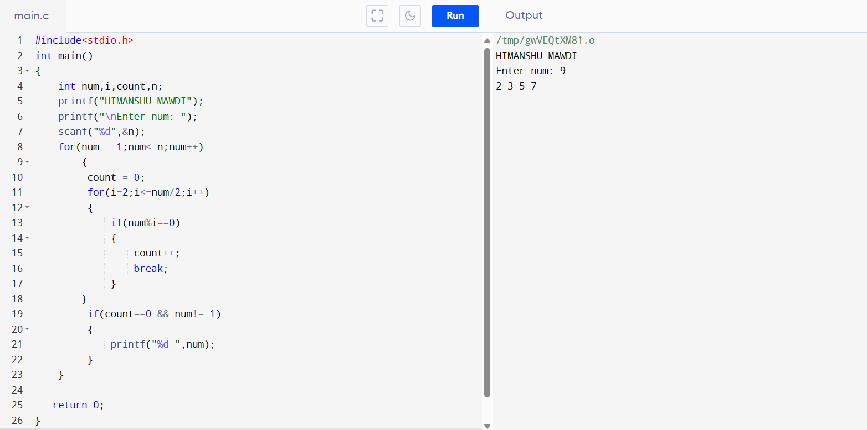

**PROGRAM 48:-TO FIND SUM OF ALL PRIME NUMBER BETWEEN 1 to n**

**#include <stdio.h>**

**int main()**

**{**

**int j, N, i, isPrime,Sum = 0;**

**printf("HIMANSHU MAWDI");**

**printf("\nEnter a Number\n");**

**scanf("%d", &N);**

**for(j = 2; j <= N; j++) {**

**isPrime = 1;**

**for(i = 2; i <=(j/2); ++i) {**

**if(j%i==0) {**

**isPrime = 0;**

**break;**

**}**

**}**

**if(isPrime==1)**

**Sum= Sum+j;**

**}**

**printf("Sum of Prime Numbers %d= %d",N,Sum);**

**return 0;**

**}**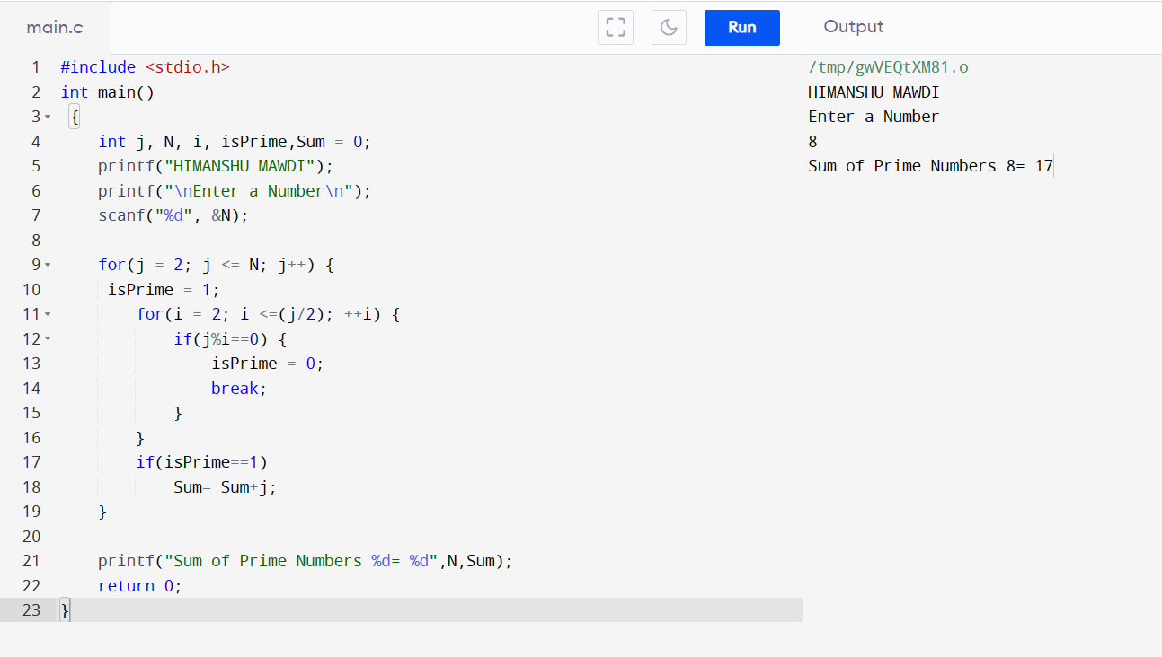

**PROGRAM 49:- TO FIND ALL PRIME FACTORS OF A NUMBER**

**#include<stdio.h>**

**int main()**

**{**

**int n,i;**

**printf("Enter a positive integer\n");**

**scanf("%d", &n);**

**printf("HIMANSHU MAWDI");**

**printf("\nPrime Factors of %d are\n", n);**

**for(i = 2; n > 1; i++)**

**{**

**while(n % i == 0)**

**{**

**printf("%d ", i);**

**n = n / i;**

**}**

**}**

**printf("\n");**

**return 0;**

**}**

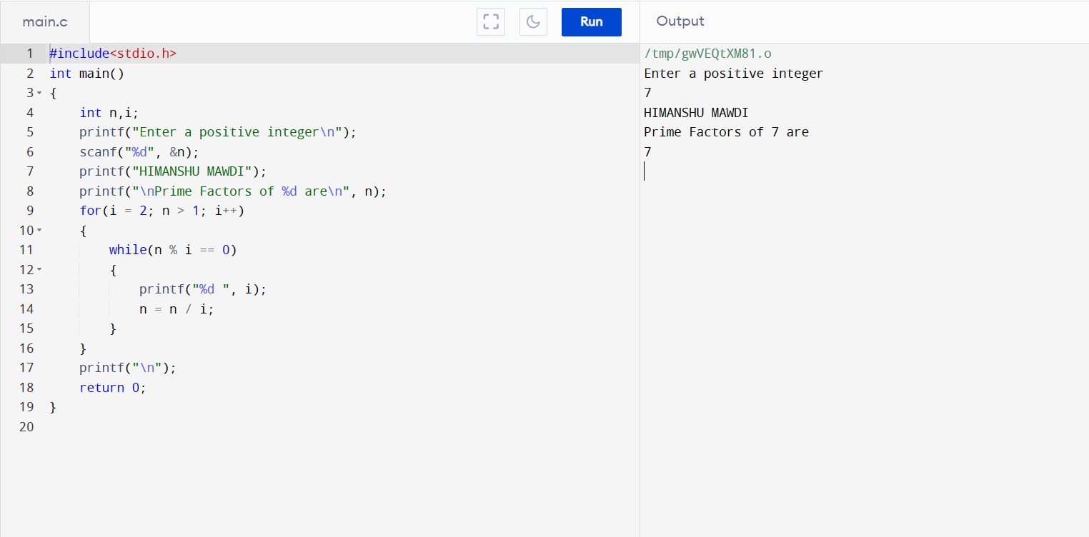

**PROGRAM 50:-TO CHECK WHETHER A NUMBER IS ARMSTRONG OR NOT**

**#include<stdio.h>**

**int main()**

**{**

**int n,r,sum=0,temp;**

**printf("HIMANSHU MAWDI");**

**printf("\nenter the number=");**

**scanf("%d",&n);**

**temp=n;**

**while(n>0)**

**{**

**r=n%10;**

**sum=sum+(r*r*r);**

**n=n/10;**

**}**

**if(temp==sum)**

**printf("armstrong number ");**

**else**

**printf("not armstrong number");**

**return 0;**

**}**

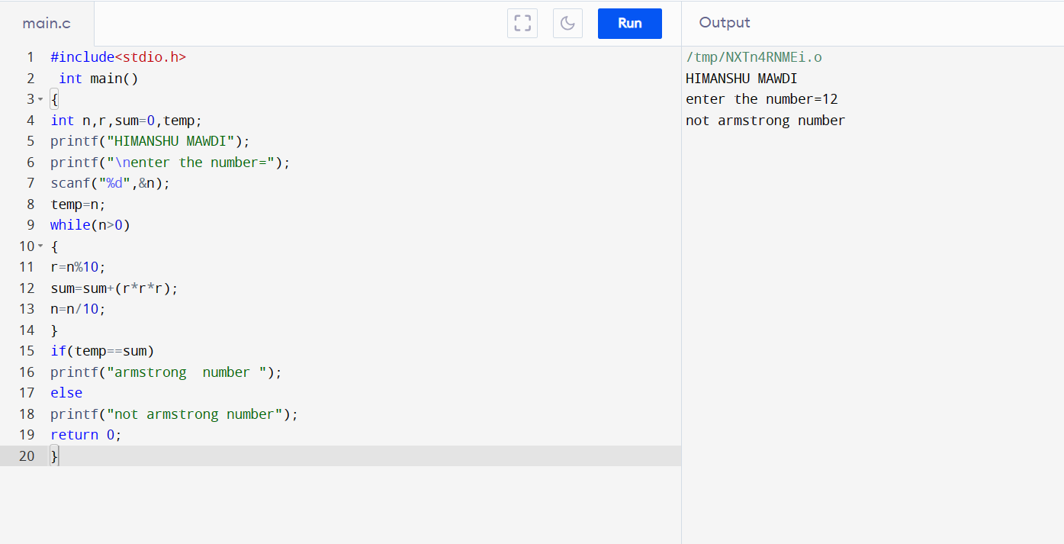

**PROGRAM 51:- TO PRINT ALL ARMSTRONG NUMBER BETWEEN 1 to n**

**#include<stdio.h>**

**int main()**

**{**

**int digit,n,sum=0,number;**

**printf("HIMANSHU MAWDI");**

**printf("\nThe armstrong numbers are-");**

**scanf("%d",&n);**

**for(number = 1; number <=n; number++)**

**{**

**int temporary = number;**

**sum = 0;**

**while(temporary > 0)**

**{**

**digit = temporary % 10;**

**sum = sum + (digit * digit * digit);**

**temporary = temporary / 10;**

**}**

**if(sum == number)**

**printf("%d ",number);**

**}**

**return 0;**

**}**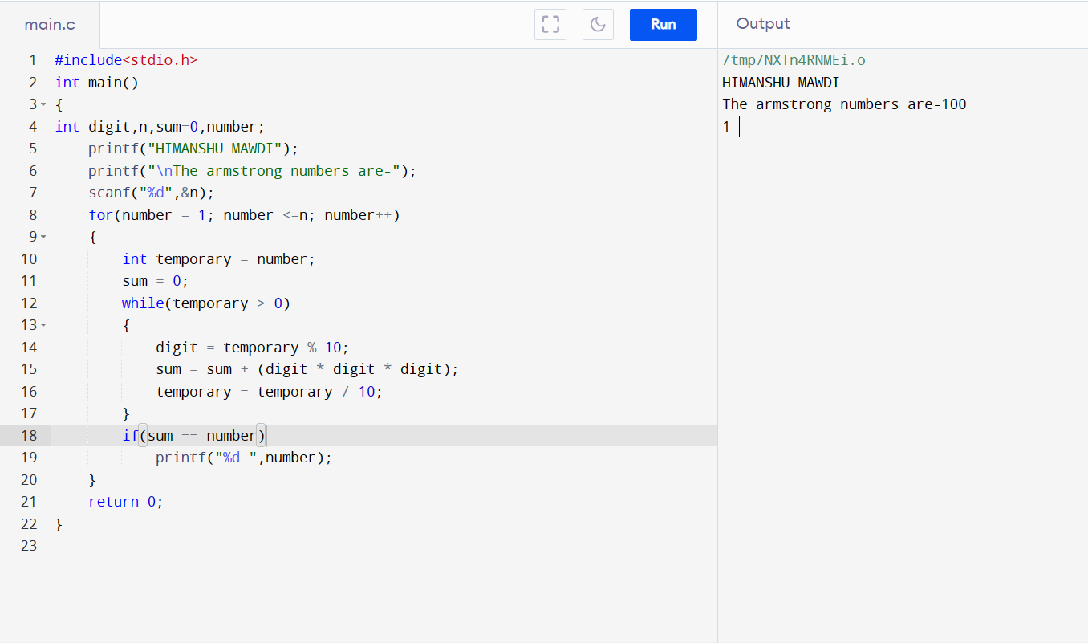

**PROGRAM 52:- TO CHECK WHETHER NUMBER IS PERFECT NUMBER OR NOT**

**#include<stdio.h>**

**#include<conio.h>**

**void main()**

**{**

**int num, rem, sum = 0, i;**

**printf("HIMANSHU MAWDI");**

**printf("\nEnter a number\n");**

**scanf("%d", &num);**

**for(i = 1; i < num; i++)**

**{**

**rem = num % i;**

**if (rem == 0)**

**{**

**sum = sum + i;**

**}**

**}**

**if (sum == num)**

**{**

**printf(" %d is a Perfect Number",sum,num);**

**}**

**else**

**{**

**printf("\n %d is not a Perfect Number",sum,num);**

**}**

**return 0;**

**}**

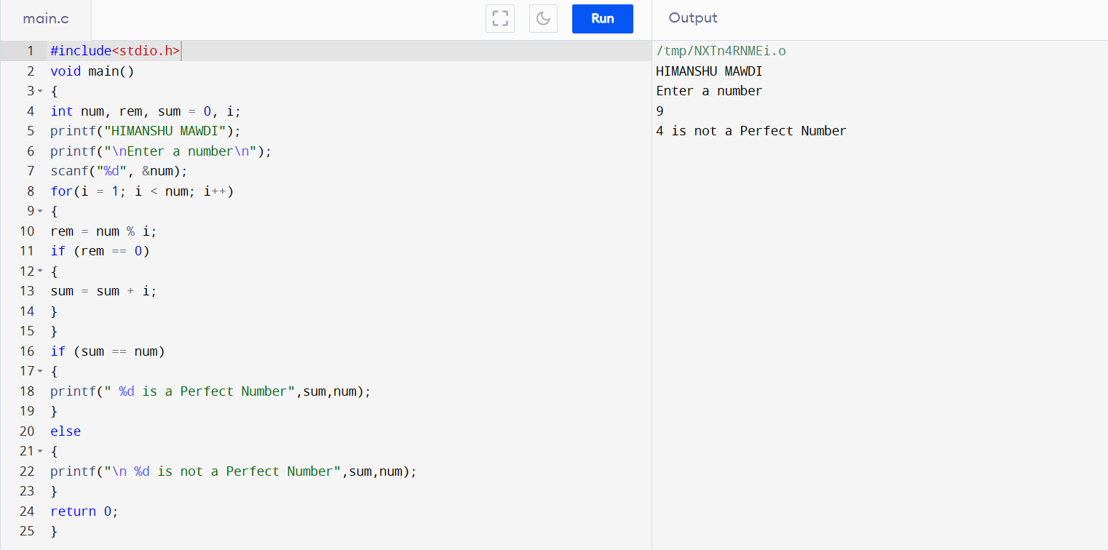

**PROGRAM 53:- TO PRINT ALL PERFECT NUMBER BETWEEN 1 to n**

**#include <stdio.h>**

**int main()**

**{**

**int i, j, n, sum;**

**printf("HIMANSHU MAWDI");**

**printf("\nEnter limit: ");**

**scanf("%d", &n);**

**printf("\nAll Perfect numbers between 1 to %d:\n", n);**

**for(i=1; i<=n; i++)**

**{**

**sum = 0;**

**for(j=1; j<i; j++)**

**{**

**if(i % j == 0)**

**{**

**sum += j;**

**}**

**}**

**if(sum == i)**

**{**

**printf("%d, ", i);**

**}**

**}**

**return 0;**

**}**

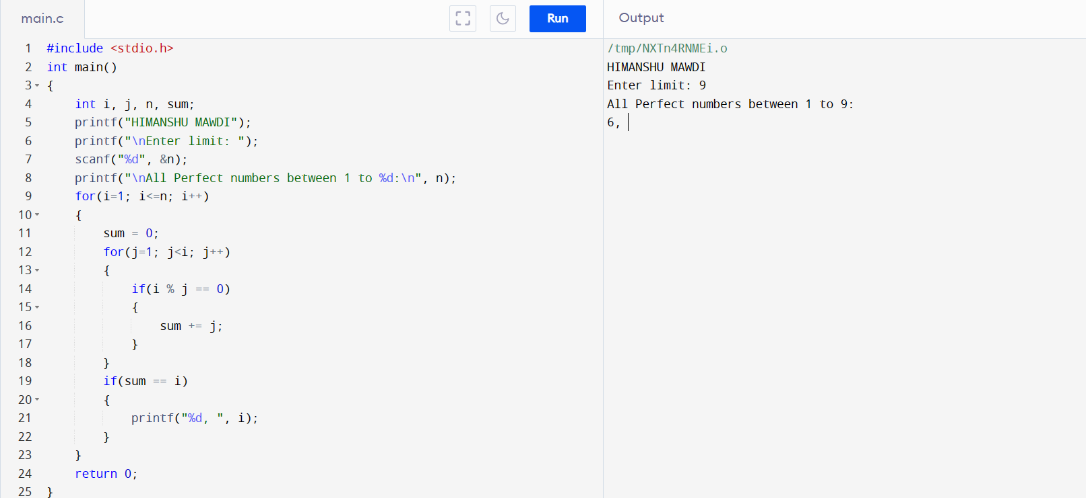

**PROGRAM 54:- Write a C program to check whether a number is Strong number or not.**

**#include<stdio.h>**

**int main()**

**{**

**int number, original, rem, sum=0, fact, i;**

**printf("HIMANSHU MAWDI");**

**printf("/nEnter number: ");**

**scanf("%d", &number);**

**original = number;**

**while(number != 0)**

**{**

**rem = number%10;**

**fact = 1;**

**for(i=1; i<=rem; i++)**

**{**

**fact = fact*i;**

**}**

**sum = sum + fact;**

**number = number/10;**

**}**

**if(sum == original)**

**{**

**printf("%d is STRONG.", original);**

**}**

**else**

**{**

**printf("%d is NOT STRONG.", original);**

**}**

**return 0;**

**}**

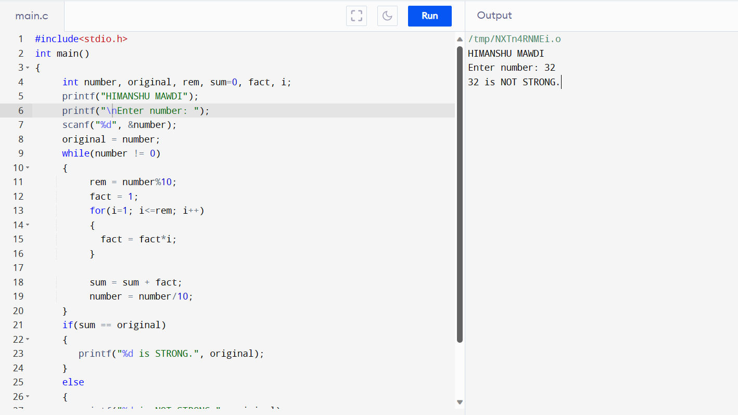

**PROGRAM 54:- TO PRINT ALL STRONG NUMBERS BETWEEN 1 to n**

**#include <stdio.h>**

**#include <stdlib.h>**

**int factorial(int f) {**

**int mul = 1;**

**for (int i = 1; i <= f; i++) {**

**mul = mul * i;**

**}**

**return mul;**

**}**

**int main() {**

**int fact = 1, sum = 0;**

**int n, r;**

**printf(“HIMANSHU MAWDI”);**

**printf("Enter the n:");**

**scanf("%d",&n);**

**printf("Strong numbers are :");**

**for (int i = 1; i <= n; i++) {**

**int k = i;**

**while (k != 0) {**

**r = k % 10;**

**fact = factorial(r);**

**k = k / 10;**

**sum = sum + fact;**

**}**

**if (sum == i) {**

**printf("%d, ", i);**

**}**

**sum = 0;**

**}**

**return 0;**

**}**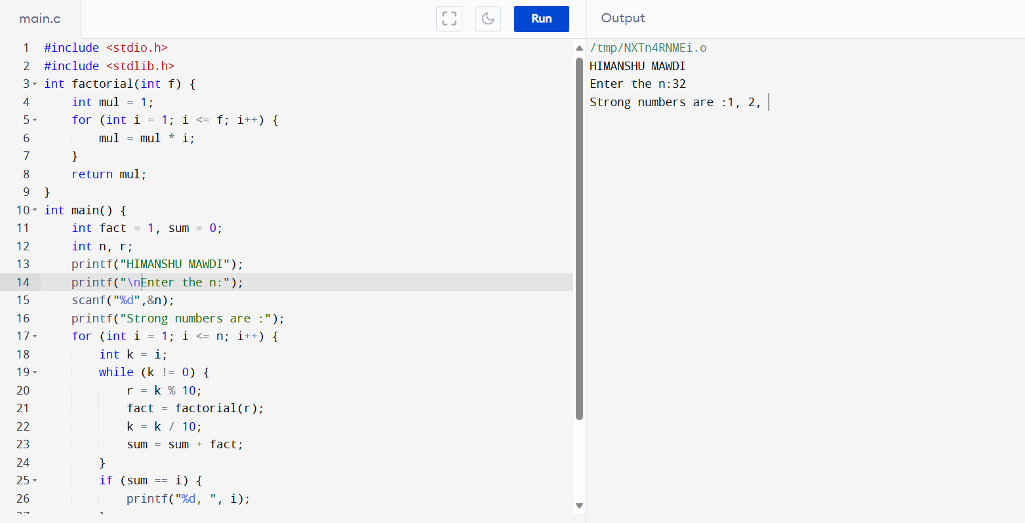

**PROGRAM 55:- TO PRINT FIBONACCI SERIES UPTO n Terms**

**#include<stdio.h>**

**int main()**

**{**

**int n1=0,n2=1,n3,i,num;**

**printf("HIMANSHU MAWDI");**

**printf("\nEnter the number of elements:");**

**scanf("%d",&num);**

**printf("\n%d %d",n1,n2);**

**for(i=2;i<num;++i)**

**{**

**n3=n1+n2;**

**printf(" %d",n3);**

**n1=n2;**

**n2=n3;**

**}**

**return 0;**

**}**

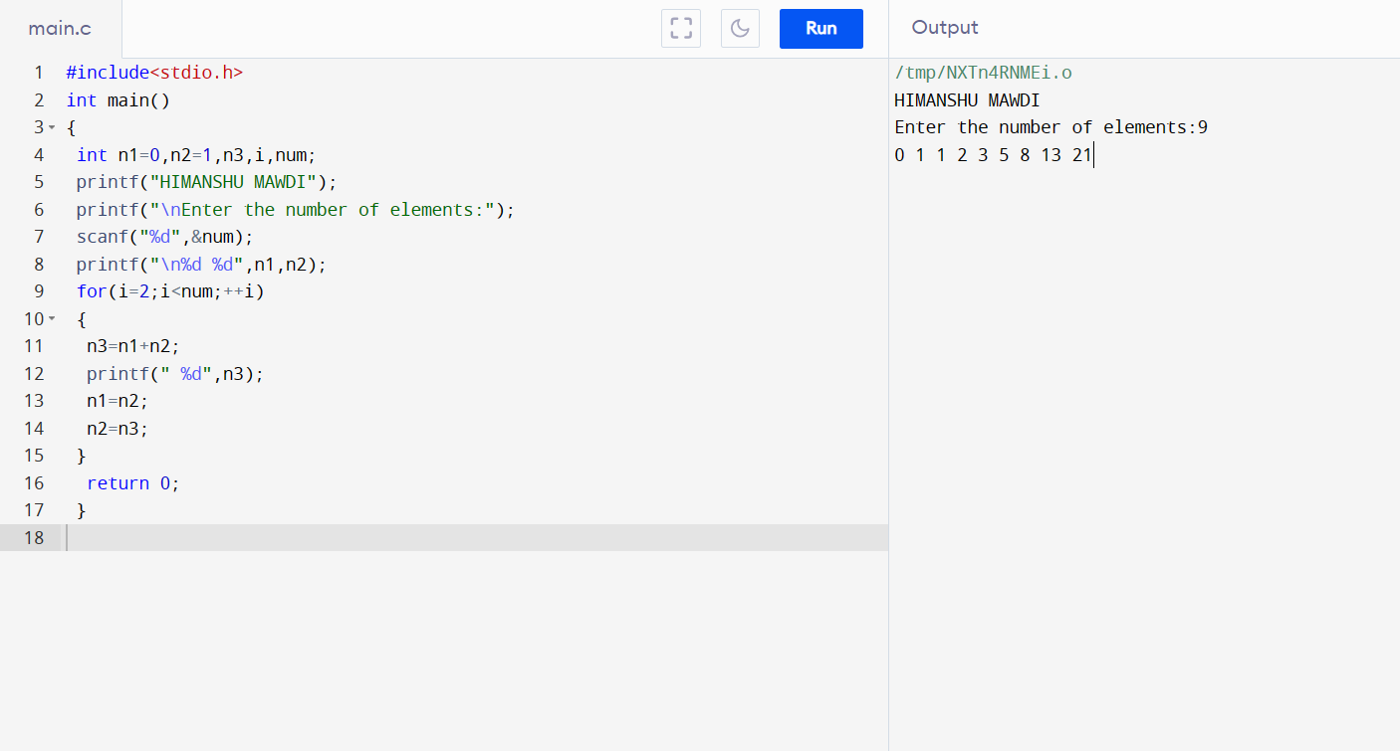

**PROGRAM 56:- TO FIND ONEs COMPLEMENT OF A BINARY NUMBER.**

**#include <stdio.h>**

**#include <string.h>**

**int main()**

**{**

**char binaryNumber[100], onesComplement[100];**

**int counter, error=0, digitCount;**

**printf("HIMANSHU MAWDI");**

**printf("\nEnter a Binary Number\n");**

**scanf("%s", binaryNumber);**

**digitCount = strlen(binaryNumber);**

**for(counter=0; counter < digitCount; counter++)**

**{**

**if(binaryNumber[counter]=='1')**

**{**

**onesComplement[counter] = '0';**

**}**

**else if(binaryNumber[counter]=='0')**

**{**

**onesComplement[counter] = '1';**

**}**

**else**

**{**

**printf("Error :( ");**

**return 1;**

**}**

**}**

**onesComplement[digitCount] = '\0';**

**printf("Ones Complement : %s", onesComplement);**

**return 0;**

**}**

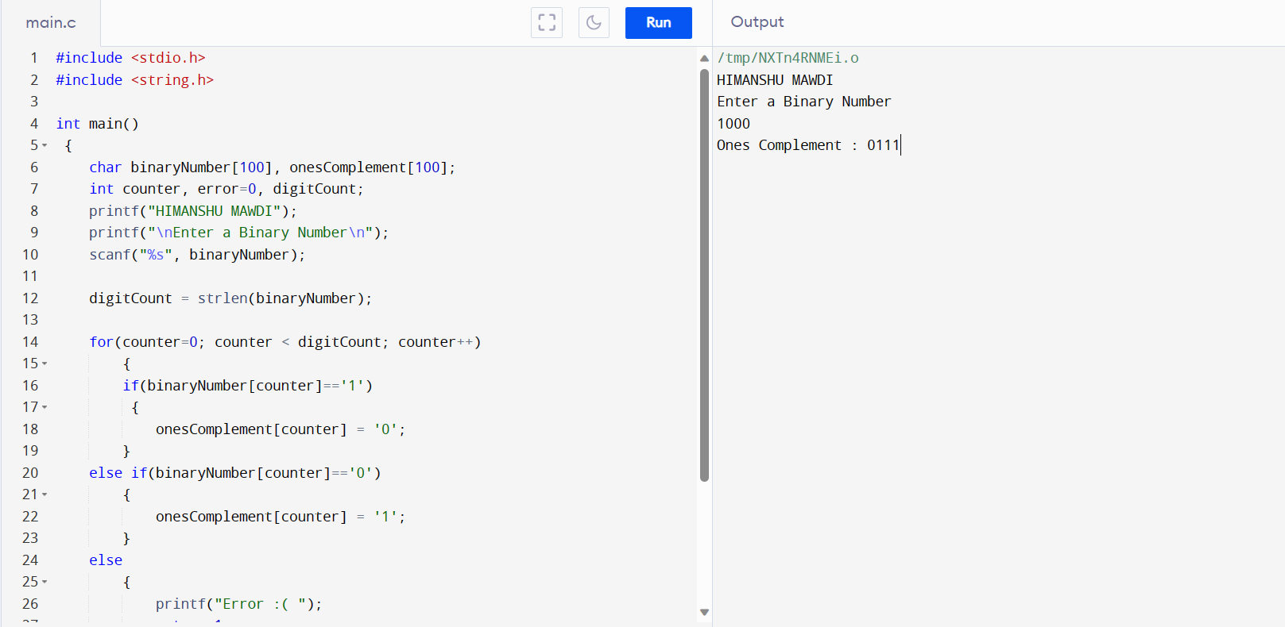

**PROGAM 57:- TO FIND TWO’s COMPLEMENT OF A BINARY NUMBER**

**#include<stdio.h>**

**#include<stdlib.h>**

**#define SIZE 8**

**int main()**

**{**

**int i, carry = 1;**

**char num[SIZE + 1], one[SIZE + 1], two[SIZE + 1];**

**printf("HIMANSHU MAWDI");**

**printf("\nEnter the binary number");**

**gets(num);**

**for(i = 0; i < SIZE; i++)**

**{**

**if(num[i] == '0')**

**{**

**one[i] = '1';**

**}**

**else if(num[i] == '1')**

**{**

**one[i] = '0';**

**}**

**}**

**one[SIZE] = '\0';**

**printf("\nOnes' complement of binary number %s is %s",num, one);**

**for(i = SIZE - 1; i >= 0; i--)**

**{**

**if(one[i] == '1' && carry == 1)**

**{**

**two[i] = '0';**

**}**

**else if(one[i] == '0' && carry == 1)**

**{**

**two[i] = '1';**

**carry = 0;**

**}**

**else{**

**two[i] = one[i];**

**}**

**}**

**two[SIZE] = '\0';**

**printf("Two's complement of binary number %s is %s",num, two);**

**return 0;**

**}**

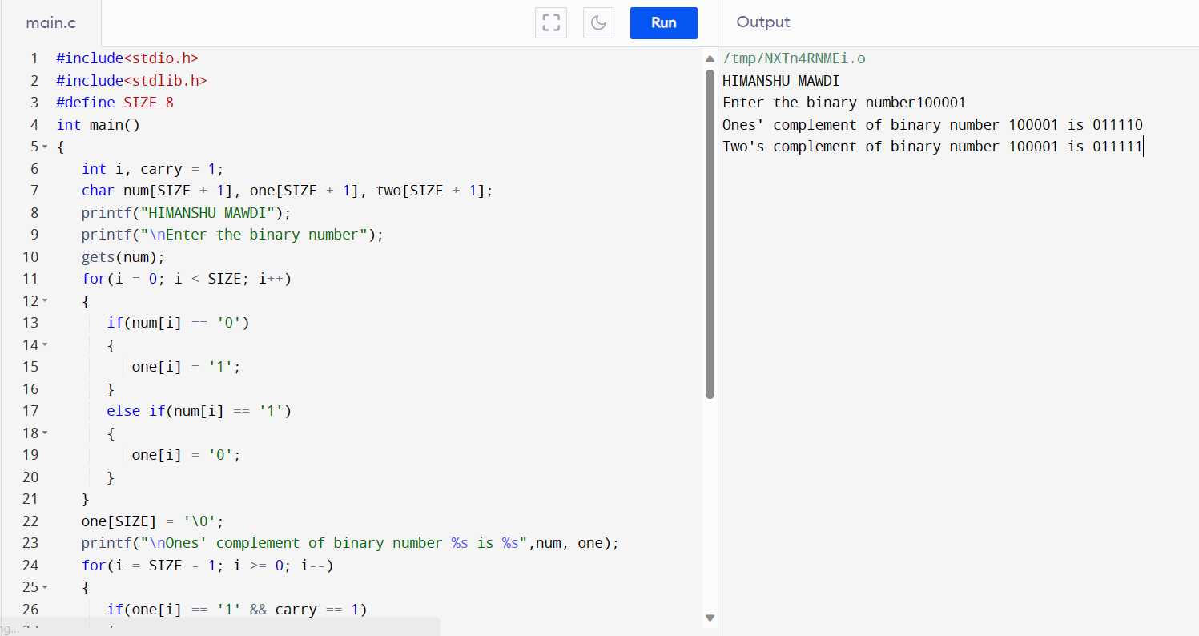

**PROGRAM 58:- TO CONVERT BINARY NUMBER TO OCTAL NUMBER**

**#include <stdio.h>**

**#include<math.h>**

**int main()**

**{**

**int i, octal = 0, decimal = 0;**

**long binary;**

**printf("HIMANSHU MAWDI");**

**printf("\nEnter the Binary Number = ");**

**scanf("%ld", &binary);**

**i = 0;**

**while(binary != 0)**

**{**

**decimal = decimal + (binary % 10) * pow(2, i);**

**i++;**

**binary = binary/10;**

**}**

**i = 1;**

**while(decimal != 0)**

**{**

**octal = octal + (decimal % 8) * i;**

**decimal = decimal / 8;**

**i = i * 10;**

**}**

**printf("The octal Value = %d\n", octal);**

**return 0;**

**}**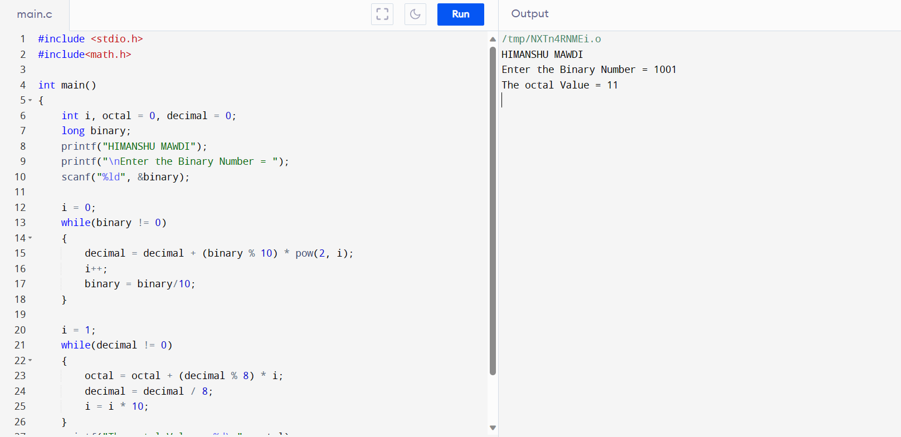

**PROGRAM 59:- TO CONVERT BINARY NUMBER TO DECIMAL NUMBER**

**#include <stdio.h>**

**PROGRAM 62:- TO CONVERT OCTAL NUMBER TO BINARY NUMBER**

**#include <stdio.h>**

**#include <math.h>**

**int main()**

**{**

**int i, octal, decimal = 0;**

**long binary = 0;**

**i = 0;**

**printf("Enter the Octal Number = ");**

**scanf("%d",&octal);**

**while(octal != 0)**

**{**

**decimal = decimal + (octal % 10) * pow(8, i);**

**i++;**

**octal = octal / 10;**

**}**

**i = 1;**

**while(decimal != 0)**

**{**

**binary += ((decimal % 2) * i);**

**decimal = decimal / 2;**

**i = i * 10;**

**}**

**printf("The Binay Value = %ld\n", binary);**

**}**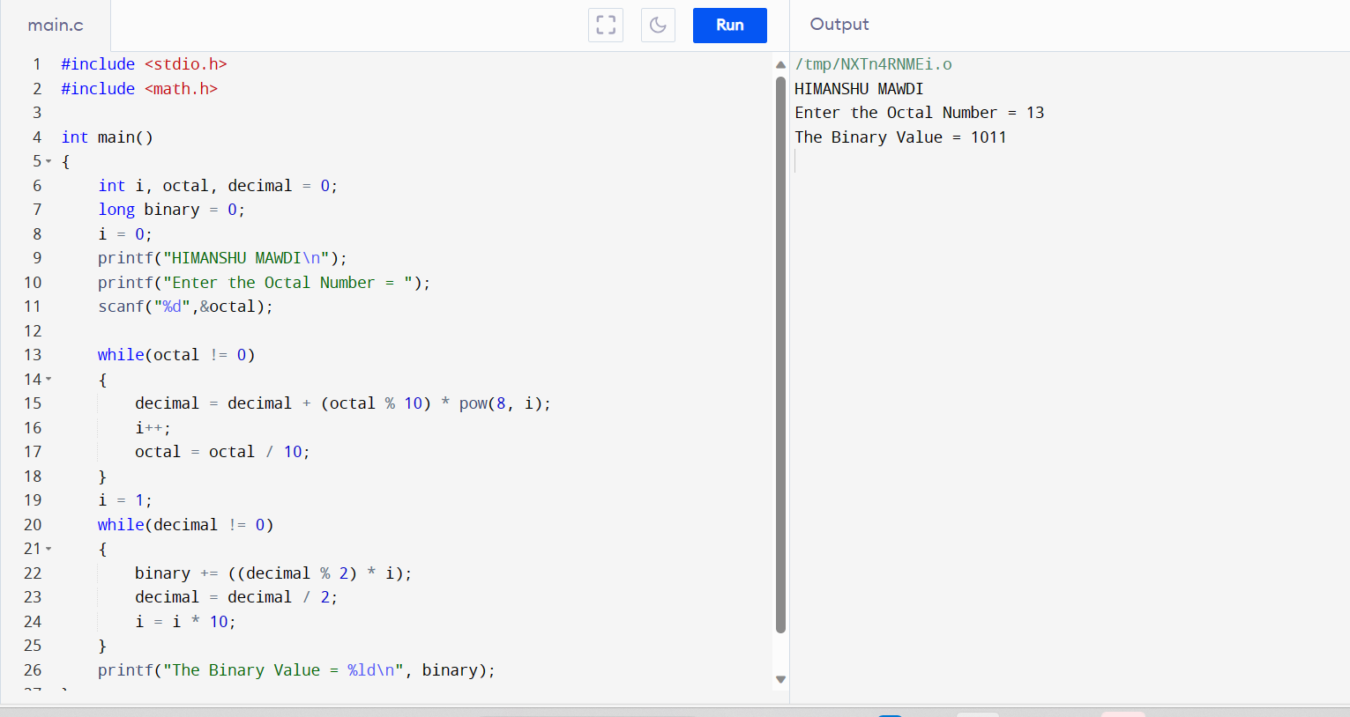

**PROGRAM 63:- TO CONERT OCTAL NUMBER TO DECIMAL NUMBER**

**#include <stdio.h>**

**#include <math.h>**

**int main()**

**{**

**int octal, decimal = 0;**

**int i = 0;**

**printf(" \n");**

**printf("Enter the Octal Number = ");**

**scanf("%d",&octal);**

**while(octal != 0)**

**{**

**decimal = decimal + (octal % 10) * pow(8, i++);**

**octal = octal / 10;**

**}**

**printf("The Decimal Value = %d\n", decimal);**

**return 0;**

**}**

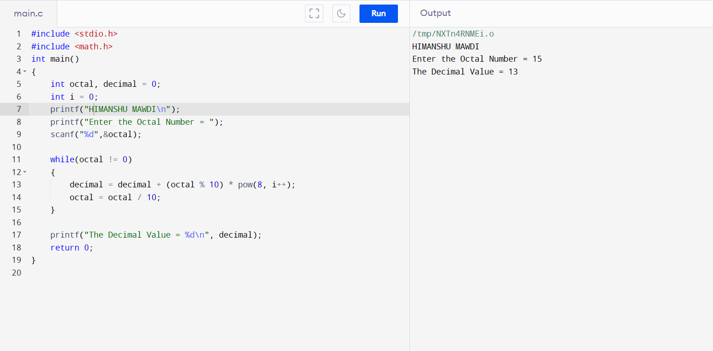

**PROGRAM 65:- TO CONVERT DECIMAL NUMBER TO BINARY NUMBER**

**#include <stdio.h>**

**int main()**

**{**

**long long decimal, tempDecimal, binary;**

**int rem, place = 1;**

**binary = 0;**

**printf("HIMANSHU MAWDI");**

**printf("\nEnter any decimal number: ");**

**scanf("%lld", &decimal);**

**tempDecimal = decimal;**

**while(tempDecimal > 0)**

**{**

**rem = tempDecimal % 2;**

**binary = (rem * place) + binary;**

**tempDecimal /= 2;**

**place *= 10;**

**}**

**printf("Decimal number = %lld\n", decimal);**

**printf("Binary number = %lld", binary);**

**return 0;**

**}**

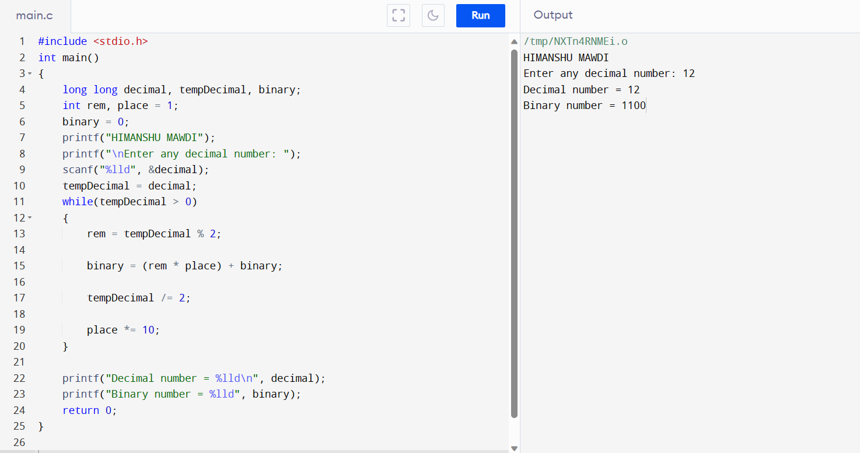

**If…Else Exercises**

**PROGRAM 66. TO FIND MAXIMUM BETWEEN TWO NUMBERS.**

**#include <stdio.h>**

**int main()**

**{**

**int num1, num2;**

**printf("HIMANSHU MAWDI");**

**printf("\nEnter two numbers: ");**

**scanf("%d%d", &num1, &num2);**

**if(num1 > num2)**

**{**

**printf("%d is maximum", num1);**

**}**

**if(num2 > num1)**

**{**

**printf("%d is maximum", num2);**

**}**

**if(num1 == num2)**

**{**

**printf("Both are equal");**

**}**

**return 0;**

**}**

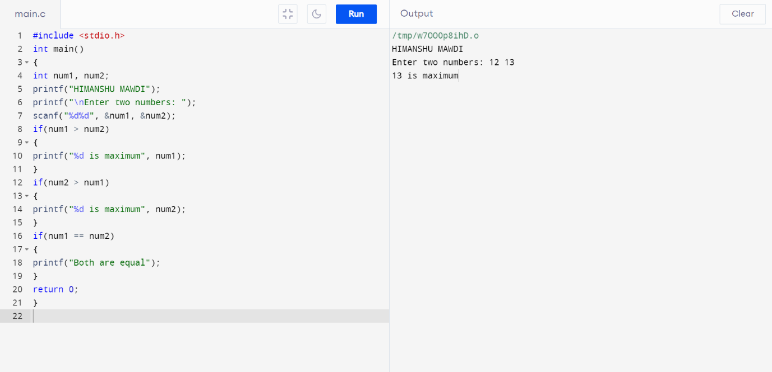

**PROGRAM 67. TO FIND MAXIMUM BETWEEN THREE NUMBERS.**

**#include <stdio.h>**

**int main()**

**{**

**int num1, num2, num3, max;**

**printf("HIMANSHU MAWDI");**

**printf("\nEnter three numbers: ");**

**scanf("%d%d%d", &num1, &num2, &num3);**

**if(num1 > num2)**

**{**

**if(num1 > num3)**

**{**

**max = num1;**

**}**

**else**

**{**

**max = num3;**

**}**

**}**

**else**

**{**

**if(num2 > num3)**

**{**

**max = num2;**

**}**

**else**

**{**

**max = num3;**

**}**

**}**

**printf("Maximum among all three numbers = %d", max);**

**return 0;**

**}**



**PROGRAM 68. TO CHECK WHETHER A NUMBER IS NEGATIVE, POSITIVE OR ZERO.**

**#include <stdio.h>**

**int main()**

**{**

**int num;**

**printf("HIMANSHU MAWDI");**

**printf("\nEnter any number: ");**

**scanf("%d", &num);**

**if(num > 0)**

**{**

**printf("Number is POSITIVE");**

**}**

**else if(num < 0)**

**{**

**printf("Number is NEGATIVE");**

**}**

**else**

**{**

**printf("Number is ZERO");**

**}**

**return 0;**

**}**



**PROGRAM 69. TO CHECK WHETHER A NUMBER IS DIVISIBLE BY 5 AND 11 OR NOT.**

**#include <stdio.h>**

**int main()**

**{**

**int num;**

**printf("HIMANSHU MAWDI");**

**printf("\nEnter any number: ");**

**scanf("%d", &num);**

**if((num % 5 == 0) && (num % 11 == 0))**

**{**

**printf("Number is divisible by 5 and 11");**

**}**

**else**

**{**

**printf("Number is not divisible by 5 and 11");**

**}**

**return 0;**

**}**

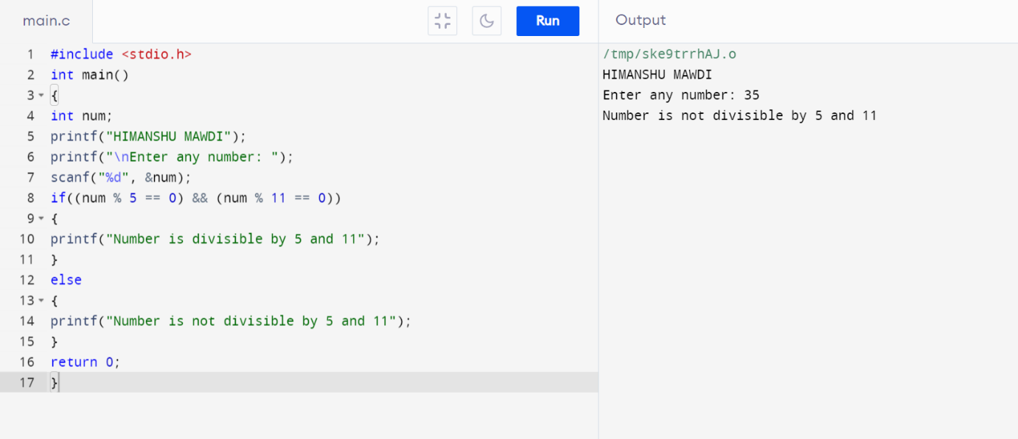

**PROGRAM 70. TO CHECK WHETHER A NUMBER IS EVEN OR ODD.**

**#include <stdio.h>**

**int main()**

**{**

**int num;**

**printf("HIMANSHU MAWDI");**

**printf("\nEnter any number to check even or odd: ");**

**scanf("%d", &num);**

**if(num % 2 == 0)**

**{**

**printf("Number is Even.");**

**}**

**else**

**{**

**printf("Number is Odd.");**

**}**

**return 0;**

**}**

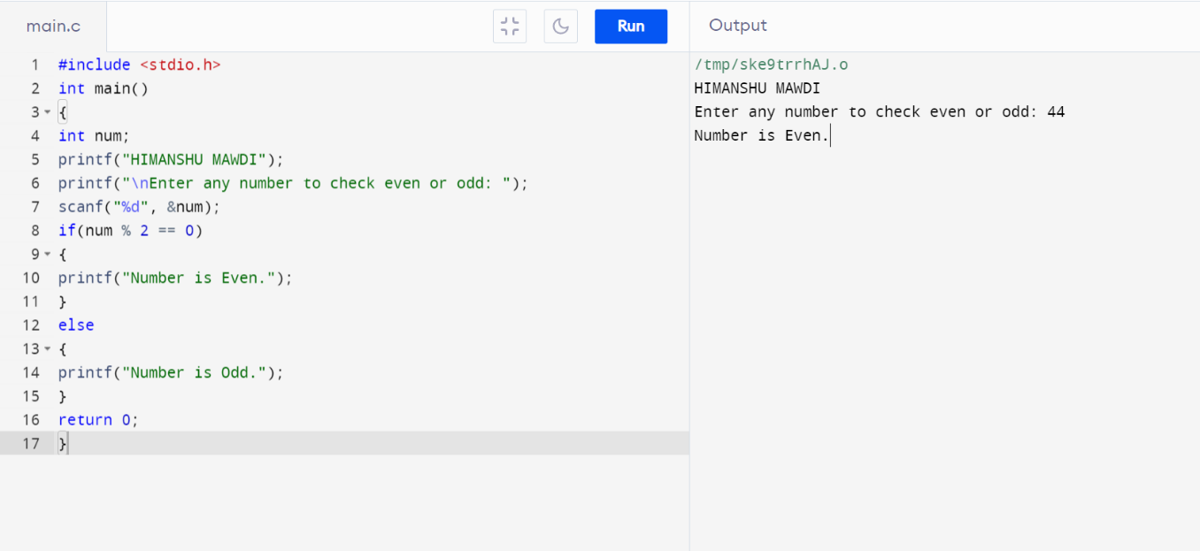

**PROGRAM 71. TO CHECK WHETHER A YEAR IS LEAP YEAR OR NOT.**

**#include <stdio.h>**

**int main()**

**{**

**int year;**

**printf("HIMANSHU MAWDI");**

**printf("\nEnter year : ");**

**scanf("%d", &year);**

**if(((year % 4 == 0) && (year % 100 !=0)) || (year % 400==0))**

**{**

**printf("LEAP YEAR");**

**}**

**else**

**{**

**printf("NOT A LEAP YEAR");**

**}**

**return 0;**

**}**

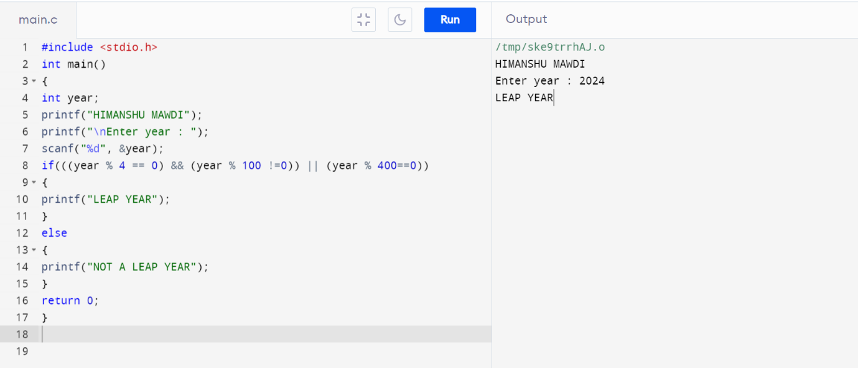

**PROGRAM 72. TO CHECK WHETHER A CHARACTER IS ALPHABET OR NOT.**

**#include <stdio.h>**

**int main()**

**{**

**char ch;**

**printf("HIMANSHU MAWDI");**

**printf("\nEnter any character: ");**

**scanf("%c", &ch);**

**if((ch >= 'a' && ch <= 'z') || (ch >= 'A' && ch <= 'Z'))**

**{**

**printf("Character is an ALPHABET.");**

**}**

**else**

**{**

**printf("Character is NOT ALPHABET.");**

**}**

**return 0;**

**}**

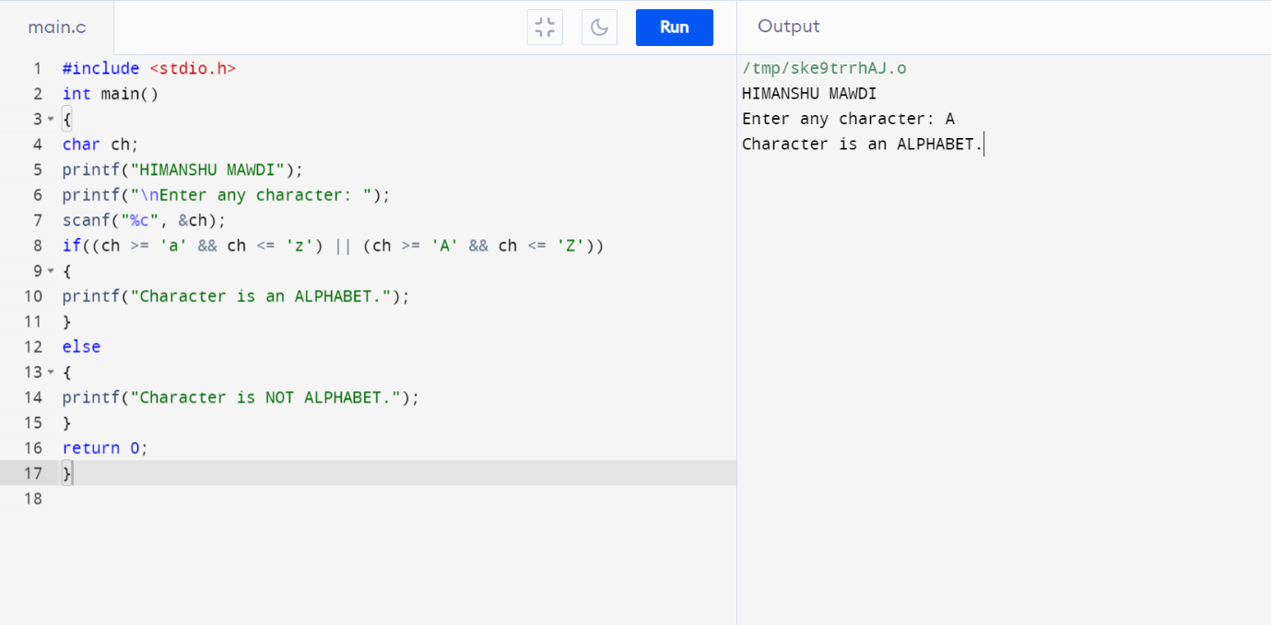

**PROGRAM 73. TO INPUT ANY ALPHABET AND CHECK WHETHER IT IS VOWEL OR CONSONANT.**

**#include <stdio.h>**

**int main()**

**{**

**char ch;**

**printf("HIMANSHU MAWDI");**

**printf("\nEnter any character: ");**

**scanf("%c", &ch);**

**if(ch=='a' || ch=='e' || ch=='i' || ch=='o' || ch=='u' ||**

**ch=='A' || ch=='E' || ch=='I' || ch=='O' || ch=='U')**

**{**

**printf("'%c' is Vowel.", ch);**

**}**

**else if((ch >= 'a' && ch <= 'z') || (ch >= 'A' && ch <= 'Z'))**

**{**

**printf("'%c' is Consonant.", ch);**

**}**

**else**

**{**

**printf("'%c' is not an alphabet.", ch);**

**}**

**return 0;**

**}**

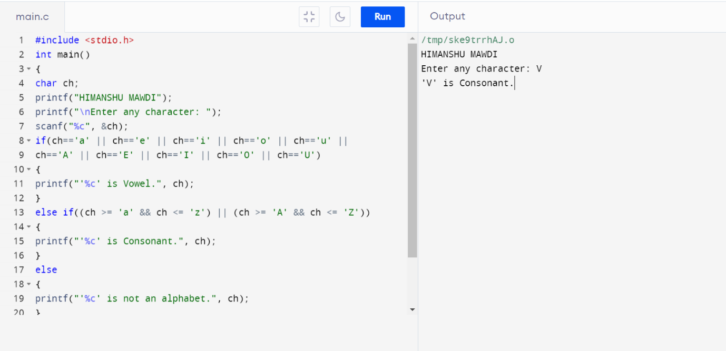

**PROGRAM 74. TO INPUT ANY CHARACTER AND CHECK WHETHER IT IS ALPHABET, DIGIT OR SPECIAL CHARACTER.**

**#include <stdio.h>**

**int main()**

**{**

**char ch;**

**printf("HIMANSHU MAWDI");**

**printf("\nEnter any character: ");**

**scanf("%c", &ch);**

**if((ch >= 'a' && ch <= 'z') || (ch >= 'A' && ch <= 'Z'))**

**{**

**printf("'%c' is alphabet.", ch);**

**}**

**else if(ch >= '0' && ch <= '9')**

**{**

**printf("'%c' is digit.", ch);**

**}**

**else**

**{**

**printf("'%c' is special character.", ch);**

**}**

**return 0;**

**}**

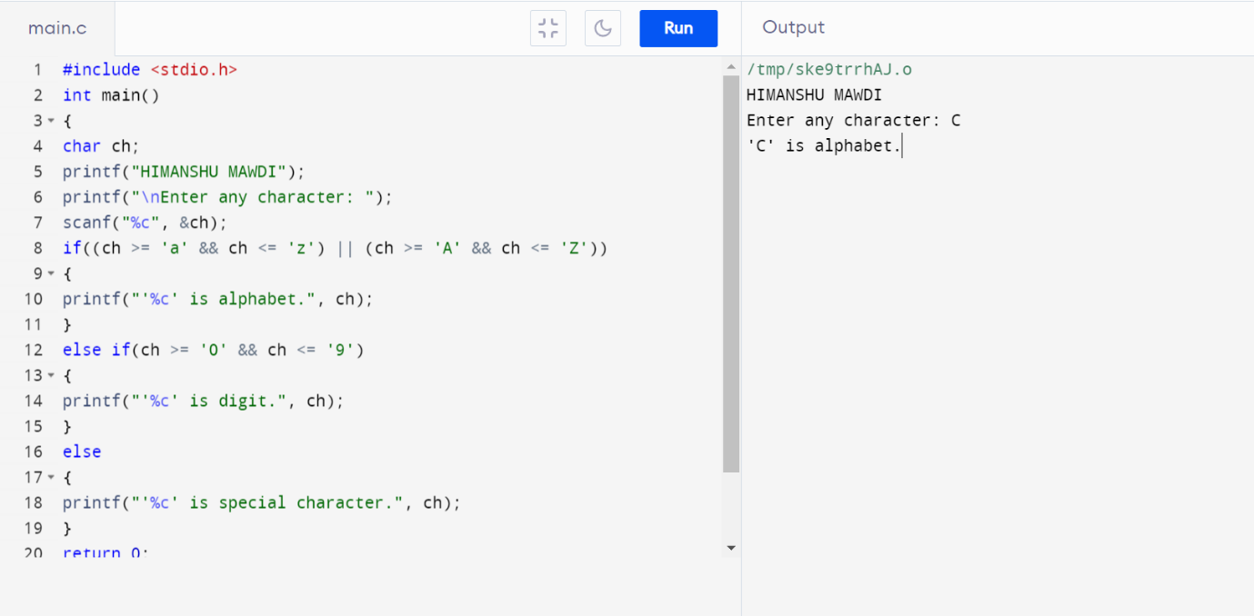

**PROGRAM 75. TO CHECK WHETHER A CHARACTER IS UPPERCASE OR LOWERCASE ALPHABET.**

**#include <stdio.h>**

**int main()**

**{**

**char ch;**

**printf("HIMANSHU MAWDI");**

**printf("\nEnter any character: ");**

**scanf("%c", &ch);**

**if(ch >= 'A' && ch <= 'Z')**

**{**

**printf("'%c' is uppercase alphabet.", ch);**

**}**

**else if(ch >= 'a' && ch <= 'z')**

**{**

**printf("'%c' is lowercase alphabet.", ch);**

**}**

**else**

**{**

**printf("'%c' is not an alphabet.", ch);**

**}**

**return 0;**

**}**

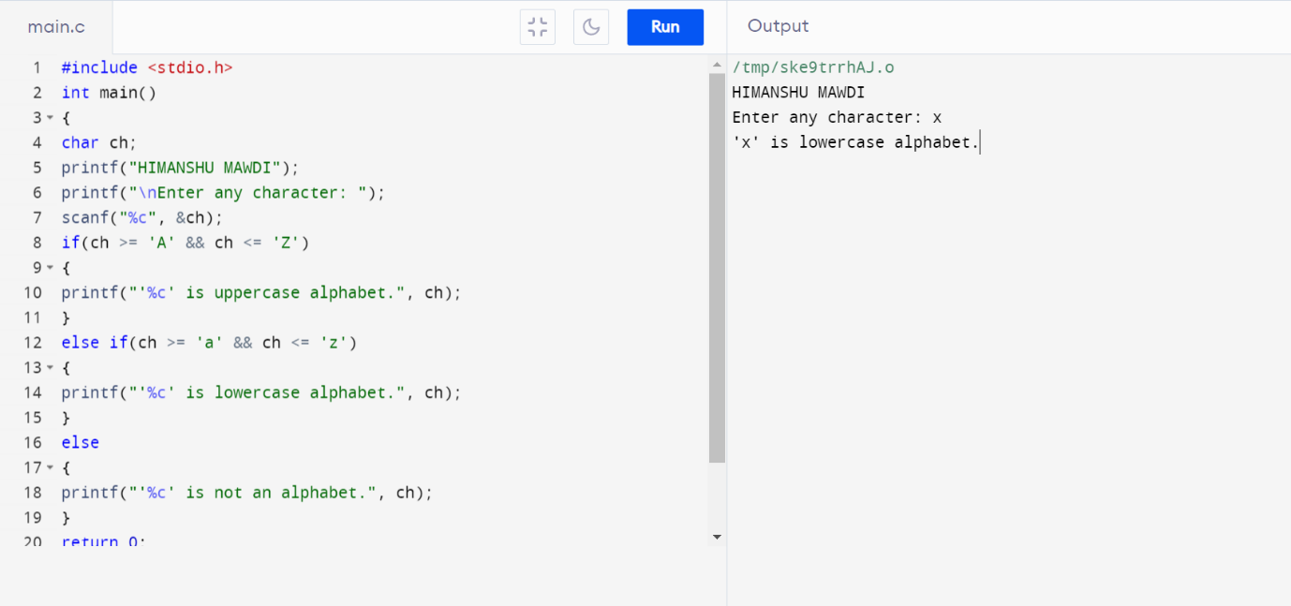

**PROGRAM 76. TO INPUT WEEK NUMBER AND PRINT WEEK DAY.**

**#include <stdio.h>**

**int main()**

**{**

**int week;**

**printf("HIMANSHU MAWDI");**

**printf("\nEnter week number (1-7): ");**

**scanf("%d", &week);**

**if(week == 1)**

**{**

**printf("Monday");**

**}**

**else if(week == 2)**

**{**

**printf("Tuesday");**

**}**

**else if(week == 3)**

**{**

**printf("Wednesday");**

**}**

**else if(week == 4)**

**{**

**printf("Thursday");**

**}**

**else if(week == 5)**

**{**

**printf("Friday");**

**}**

**else if(week == 6)**

**{**

**printf("Saturday");**

**}**

**else if(week == 7)**

**{**

**printf("Sunday");**

**}**

**else**

**{**

**printf("Invalid Input! Please enter week number between 1-7.");**

**}**

**return 0;**

**}**

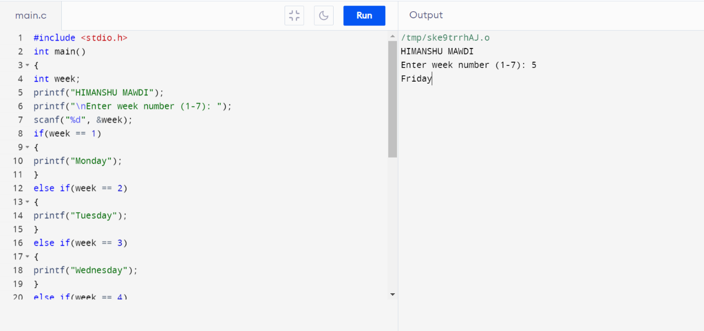

**PROGRAM 77. TO INPUT MONTH NUMBER AND PRINT NUMBER OF DAYS IN THAT MONTH.**

**#include <stdio.h>**

**int main()**

**{**

**int month;**

**printf("HIMANSHU MAWDI");**

**printf("\nEnter month number (1-12): ");**

**scanf("%d", &month);**

**if(month == 1)**

**{**

**printf("31 days");**

**}**

**else if(month == 2)**

**{**

**printf("28 or 29 days");**

**}**

**else if(month == 3)**

**{**

**printf("31 days");**

**}**

**else if(month == 4)**

**{**

**printf("30 days");**

**}**

**else if(month == 5)**

**{**

**printf("31 days");**

**}**

**else if(month == 6)**

**{**

**printf("30 days");**

**}**

**else if(month == 7)**

**{**

**printf("31 days");**

**}**

**else if(month == 8)**

**{**

**printf("31 days");**

**}**

**else if(month == 9)**

**{**

**printf("30 days");**

**}**

**else if(month == 10)**

**{**

**printf("31 days");**

**}**

**else if(month == 11)**

**{**

**printf("30 days");**

**}**

**else if(month == 12)**

**{**

**printf("31 days");**

**}**

**else**

**{**

**printf("Invalid input! Please enter month number between (1-12).");**

**}**

**return 0;**

**}**

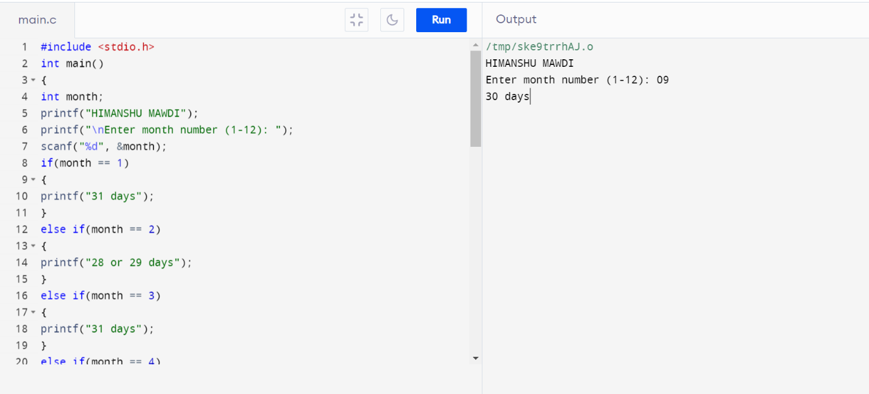

**PROGRAM 78. TO COUNT TOTAL NUMBER OF NOTES IN GIVEN AMOUNT.**

**#include <stdio.h>**

**int main()**

**{**

**int amount;**

**int note500, note100, note50, note20, note10, note5, note2, note1;note500 = note100 = note50 = note20 = note10 = note5 = note2 = note1 = 0;**

**printf("HIMANSHU MAWDI");**

**printf("\nEnter amount: ");**

**scanf("%d", &amount);**

**if(amount >= 500)**

**{**

**note500 = amount/500;**

**amount -= note500 * 500;**

**}**

**if(amount >= 100)**

**{**

**note100 = amount/100;**

**amount -= note100 * 100;**

**}**

**if(amount >= 50)**

**{**

**note50 = amount/50;**

**amount -= note50 * 50;**

**}**

**if(amount >= 20)**

**{**

**note20 = amount/20;**

**amount -= note20 * 20;**

**}**

**if(amount >= 10)**

**{**

**note10 = amount/10;**

**amount -= note10 * 10;**

**}**

**if(amount >= 5)**

**{**

**note5 = amount/5;**

**amount -= note5 * 5;**

**}**

**if(amount >= 2)**

**{**

**note2 = amount /2;**

**amount -= note2 * 2;**

**}**

**if(amount >= 1)**

**{**

**note1 = amount;**

**}**

**printf("Total number of notes = \n");**

**printf("500 = %d\n", note500);**

**printf("100 = %d\n", note100);**

**printf("50 = %d\n", note50);**

**printf("20 = %d\n", note20);**

**printf("10 = %d\n", note10);**

**printf("5 = %d\n", note5);**

**printf("2 = %d\n", note2);**

**printf("1 = %d\n", note1);**

**return 0;**

**}**

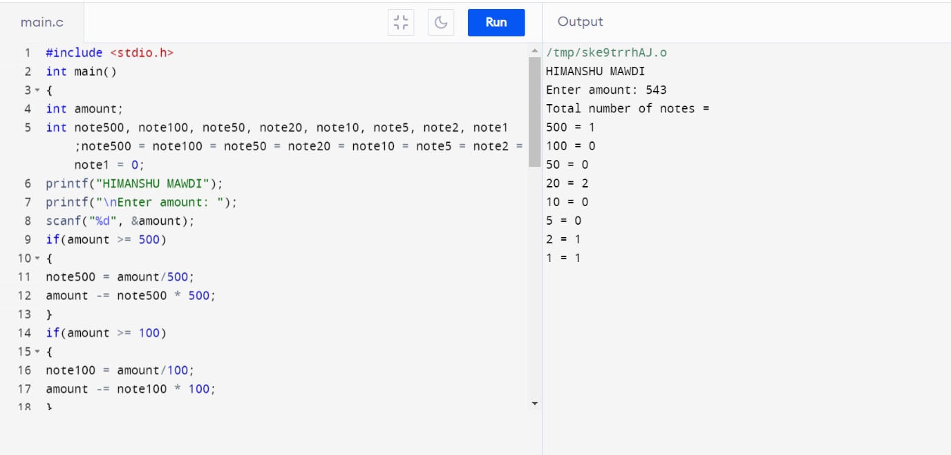

**PROGRAM 79. TO INPUT ANGLES OF A TRIANGLE AND CHECK WHETHER TRIANGLE IS VALID OR NOT.**

**#include <stdio.h>**

**int main()**

**{**

**int angle1, angle2, angle3, sum;**

**printf("HIMANSHU MAWDI");**

**printf("\nEnter three angles of triangle: \n");**

**scanf("%d%d%d", &angle1, &angle2, &angle3);**

**sum = angle1 + angle2 + angle3;**

**if(sum == 180 && angle1 > 0 && angle2 > 0 && angle3 > 0)**

**{**

**printf("Triangle is valid.");**

**}**

**else**

**{**

**printf("Triangle is not valid.");**

**}**

**return 0;**

**}**

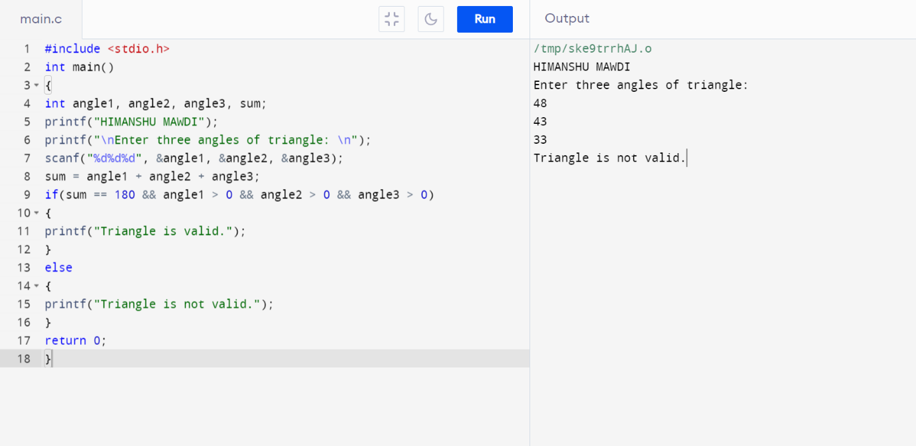

**PROGRAM 80. TO INPUT ALL SIDES OF A TRIANGLE AND CHECK WHETHER TRIANGLE IS VALID OR NOT.**

**#include <stdio.h>**

**int main()**

**{**

**int side1, side2, side3;**

**printf("HIMANSHU MAWDI");**

**printf("\nEnter three sides of triangle: \n");**

**scanf("%d%d%d", &side1, &side2, &side3);**

**if((side1 + side2) > side3)**

**{**

**if((side2 + side3) > side1)**

**{**

**if((side1 + side3) > side2)**

**{**

**printf("Triangle is valid.");**

**}**

**else**

**{**

**printf("Triangle is not valid.");**

**}**

**}**

**else**

**{**

**printf("Triangle is not valid.");**

**}**

**}**

**else**

**{**

**printf("Triangle is not valid.");**

**}**

**return 0;**

**}**

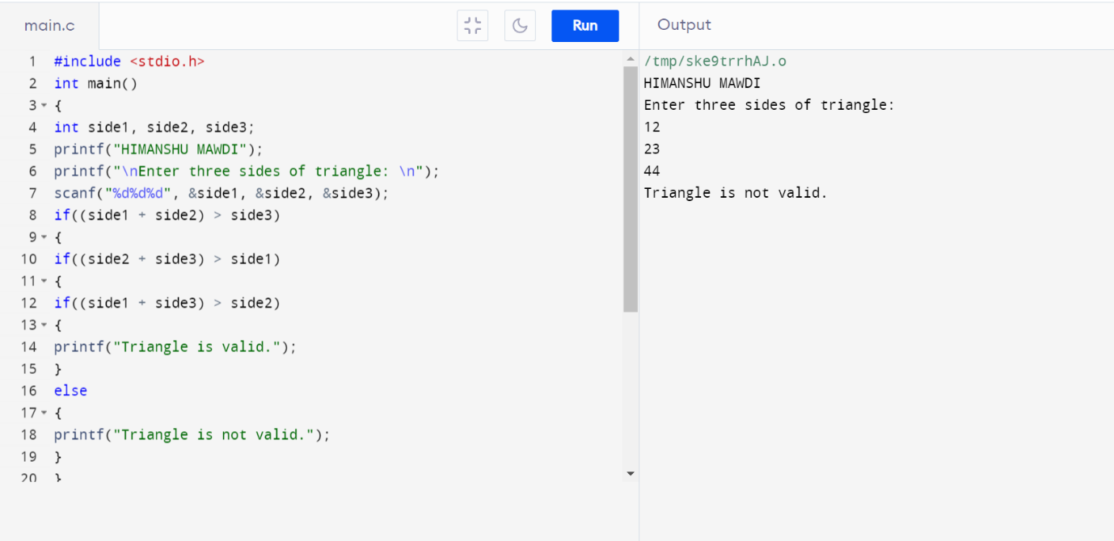

**PROGRAM 81. TO CHECK WHETHER THE TRIANGLE IS EQUILATERAL, ISOSCELES OR SCALENE TRIANGLE.**

**#include <stdio.h>**

**int main()**

**{**

**int side1, side2, side3;**

**printf("HIMANSHU MAWDI");**

**printf("\nEnter three sides of triangle: ");**

**scanf("%d%d%d", &side1, &side2, &side3);**

**if(side1==side2 && side2==side3)**

**{**

**printf("Equilateral triangle.");**

**}**

**else if(side1==side2 || side1==side3 || side2==side3)**

**{**

**printf("Isosceles triangle.");**

**}**

**else**

**{**

**printf("Scalene triangle.");**

**}**

**return 0;**

**}**

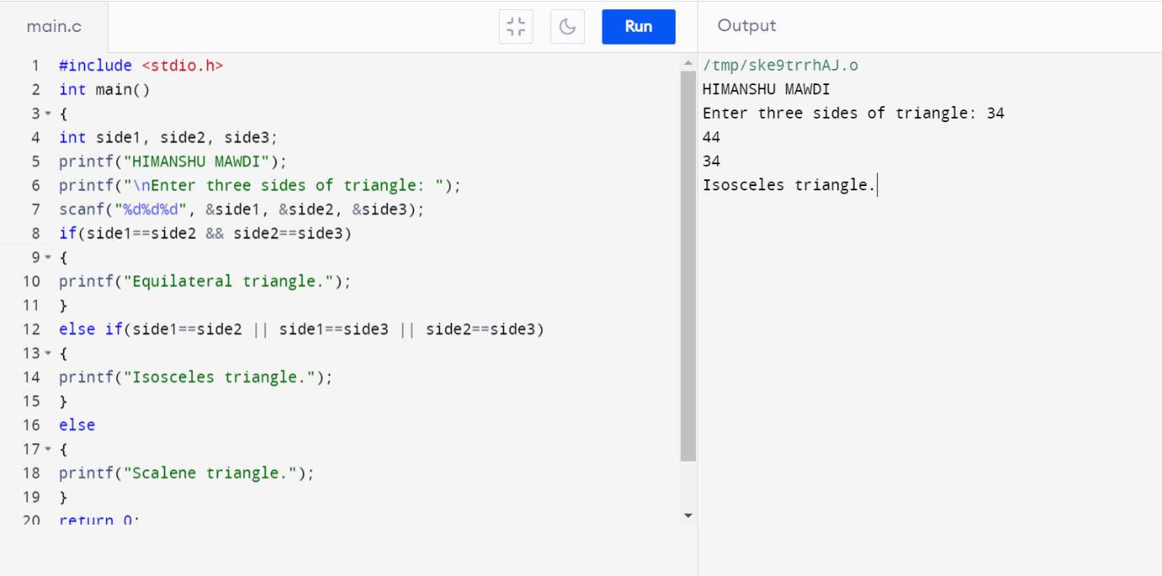

**PROGRAM 82. TO FIND ALL ROOTS OF A QUADRATIC EQUATION.**

**#include <stdio.h>**

**#include <math.h>**

**int main()**

**{**

**float a, b, c;**

**float root1, root2, imaginary;**

**float discriminant;**

**printf("HIMANSHU MAWDI");**

**printf("\nEnter values of a, b, c of quadratic equation (aX^2 + bX + c): ");**

**scanf("%f%f%f", &a, &b, &c);**

**discriminant = (b * b) - (4 * a * c);**

**if(discriminant > 0)**

**{**

**root1 = (-b + sqrt(discriminant)) / (2*a);**

**root2 = (-b - sqrt(discriminant)) / (2*a);**

**printf("Two distinct and real roots exists: %.2f and %.2f", root1, root2);**

**}**

**else if(discriminant == 0)**

**{**

**root1 = root2 = -b / (2 * a);**

**printf("Two equal and real roots exists: %.2f and %.2f", root1, root2);**

**}**

**else if(discriminant < 0)**

**{**

**root1 = root2 = -b / (2 * a);**

**imaginary = sqrt(-discriminant) / (2 * a);**

**printf("Two distinct complex roots exists: %.2f + i%.2f and %.2f - i%.2f", root1, imaginary, root2, imaginary);**

**}**

**return 0;**

**}**

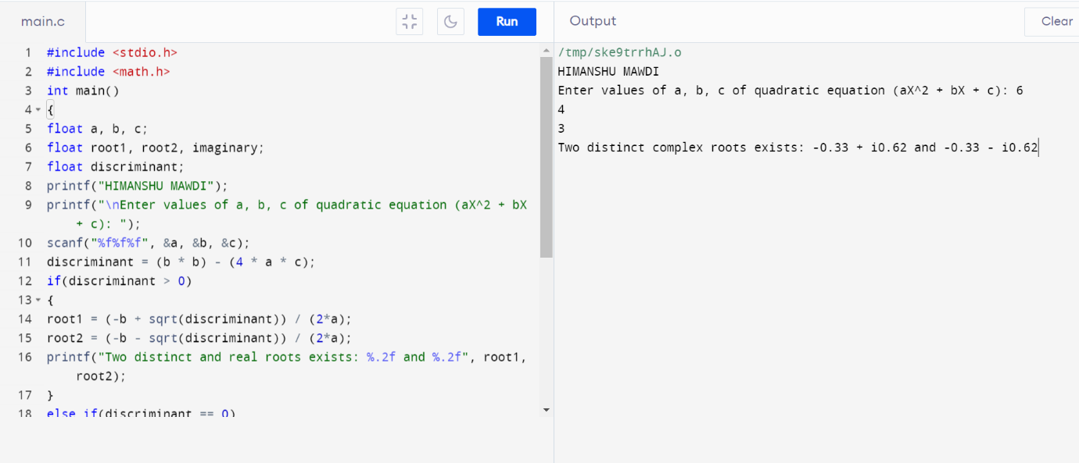

**PROGRAM 83. TO CALCULATE PROFIT OR LOSS.**

**#include <stdio.h>**

**int main()**

**{**

**int cp,sp, amt;**

**printf("HIMANSHU MAWDI");**

**printf("\nEnter cost price: ");**

**scanf("%d", &cp);**

**printf("Enter selling price: ");**

**scanf("%d", &sp);**

**if(sp > cp)**

**{**

**amt = sp - cp;**

**printf("Profit = %d", amt);**

**}**

**else if(cp > sp)**

**{**

**amt = cp - sp;**

**printf("Loss = %d", amt);**

**}**

**else**

**{**

**printf("No Profit No Loss.");**

**}**

**return 0;**

**}**

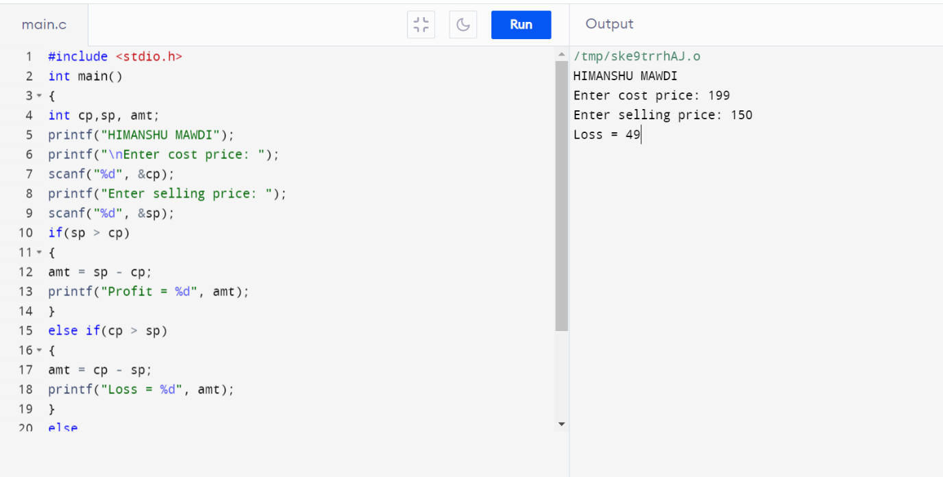

**PROGRAM 84. TO INPUT MARKS OF FIVE SUBJECTS PHYSICS, CHEMISTRY, BIOLOGY, MATHEMATICS AND COMPUTER. CALCULATE PERCENTAGE AND GRADE ACCORDING TO FOLLOWING:**

**PERCENTAGE >= 90% : GRADE A**

**PERCENTAGE >= 80% : GRADE B**

**PERCENTAGE >= 70% : GRADE C**

**PERCENTAGE >= 60% : GRADE D**

**PERCENTAGE >= 40% : GRADE E**

**PERCENTAGE < 40% : GRADE F**

**#include <stdio.h>**

**int main()**

**{**

**int phy, chem, bio, math, comp;**

**float per;**

**printf("HIMANSHU MAWDI");**

**printf("\nEnter five subjects marks: ");**

**scanf("%d%d%d%d%d", &phy, &chem, &bio, &math, &comp);**

**per = (phy + chem + bio + math + comp) / 5.0;**

**printf("Percentage = %.2f\n", per);**

**if(per >= 90)**

**{**

**printf("Grade A");**

**}**

**else if(per >= 80)**

**{**

**printf("Grade B");**

**}**

**else if(per >= 70)**

**{**

**printf("Grade C");**

**}**

**else if(per >= 60)**

**{**

**printf("Grade D");**

**}**

**else if(per >= 40)**

**{**

**printf("Grade E");**

**}**

**else**

**{**

**printf("Grade F");**

**}**

**return 0;**

**}**

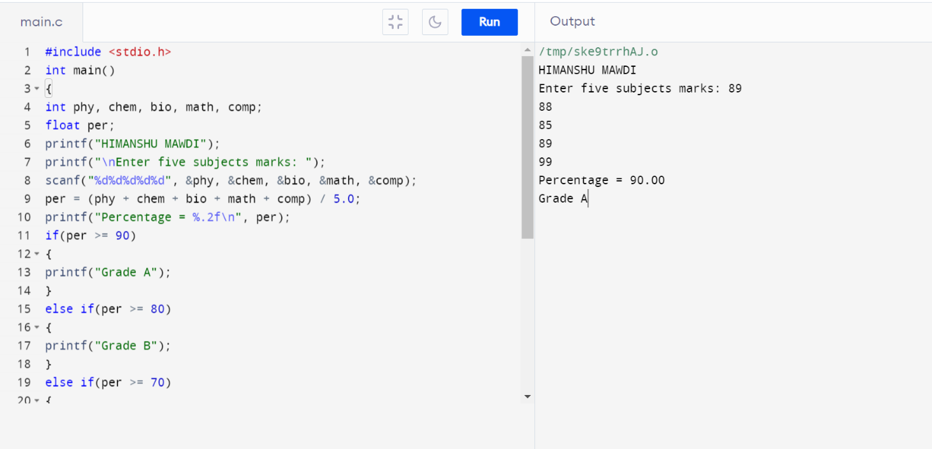

**PROGRAM 85. TO INPUT BASIC SALARY OF AN EMPLOYEE AND CALCULATE ITS GROSS SALARY ACCORDING TO FOLLOWING:**

**BASIC SALARY <= 10000 : HRA = 20%,**

**DA = 80% BASIC SALARY <= 20000 : HRA = 25%,**

**DA = 90% BASIC SALARY > 20000 : HRA = 30%,**

**DA = 95%**

**#include <stdio.h>**

**int main()**

**{**

**float basic, gross, da, hra;**

**printf("HIMANSHU MAWDI");**

**printf("\nEnter basic salary of an employee: ");**

**scanf("%f", &basic);**

**if(basic <= 10000)**

**{**

**da = basic * 0.8;**

**hra = basic * 0.2;**

**}**

**else if(basic <= 20000)**

**{**

**da = basic * 0.9;**

**hra = basic * 0.25;**

**}**

**else**

**{**

**da = basic * 0.95;**

**hra = basic * 0.3;**

**}**

**gross = basic + hra + da;**

**printf("GROSS SALARY OF EMPLOYEE = %.2f", gross);**

**return 0;**

**}**

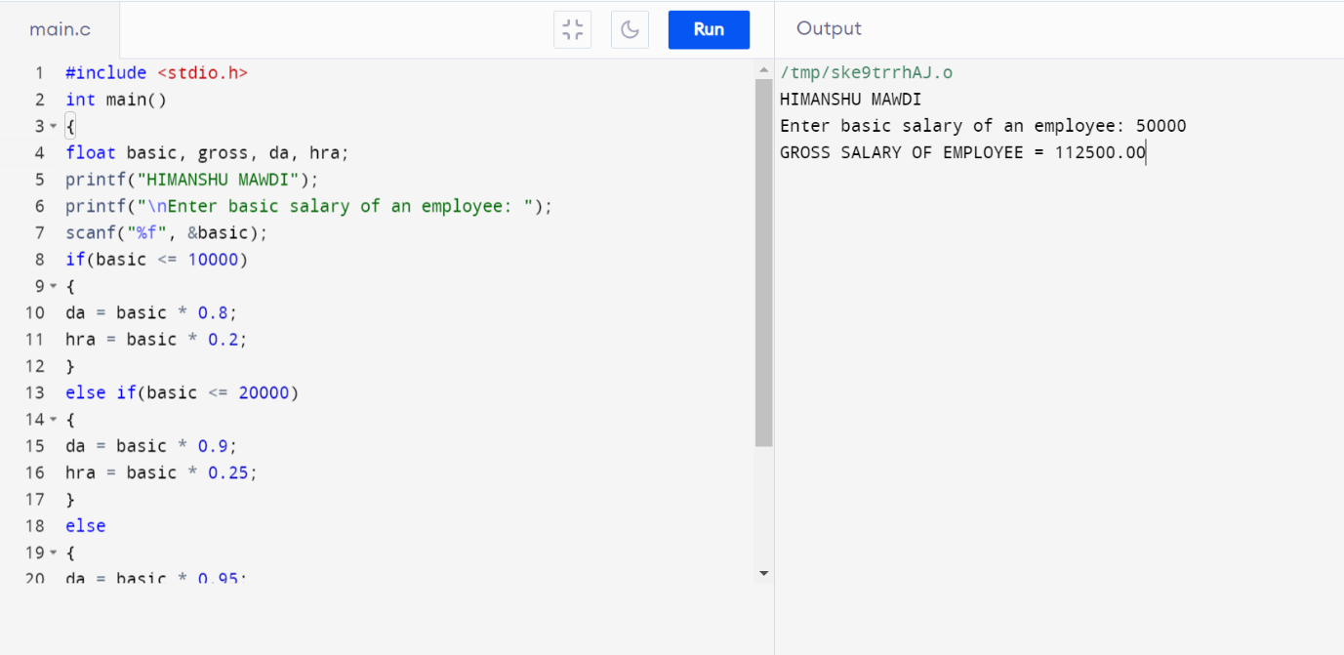

**PROGRAM 86. TO INPUT ELECTRICITY UNIT CHARGES AND CALCULATE TOTAL ELECTRICITY BILL ACCORDING TO THE GIVEN CONDITION:**

**FOR FIRST 50 UNITS RS. 0.50/UNIT**

**FOR NEXT 100 UNITS RS. 0.75/UNIT**

**FOR NEXT 100 UNITS RS. 1.20/UNIT**

**FOR UNIT ABOVE 250 RS. 1.50/UNIT**

**AN ADDITIONAL SURCHARGE OF 20% IS ADDED TO THE BILL**

**#include <stdio.h>**

**int main()**

**{**

**int unit;**

**float amt, total_amt, sur_charge;**

**printf("HIMANSHU MAWDI");**

**printf("\nEnter total units consumed: ");**

**scanf("%d", &unit);**

**if(unit <= 50)**

**{**

**amt = unit * 0.50;**

**}**

**else if(unit <= 150)**

**{**

**amt = 25 + ((unit-50) * 0.75);**

**}**

**else if(unit <= 250)**

**{**

**amt = 100 + ((unit-150) * 1.20);**

**}**

**else**

**{**

**amt = 220 + ((unit-250) * 1.50);**

**}**

**sur_charge = amt * 0.20;**

**total_amt = amt + sur_charge;**

**printf("Electricity Bill = Rs. %.2f", total_amt);**

**return 0;**

**}**

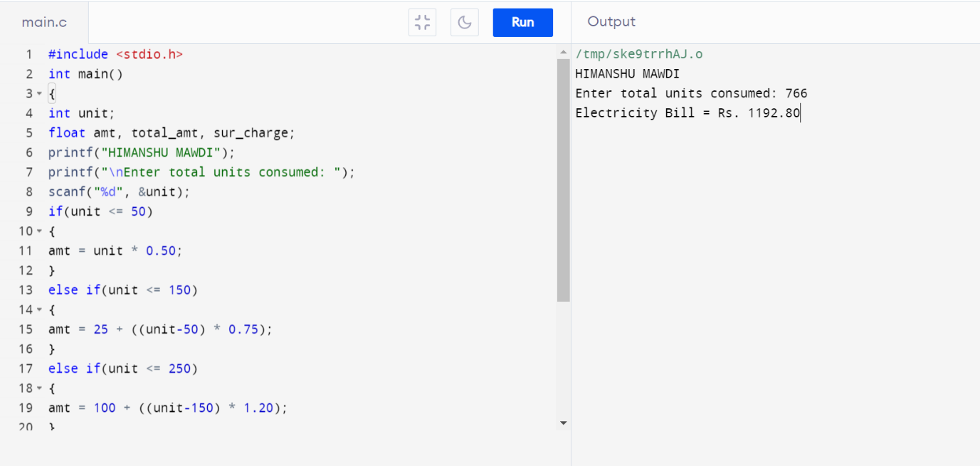

**PROGRAM 87.TO CONVERT SPECIFIED DAYS INTO YEARS, WEEKS AND DAYS.**

**#include <stdio.h>**

**int main()**

**{**

**int days, years, weeks;**

**printf("HIMANSHU MAWDI");**

**days = 1329;**

**years = days/365;**

**weeks = (days % 365)/7;**

**days = days- ((years*365) + (weeks*7));**

**printf("\nYears: %d\n", years);**

**printf("Weeks: %d\n", weeks);**

**printf("Days: %d \n", days);**

**return 0;**

**}**

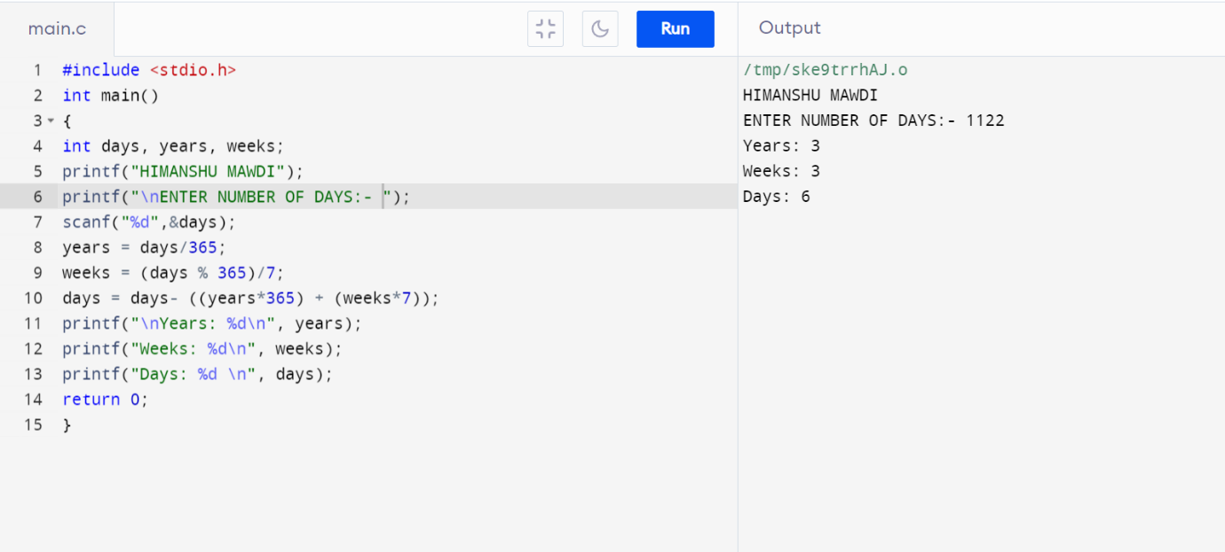

**Pattern Exercises *STAR PATTERN PROGRAMS***

**PROGRAM 88. PYRAMID STAR PATTERN**

**#include <stdio.h>**

**int main()**

**{**

**int i, j, rows;**

**printf("HIMANSHU MAWDI");**

**printf("\nEnter number of rows : ");**

**scanf("%d", &rows);**

**for(i=1; i<=rows; i++)**

**{**

**for(j=i; j<rows; j++)**

**{**

**printf(" ");**

**}**

**for(j=1; j<=(2*i-1); j++)**

**{**

**printf("*");**

**}**

**printf("\n");**

**}**

**return 0;**

**}**

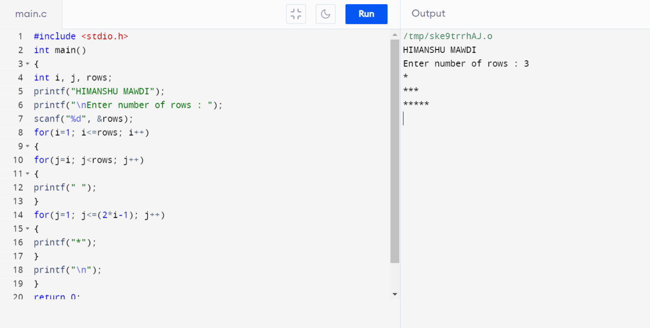

**PROGRAM 89.HOLLOW PYRAMID STAR PATTERN**

**#include <stdio.h>**

**int main()**

**{**

**int i, j, rows;**

**printf("HIMANSHU MAWDI");**

**printf("\nEnter number of rows : ");**

**scanf("%d", &rows);**

**for(i=1; i<=rows; i++)**

**{**

**for(j=i; j<rows; j++)**

**{**

**printf(" ");**

**}**

**for(j=1; j<=(2*i-1); j++)**

**{**

**if(i==rows || j==1 || j==(2*i-1))**

**{**

**printf("*");**

**}**

**else**

**{**

**printf(" ");**

**}**

**}**

**printf("\n");**

**}**

**return 0;**

**}**

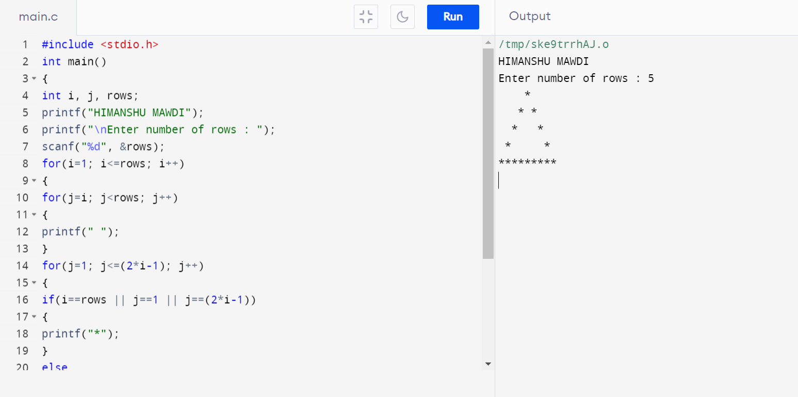

**PROGRAM 90. INVERTED PYRAMID STAR PATTERN**

**#include <stdio.h>**

**int main()**

**{**

**int i, j, rows;**

**printf("HIMANSHU MAWDI");**

**printf("\nEnter number of rows : ");**

**scanf("%d", &rows);**

**for(i=1; i<=rows; i++)**

**{**

**for(j=1; j<i; j++)**

**{**

**printf(" ");**

**}**

**for(j=1; j<=(rows*2 -(2*i-1)); j++)**

**{**

**printf("*");**

**}**

**printf("\n");**

**}**

**Return 0;**

**}**

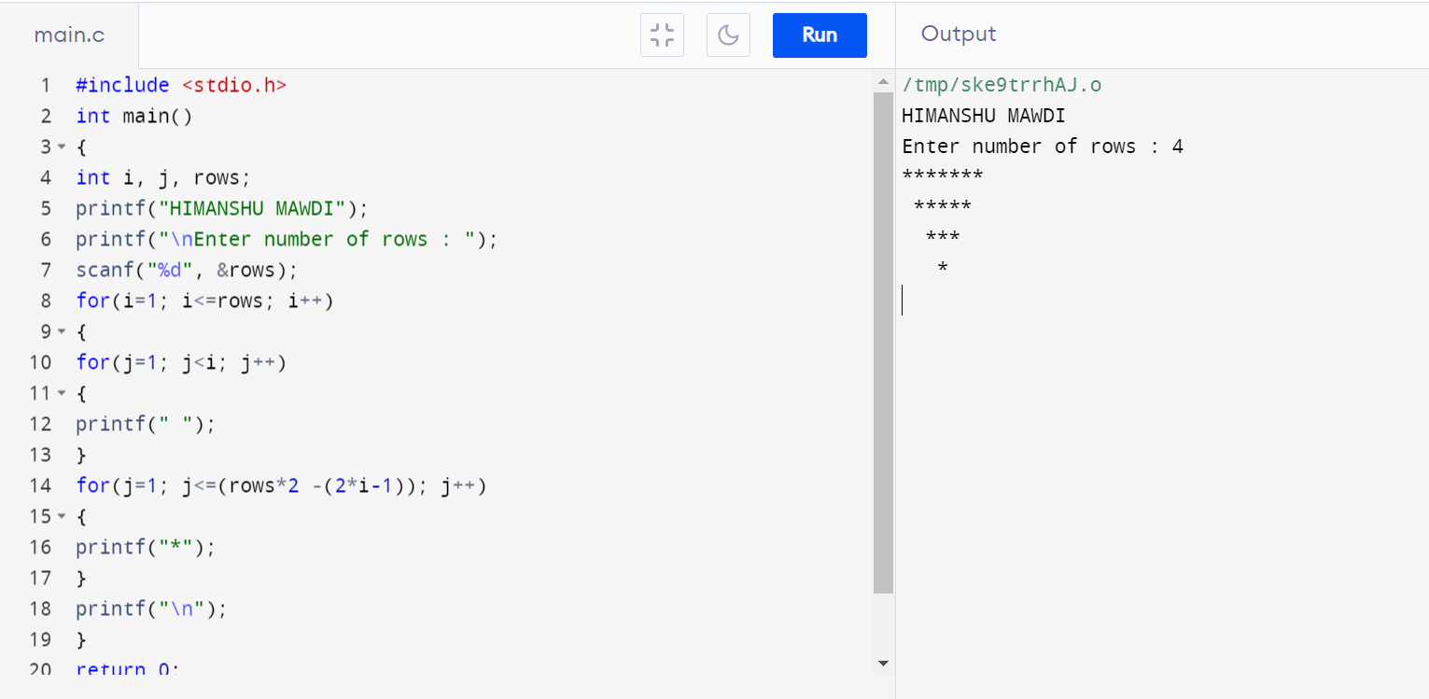

**PROGRAM 91.HOLLOW INVERTED STAR PATTERN**

**#include <stdio.h>**

**int main()**

**{**

**int i, j, rows;**

**printf("HIMANSHU MAWDI");**

**printf("\nEnter number of rows: ");**

**scanf("%d", &rows);**

**for(i=1; i<=rows; i++)**

**{**

**for(j=1; j<i; j++)**

**{**

**printf(" ");**

**}**

**for(j=1; j<=(rows*2 - (2*i-1)); j++)**

**{**

**if(i==1 || j==1 || j==(rows*2 - (2*i - 1)))**

**{**

**printf("*");**

**}**

**else**

**{**

**printf(" ");**

**}**

**}**

**printf("\n");**

**}**

**return 0;**

**}**

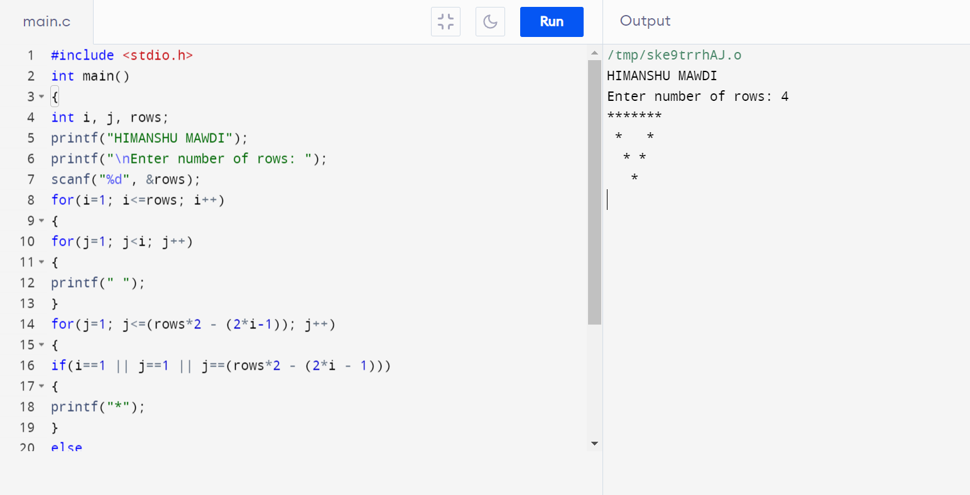

**PROGRAM 92.HALF DIAMOND STAR PATTERN**

**#include<stdio.h>**

**int main()**

**{**

**int i, j, N, columns;**

**printf("HIMANSHU MAWDI");**

**printf("\nEnter number of columns:");**

**scanf("%d",&N);**

**columns=1;**

**for(i=1;i<N*2;i++)**

**{**

**for(j=1; j<=columns; j++)**

**{**

**printf("*");**

**}**

**if(i < N)**

**{**

**columns++;**

**}**

**else**

**{**

**columns--;**

**}**

**printf("\n");**

**}**

**return 0;**

**}**

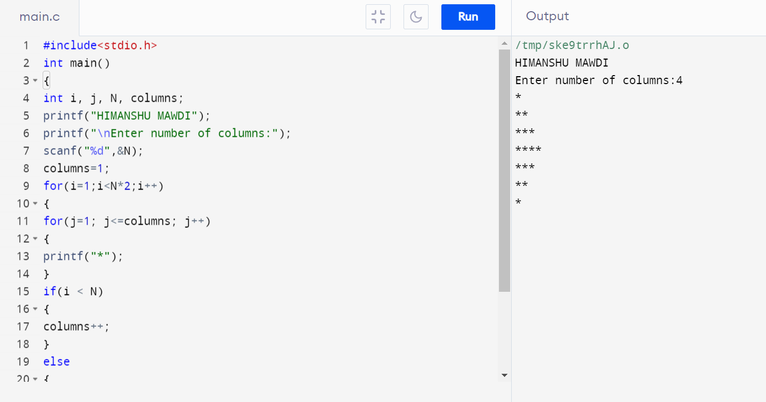

**PROGRAM 93.MIRRORED HALF DIAMOND STAR PATTERN**

**#include <stdio.h>**

**int main()**

**{**

**int i, j, N;**

**int star, spaces;**

**printf("HIMANSHU MAWDI");**

**printf("\nEnter number of columns : ");**

**scanf("%d", &N);**

**spaces = N-1;**

**star = 1;**

**for(i=1; i<N*2; i++)**

**{**

**for(j=1; j<=spaces; j++)**

**printf(" ");**

**for(j=1; j<=star; j++)**

**printf("*");**

**printf("\n");**

**if(i < N)**

**{**

**star++;**

**spaces--;**

**}**

**else**

**{**

**star--;**

**spaces++;**

**}**

**}**

**return 0;**

**}**

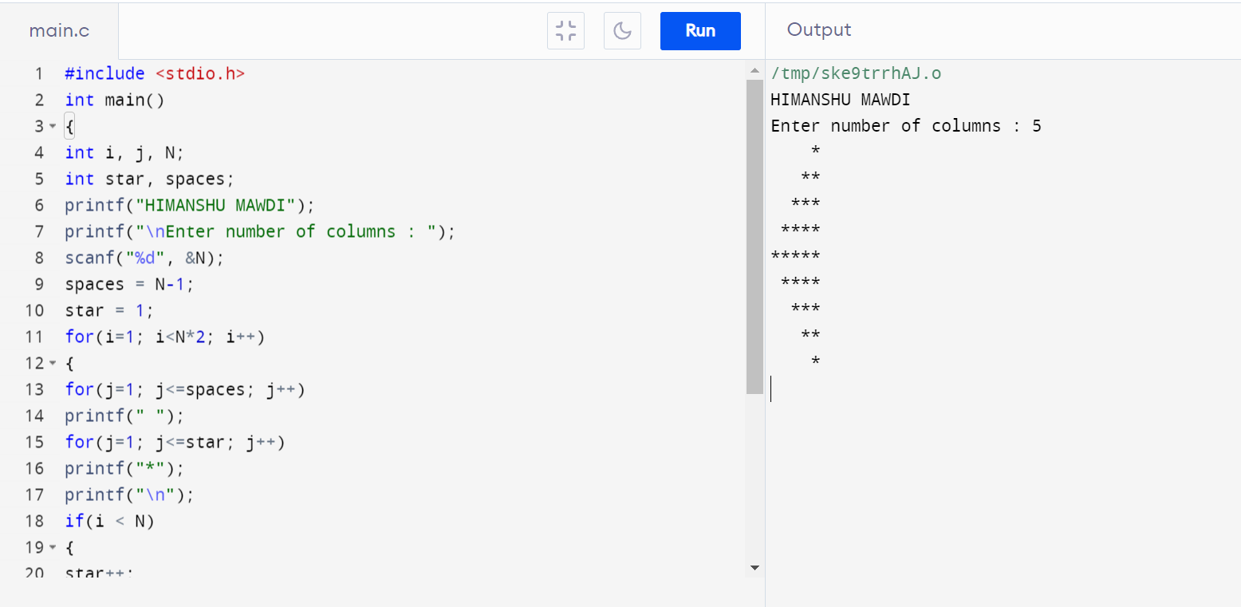

***NUMBER PATTERN PROGRAMS –***

**PROGRAM 94. NUMBER PATTERN 1**

**11111**

**11111**

**11111**

**11111**

**11111**

**#include <stdio.h>**

**int main()**

**{**

**int rows, cols, i, j;**

**printf("HIMANSHU MAWDI");**

**printf("\nEnter number of rows: ");**

**scanf("%d", &rows);**

**printf("Enter number of columns: ");**

**scanf("%d", &cols);**

**for(i=1; i<=rows; i++)**

**{**

**for(j=1; j<=cols; j++)**

**{**

**printf("1 ");**

**}**

**printf("\n");**

**}**

**return 0;**

**}**

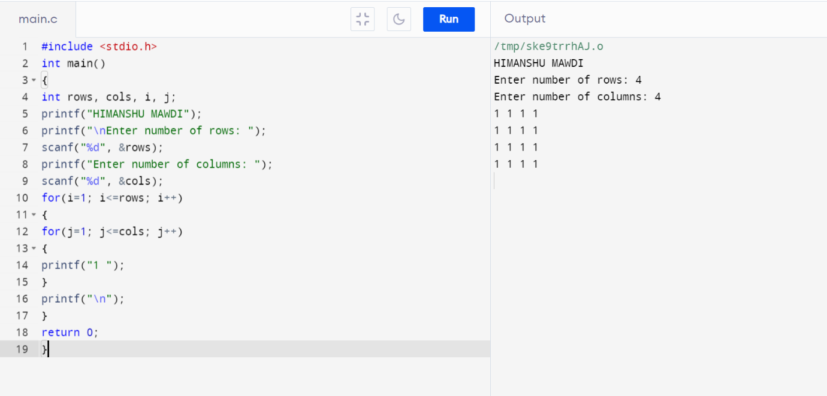

**PROGRAM 95.NUMBER PATTERN 2**

**11111**

**00000**

**11111**

**00000**

**11111**

**#include <stdio.h>**

**int main()**

**{**

**int rows, cols, i, j;**

**printf("HIMANSHU MAWDI");**

**printf("\nEnter number of rows: ");**

**scanf("%d", &rows);**

**printf("\nEnter number of columns: ");**

**scanf("%d", &cols);**

**for(i=1; i<=rows; i++)**

**{**

**for(j=1; j<=cols; j++)**

**{**

**if(i%2 == 1)**

**{**

**printf("1 ");**

**}**

**else**

**{**

**printf("0 ");**

**}**

**}**

**printf("\n");**

**}**

**return 0;**

**}**

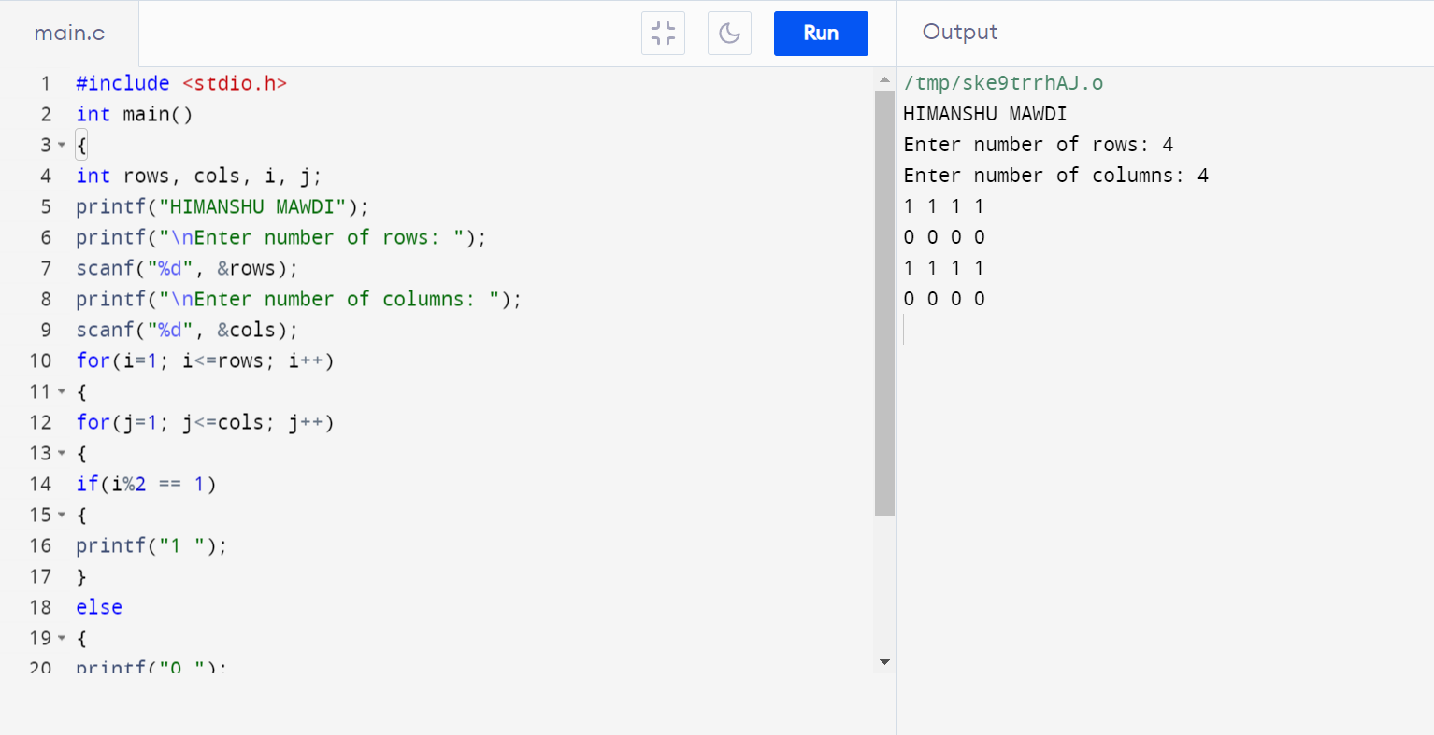

**PROGRAM 96.NUMBER PATTERN 3**

**01010**

**01010**

**01010**

**01010**

**01010**

**#include <stdio.h>**

**int main()**

**{**

**int rows, cols, i, j;**

**printf("HIMANSHU MAWDI");**

**printf("\nEnter number of rows: ");**

**scanf("%d", &rows);**

**printf("\nEnter number of columns: ");**

**scanf("%d", &cols);**

**for(i=1; i<=rows; i++)**

**{**

**for(j=1; j<=cols; j++)**

**{**

**if(j%2 == 1)**

**{**

**printf("0 ");**

**}**

**else**

**{**

**printf("1 ");**

**}**

**}**

**printf("\n");**

**}**

**return 0;**

**}**

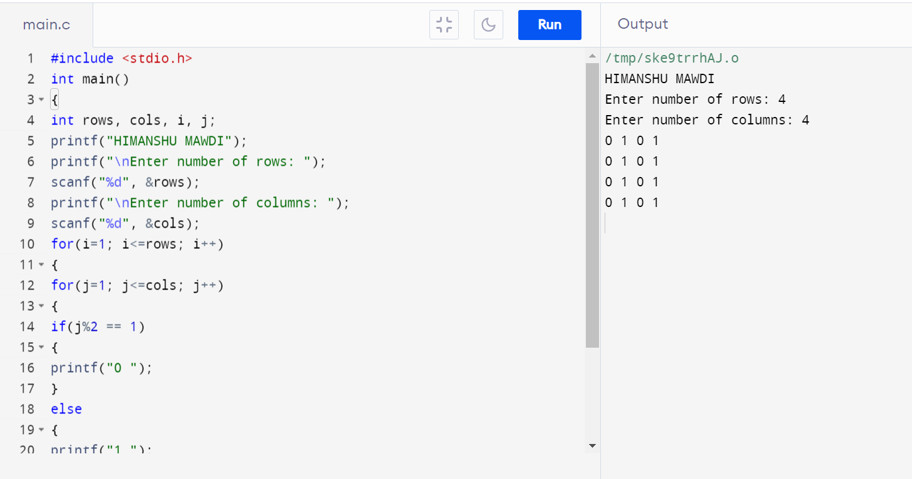

**PROGRAM 97.NUMBER PATTERN 4**

**11111**

**10001**

**10001**

**10001**

**11111**

**#include <stdio.h>**

**int main()**

**{**

**int rows, cols, i, j;**

**printf("HIMANSHU MAWDI");**

**printf("\nEnter number of rows: ");**

**scanf("%d", &rows);**

**printf("Enter number of columns: ");**

**scanf("%d", &cols);**

**for(i=1; i<=rows; i++)**

**{**

**for(j=1; j<=cols; j++)**

**{**

**if(i==1 || i==rows || j==1 || j==cols)**

**{**

**printf("1 ");**

**}**

**else**

**{**

**printf("0 ");**

**}**

**}**

**printf("\n");**

**}**

**return 0;**

**}**

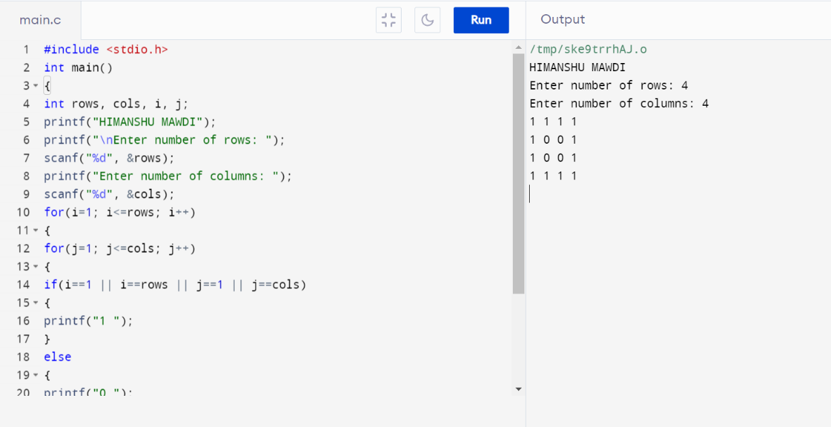

**PROGRAM 98.NUMBER PATTERN 5**

**11111**

**11111**

**11011**

**11111**

**11111**

**#include <stdio.h>**

**int main()**

**{**

**int rows, cols, i, j;**

**int centerRow, centerCol;**

**printf("HIMANSHU MAWDI");**

**printf("\nEnter number of rows: ");**

**scanf("%d", &rows);**

**printf("Enter number of columns: ");**

**scanf("%d", &cols);**

**centerRow = (rows + 1) / 2;**

**centerCol = (cols + 1) / 2;**

**for(i=1; i<=rows; i++)**

**{**

**for(j=1; j<=cols; j++)**

**{**

**if(centerCol == j && centerRow == i)**

**{**

**printf("0 ");**

**}**

**else if(cols%2 == 0 && centerCol+1 == j)**

**{**

**if(centerRow == i || (rows%2 == 0 && centerRow+1 == i))**

**printf("0 ");**

**else**

**printf("1 ");**

**}**

**else if(rows%2 == 0 && centerRow+1 == i)**

**{**

**if(centerCol == j || (cols%2 == 0 && centerCol+1 == j))**

**printf("0 ");**

**else**

**printf("1 ");**

**}**

**else**

**{**

**printf("1 ");**

**}**

**}**

**printf("\n");**

**}**

**return 0;**

**}**

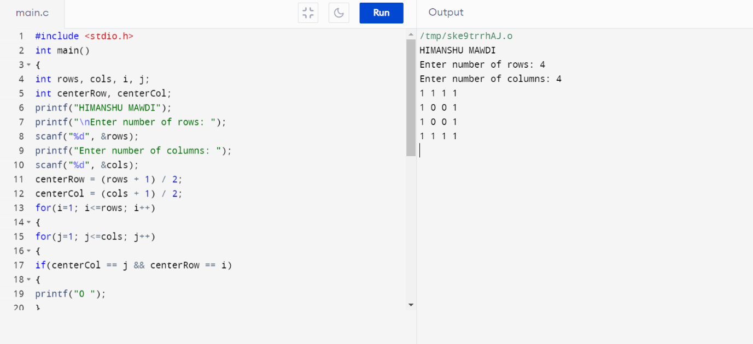

**PROGRAM 99.NUMBER PATTERN 6**

**10101**

**01010**

**10101**

**01010**

**10101**

**#include <stdio.h>**

**int main()**

**{**

**int rows, cols, i, j, k;**

**printf("HIMANSHU MAWDI");**

**printf("\nEnter number of rows: ");**

**scanf("%d", &rows);**

**printf("Enter number of columns: ");**

**scanf("%d", &cols);**

**k = 1;**

**for(i=1; i<=rows; i++)**

**{**

**for(j=1; j<=cols; j++)**

**{**

**if(k == 1)**

**{**

**printf("1 ");**

**}**

**else**

**{**

**printf("0 ");**

**}**

**k *= -1;**

**}**

**if(cols % 2 == 0)**

**{**

**k *= -1;**

**}**

**printf("\n");**

**}**

**return 0;**

**}**

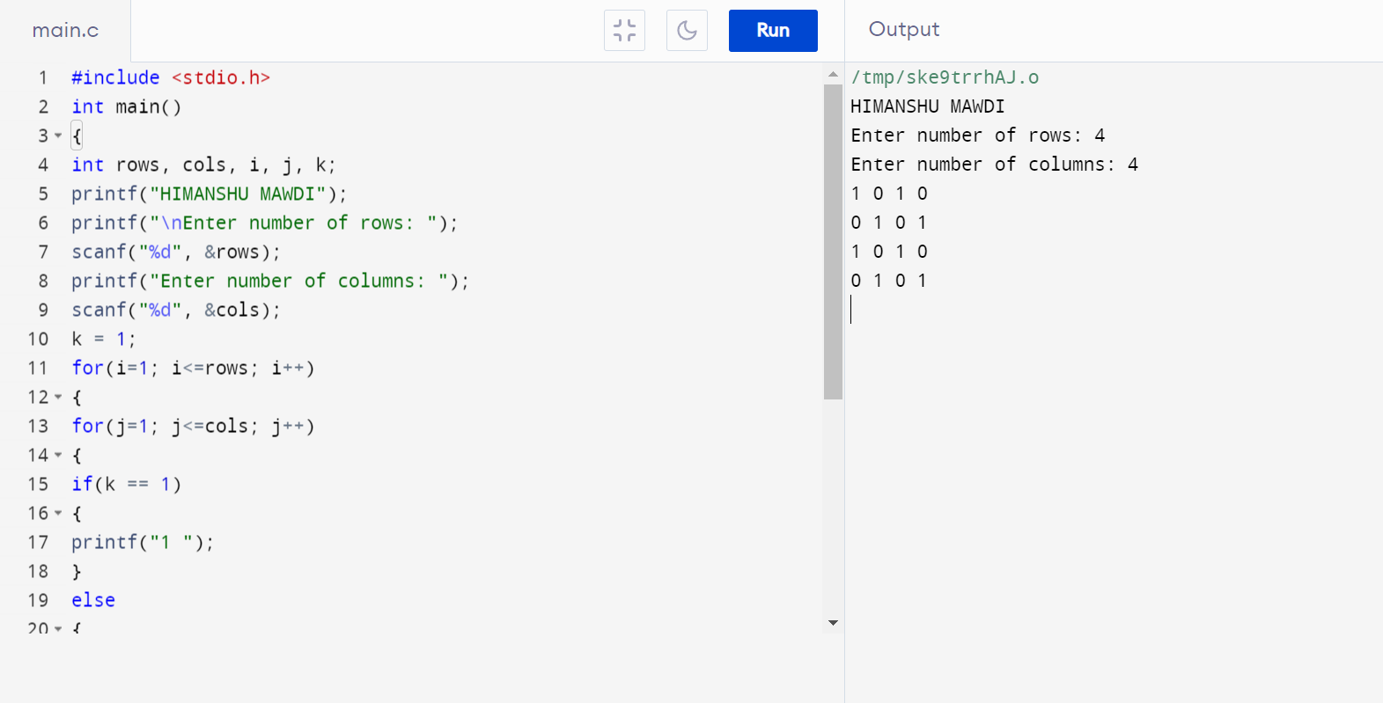

**PROGRAM 100**.  **TO READ N NUMBER OF VALUES IN AN ARRAY AND DISPLAY THEM IN REVERSE ORDER.**

**#include <stdio.h>**

**int main() {**

**int b, c, a[100];**

**printf("HIMANSHU MAWDI");**

**printf("\nEnter the number of elements in the array: ");**

**scanf("%d", &b);**

**printf("Enter %d integers\n", b);**

**for (c = 0; c < b; c++) {**

**scanf("%d", &a[c]);**

**}**

**printf("The elements in reverse order are:\n");**

**for (c = b - 1; c >= 0; c--) {**

**printf("%d\n", a[c]);**

**}**

**return 0;**

**}**

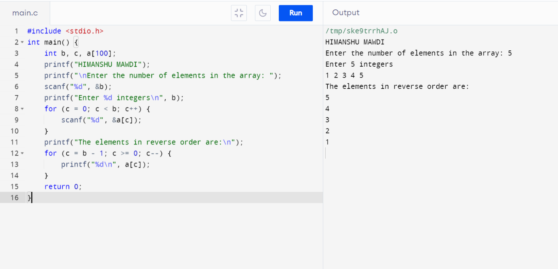

**PROGRAM 101. TO FIND THE SUM OF ALL ELEMENTS OF THE ARRAY.**

**#include <stdio.h>**

**int main()**

**{**

**printf("HIMANSHU MAWDI");**

**int n, sum = 0;**

**printf("\nEnter the number of elements in the array: ");**

**scanf("%d", &n);**

**int arr[n];**

**printf("Enter %d integers\n", n);**

**for (int i = 0; i < n; i++) {**

**scanf("%d", &arr[i]);**

**sum += arr[i];**

**}**

**printf("The sum of the elements in the array is: %d\n", sum);**

**return 0;**

**}**

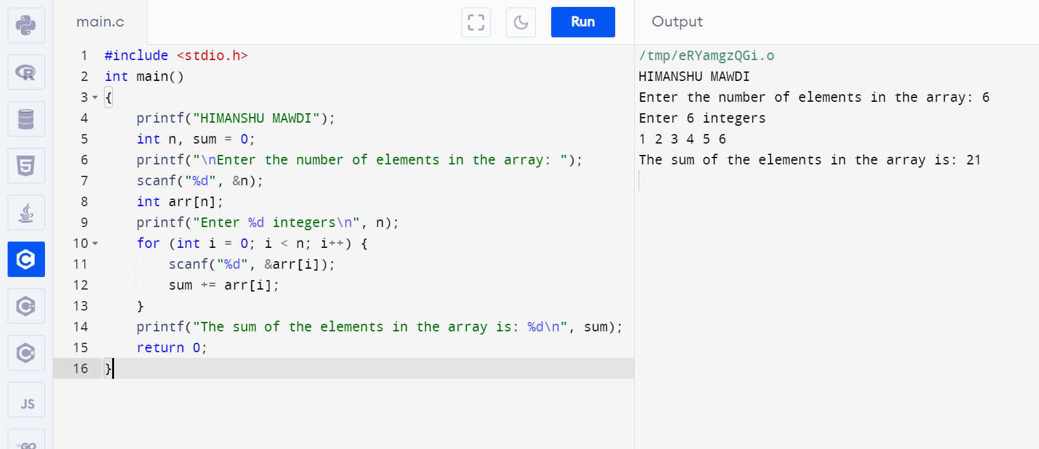

**PROGRAM 102. TO COPY THE ELEMENTS OF ONE ARRAY INTO ANOTHER ARRAY.**

**#include <stdio.h>**

**int main()**

**{**

**int n, i;**

**printf("HIMANSHU MAWDI");**

**printf("\nEnter the number of elements in the array: ");**

**scanf("%d", &n);**

**int array[n];**

**int copiedarray[n];**

**printf("Enter %d integers for the source array\n", n);**

**for (i = 0; i < n; i++) {**

**scanf("%d", &array[i]);**

**}**

**for (i = 0; i < n; i++) {**

**copiedarray[i] = array[i];**

**}**

**printf("Elements copied from source array to destination array are: \n");**

**for (i = 0; i < n; i++) {**

**printf("%d ", copiedarray[i]);**

**}**

**printf("\n");**

**return 0;**

**}**

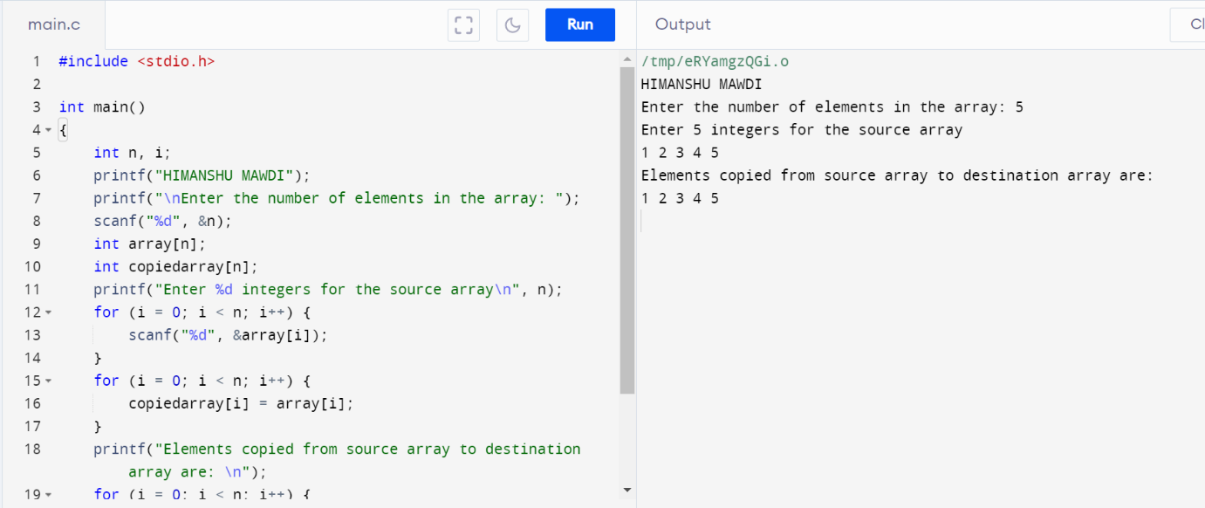

**PROGRAM 103. TO COUNT THE TOTAL NUMBER OF DUPLICATE ELEMENTS IN AN ARRAY.**

**#include <stdio.h>**

**int main()**

**{**

**int n, i, j, count = 0;**

**printf("HIMANSHU MAWDI");**

**printf("\nEnter the number of elements in the array: ");**

**scanf("%d", &n);**

**int arr[n];**

**int duplicate[n];**

**printf("Enter %d integers\n", n);**

**for (i = 0; i < n; i++) {**

**scanf("%d", &arr[i]);**

**duplicate[i] = -1;**

**}**

**for (i = 0; i < n; i++) {**

**int currentElement = arr[i];**

**int duplicateCount = 1;**

**for (j = i + 1; j < n; j++) {**

**if (currentElement == arr[j]) {**

**duplicateCount++;**

**duplicate[j] = 0;**

**}**

**}**

**if (duplicate[i] != 0) {**

**duplicate[i] = duplicateCount;**

**}**

**}**

**for (i = 0; i < n; i++) {**

**if (duplicate[i] > 1) {**

**count++;**

**}**

**}**

**printf("The total number of duplicate elements in the array is: %d\n", count);**

**return 0;**

**}**

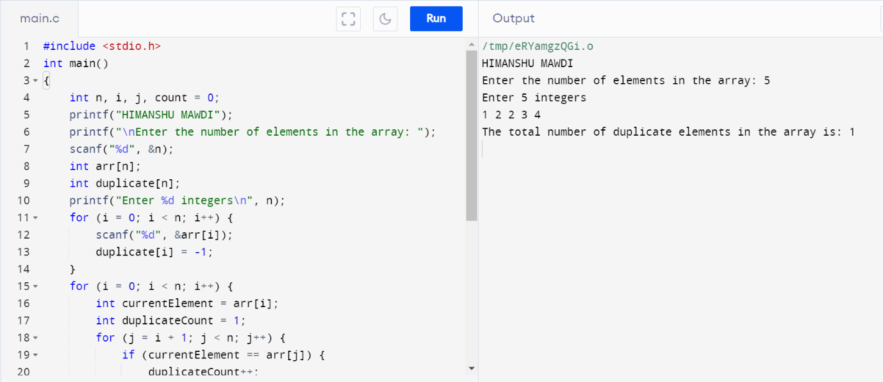

**PROGRAM 104. TO FIND THE MAXIMUM AND MINIMUM ELEMENTS IN AN ARRAY.**

**#include <stdio.h>**

**int main()**

**{**

**int n, i;**

**printf("HIMANSHU MAWDI");**

**printf("\nEnter the number of elements in the array: ");**

**scanf("%d", &n);**

**int arr[n];**

**printf("Enter %d integers\n", n);**

**for (i = 0; i < n; i++) {**

**scanf("%d", &arr[i]);**

**}**

**int maximum = arr[0];**

**int minimum = arr[0];**

**for (i = 1; i < n; i++) {**

**if (arr[i] > maximum) {**

**maximum = arr[i];**

**}**

**if (arr[i] < minimum) {**

**minimum = arr[i];**

**}**

**}**

**printf("The maximum element in the array is: %d\n", maximum);**

**printf("The minimum element in the array is: %d\n", minimum);**

**return 0;**

**}**

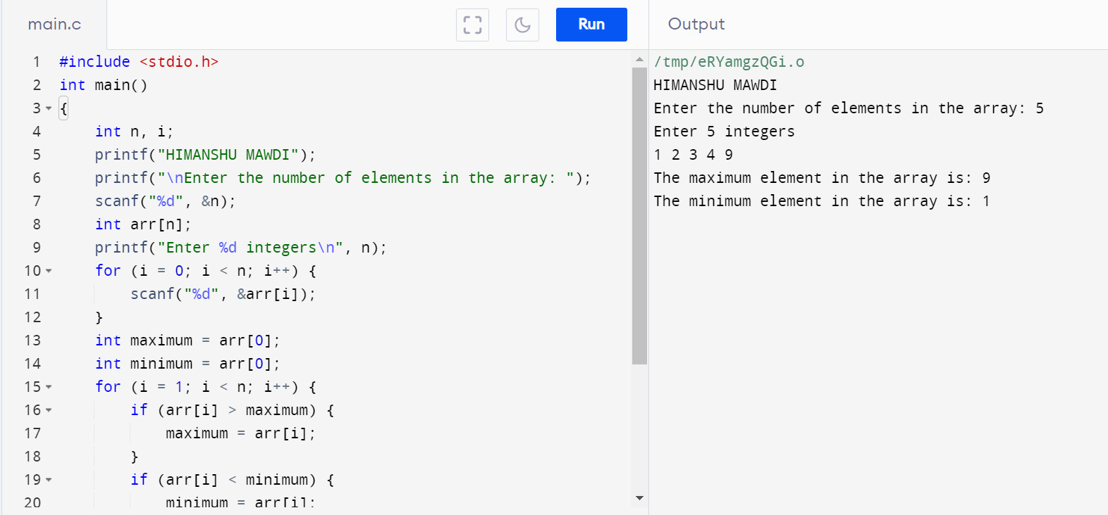

**PROGRAM 105.. TO SORT THE ELEMENTS OF AN ARRAY IN DESCENDING ORDER**

**#include <stdio.h>**

**int main()**

**{**

**int n, i, j, temp;**

**printf("HIMANSHU MAWDI");**

**printf("\nEnter the number of elements in the array: ");**

**scanf("%d", &n);**

**int arr[n];**

**printf("Enter %d integers\n", n);**

**for (i = 0; i < n; i++) {**

**scanf("%d", &arr[i]);**

**}**

**for (i = 0; i < n; i++) {**

**for (j = i + 1; j < n; j++) {**

**if (arr[i] < arr[j]) {**

**temp = arr[i];**

**arr[i] = arr[j];**

**arr[j] = temp;**

**}**

**}**

**}**

**printf("The array in descending order is: \n");**

**for (i = 0; i < n; i++) {**

**printf("%d ", arr[i]);**

**}**

**printf("\n");**

**return 0;**

**}**

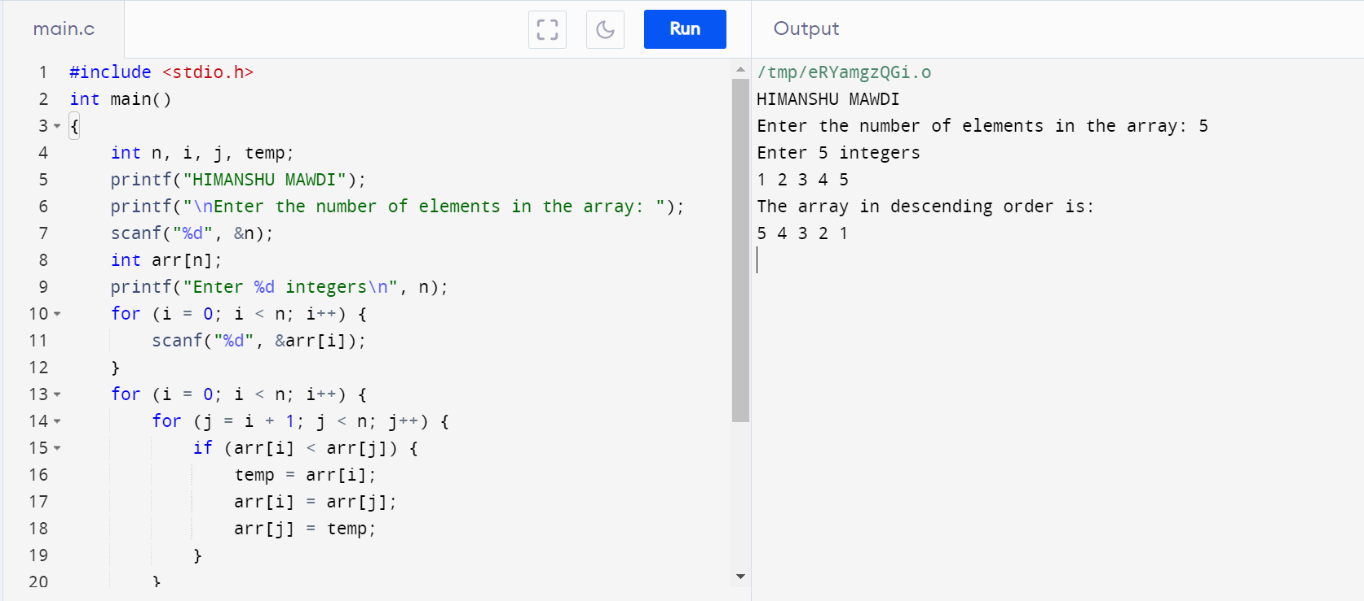

**PROGRAM 106. TO SEPARATE ODD AND EVEN INTEGERS INTO SEPARATE ARRAYS.**

**#include <stdio.h>**

**int main()**

**{**

**int n, i, j = 0, k = 0;**

**printf("HIMANSHU MAWDI");**

**printf("\nEnter the number of elements in the array: ");**

**scanf("%d", &n);**

**int arr[n];**

**int evenArray[n], oddArray[n];**

**printf("Enter %d integers\n", n);**

**for (i = 0; i < n; i++) {**

**scanf("%d", &arr[i]);**

**if (arr[i] % 2 == 0) {**

**evenArray[j] = arr[i];**

**j++;**

**} else {**

**oddArray[k] = arr[i];**

**k++;**

**}**

**}**

**printf("The even elements are: \n");**

**for (i = 0; i < j; i++) {**

**printf("%d ", evenArray[i]);**

**}**

**printf("\n");**

**printf("The odd elements are: \n");**

**for (i = 0; i < k; i++) {**

**printf("%d ", oddArray[i]);**

**}**

**printf("\n");**

**return 0;**

**}**

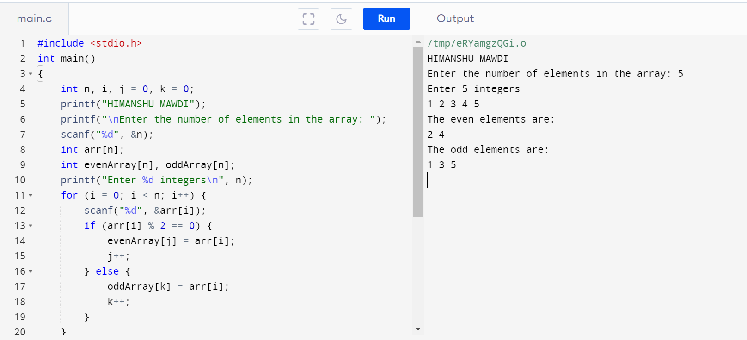

**PROGRAM 107. WRITE A PROGRAM IN C TO MERGE TWO ARRAYS OF THE SAME SIZE SORTED IN ASCENDING ORDER**

**#include <stdio.h>**

**void mergeArrays(int arr1[], int arr2[], int n, int result[])**

**{**

**int i = 0, j = 0, k = 0;**

**printf("HIMANSHU MAWDI");**

**while (i < n && j < n) {**

**if (arr1[i] <= arr2[j]) {**

**result[k] = arr1[i];**

**i++;**

**} else {**

**result[k] = arr2[j];**

**j++;**

**}**

**k++;**

**}**

**while (i < n) {**

**result[k] = arr1[i];**

**i++;**

**k++;**

**}**

**while (j < n) {**

**result[k] = arr2[j];**

**j++;**

**k++;**

**}**

**}**

**int main() {**

**int n;**

**printf("\nEnter the size of the arrays: ");**

**scanf("%d", &n);**

**int arr1[n], arr2[n], result[2 * n];**

**printf("Enter elements of the first array (ascending order):\n");**

**for (int i = 0; i < n; i++) {**

**scanf("%d", &arr1[i]);**

**}**

**printf("Enter elements of the second array (ascending order):\n");**

**for (int i = 0; i < n; i++) {**

**scanf("%d", &arr2[i]);**

**}**

**mergeArrays(arr1, arr2, n, result);**

**printf("\nMerged array in ascending order:\n");**

**for (int i = 0; i < 2 * n; i++) {**

**printf("%d ", result[i]);**

**}**

**printf("\n");**

**return 0;**

**}**

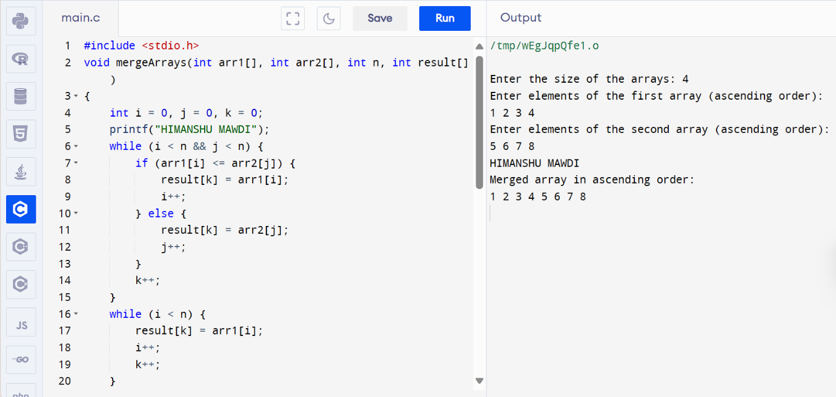

**PROGRAM 108. TO MERGE TWO ARRAYS OF THE SAME SIZE SORTED IN DESCENDING ORDER.**

**#include <stdio.h>**

**void mergeDescending(int arr1[], int arr2[], int result[], int size) {**

**int i = 0, j = 0, k = 0;**

**while (i < size && j < size) {**

**if (arr1[i] >= arr2[j]) {**

**result[k] = arr1[i];**

**i++;**

**} else {**

**result[k] = arr2[j];**

**j++;**

**}**

**k++;**

**}**

**while (i < size) {**

**result[k] = arr1[i];**

**i++;**

**k++;**

**}**

**while (j < size) {**

**result[k] = arr2[j];**

**j++;**

**k++;**

**}**

**}**

**int main()**

**{**

**int size;**

**printf("HIMANSHU MAWDI");**

**printf("\nEnter the size of the arrays: ");**

**scanf("%d", &size);**

**int arr1[size], arr2[size], mergedArray[2 * size];**

**printf("Enter elements of the first array in descending order:\n");**

**for (int i = 0; i < size; i++) {**

**scanf("%d", &arr1[i]);**

**}**

**printf("Enter elements of the second array in descending order:\n");**

**for (int i = 0; i < size; i++) {**

**scanf("%d", &arr2[i]);**

**}**

**mergeDescending(arr1, arr2, mergedArray, size);**

**printf("Merged array in descending order: ");**

**for (int i = 0; i < 2 * size; i++) {**

**printf("%d ", mergedArray[i]);**

**}**

**return 0;**

**}**

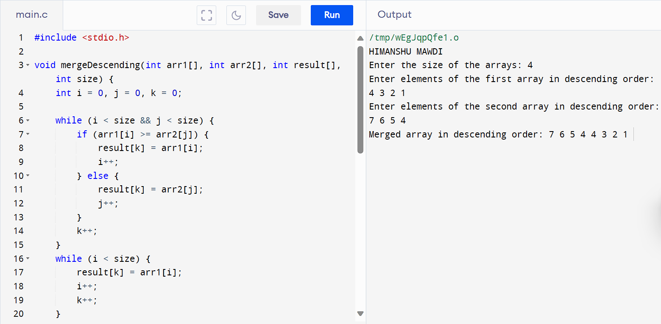

**PROGRAM . CONSIDER TWO MATRICES OF THE SIZE M AND N. IMPLEMENT MATRIX OPERATION AND DISPLAY. SHOW THESE THINGS IN PROGRAM**

**109) READ MATRIX ELEMENTS AND DISPLAY**

**#include <stdio.h>**

**int main()**

**{**

**int i, j, m, n;**

**int matrix[10][20];**

**printf("HIMANSHU MAWDI");**

**printf("\nEnter number of rows : ");**

**scanf("%d", &m);**

**printf("Enter number of columns : ");**

**scanf("%d", &n);**

**/* Input data in matrix */**

**for (i = 0; i < m; i++)**

**{**

**for (j = 0; j < n; j++)**

**{**

**printf("Enter data in [%d][%d]: ", i, j);**

**scanf("%d", &matrix[i][j]);**

**}**

**}**

**for (i = 0; i < m; i++)**

**{**

**for (j = 0; j < n; j++)**

**{**

**printf("%d\t", matrix[i][j]);**

**}**

**printf("\n");**

**}**

**return 0;**

**}**

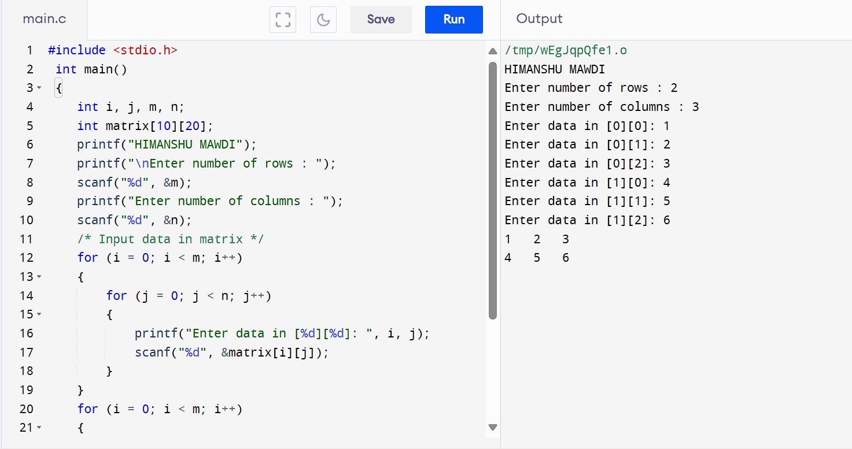

**110) MATRIX MULTIPLICATION AND DISPLAY**

**#include<stdio.h>**

**#include<stdlib.h>**

**int main()**

**{**

**int a[10][10],b[10][10],mul[10][10],r,c,i,j,k;**

**printf("HIMANSHU MAWDI");**

**printf("\nenter the number of row=");**

**scanf("%d",&r);**

**printf("enter the number of column=");**

**scanf("%d",&c);**

**printf("enter the first matrix element=\n");**

**for(i=0;i<r;i++)**

**{**

**for(j=0;j<c;j++)**

**{**

**scanf("%d",&a[i][j]);**

**}**

**}**

**printf("enter these second matrix element=\n");**

**for(i=0;i<r;i++)**

**{**

**for(j=0;j<c;j++)**

**{**

**scanf("%d",&b[i][j]);**

**}**

**}**

**printf("multiply of the matrix=\n");**

**for(i=0;i<r;i++)**

**{**

**for(j=0;j<c;j++)**

**{**

**mul[i][j]=0;**

**for(k=0;k<c;k++)**

**{**

**mul[i][j]+=a[i][k]*b[k][j];**

**}**

**}**

**}**

**for(i=0;i<r;i++)**

**{**

**for(j=0;j<c;j++)**

**{**

**printf("%d\t",mul[i][j]);**

**}**

**printf("\n");**

**}**

**return 0;**

**}**

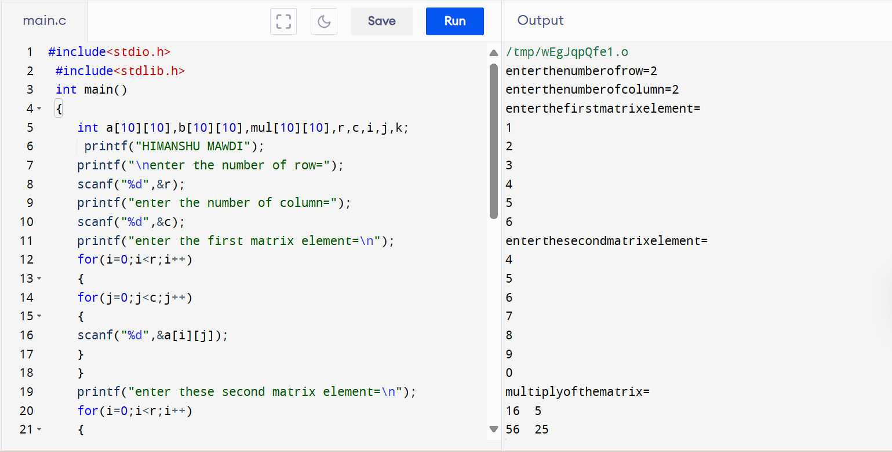

**111) ADDITION OF MATRIX AND DISPLAY**

**#include <stdio.h>**

**int main() {**

**int r, c, a[100][100], b[100][100], sum[100][100], i, j;**

**printf("HIMANSHU MAWDI");**

**printf("\nEnter the number of rows : ");**

**scanf("%d", &r);**

**printf("Enter the number of columns: ");**

**scanf("%d", &c);**

**printf("\nEnter elements of 1st matrix:\n");**

**for (i = 0; i < r; ++i)**

**for (j = 0; j < c; ++j) {**

**printf("Enter element a%d%d: ", i + 1, j + 1);**

**scanf("%d", &a[i][j]);**

**}**

**printf("Enter elements of 2nd matrix:\n");**

**for (i = 0; i < r; ++i)**

**for (j = 0; j < c; ++j) {**

**printf("Enter element b%d%d: ", i + 1, j + 1);**

**scanf("%d", &b[i][j]);**

**}**

**for (i = 0; i < r; ++i)**

**for (j = 0; j < c; ++j) {**

**sum[i][j] = a[i][j] + b[i][j];**

**}**

**printf("\nSum of two matrices: \n");**

**for (i = 0; i < r; ++i)**

**for (j = 0; j < c; ++j) {**

**printf("%d ", sum[i][j]);**

**if (j == c - 1) {**

**printf("\n\n");**

**}**

**}**

**return 0;**

**}**

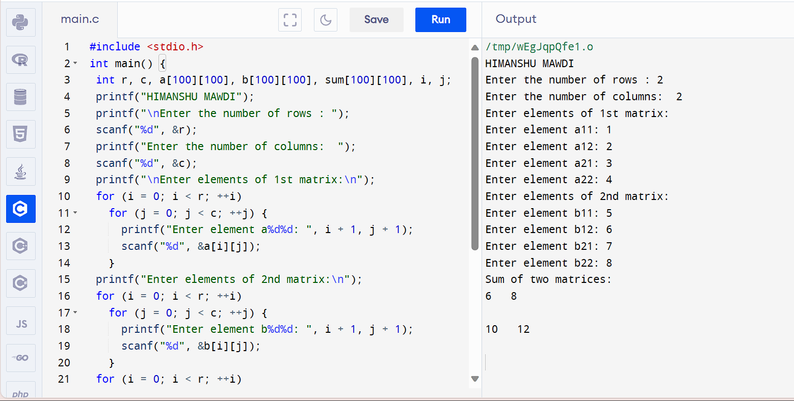

**112)SUBTRACTION OF MATRIX AND DISPLAY**

**#include <stdio.h>**

**int main()**

**{**

**int m,n,c,d,first[10][10],second[10][10],difference[10][10];**

**printf("HIMANSHU MAWDI");**

**printf("\nEnter the number of rows and columns of matrix\n");**

**scanf("%d%d",&m,&n);**

**printf("Enter the elements of first matrix\n");**

**for (c=0;c<m;c++)**

**for(d=0;d<n;d++)scanf("%d",&first[c][d]);**

**printf("Enter the elements of second matrix\n");**

**for(c=0;c<m;c++)**

**for(d= 0;d< n;d++) scanf("%d", &second[c][d]);**

**printf("Difference of entered matrices:\n");**

**for (c= 0;c< m;c++)**

**{**

**for(d=0;d< n;d++)**

**{**

**difference[c][d] =first[c][d]-second[c][d];**

**printf("%d\t",difference[c][d]);**

**}**

**printf("\n");**

**}**

**return 0;**

**}**

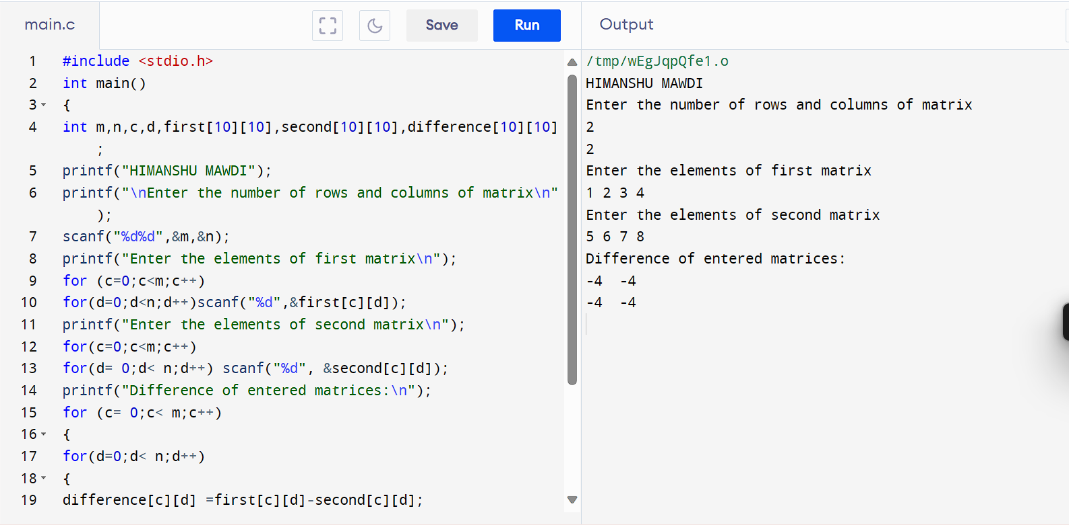

**113)TRANSPOSE OF MATRIX AND DISPLAY**

**#include <stdio.h>**

**int main()**

**{**

**int rows, cols;**

**printf("HIMANSHU MAWDI");**

**printf("\nEnter the number of rows: ");**

**scanf("%d", &rows);**

**printf("Enter the number of columns: ");**

**scanf("%d", &cols);**

**int matrix[rows][cols];**

**int transpose[cols][rows];**

**printf("Enter the elements of the matrix:\n");**

**for (int i = 0; i < rows; i++) {**

**for (int j = 0; j < cols; j++) {**

**scanf("%d", &matrix[i][j]);**

**}**

**}**

**for (int i = 0; i < rows; i++) {**

**for (int j = 0; j < cols; j++) {**

**transpose[j][i] = matrix[i][j];**

**}**

**}**

**printf("Transpose of the matrix:\n");**

**for (int i = 0; i < cols; i++) {**

**for (int j = 0; j < rows; j++) {**

**printf("%d ", transpose[i][j]);**

**}**

**printf("\n");**

**}**

**return 0;**

**}**

